EEA Report Template

IMPORTANT: Please read this section then delete before submitting your report.

How to use the EEA report template
This is the EEA report template. You should use it to prepare your report before submitting it for layout. The template provides the structure to be used as you develop your report. For more information about report structure and style, please refer to the EEA Writing Manual 2017.

Before starting to work in the template, you should save the file under the name of your report.

Styles and numbering
Predefined Word styles are used in the template for all headings, body text, feature (figures/maps/tables/boxes/photos) captions, notes and sources. These styles set fonts and font sizes. When writing your report, simply replace the existing text with your own text (e.g. chapter titles, headings, subheadings) without altering the predefined styles.

The following styles are used in EEA reports:

Title

The report title takes the ‘Title’ style.

Chapter titles, headings, sections and sub-sections are styled as follows:

Heading 1 (Calibri (Body), 22. Bold)
This is used to number chapters.

Heading 2 (Calibri (Body), 14. Bold)
This is used to number sections.

Heading 3 (Calibri (Body), 12. Bold, italic)
This is used to number sub-sections.

Heading 4 (Calibri Light (Headings), 11. Bold, italic)
This is used for a further level of sub-section. Note, no numbering is used so this level will not appear in the table of contents.

Note: Headings 1-4 are used for the main body of your report/assessment. The remaining headings are used to number annexes, and annex sections and sub-sections.

Heading 5 (Calibri (Body), 22. Bold)

This is used to number annexes. Note that the style is set up to number annexes sequentially from Annex 1.

Heading 6 (Calibri (Body), 14. Bold)

This is used to number sections of annexes.

Heading 7 (Calibri (Body), 12. Bold, italic)

This is used to number sub-sections of annexes.

Any further levels of sub-section in annexes use Heading 4 style.

The numbering of chapters, headings and sub-headings is automatic when these styles are used. Note that numbering only begins with the Introduction. Your foreword, preface, table of contents, acknowledgements and executive summary are not numbered. The last numbered chapter should be your conclusions. Lists of abbreviations, references and annexes are not numbered in this way.

The table of contents will be generated automatically if you respect the pre-defined styles for chapters, headings, sections and sub-sections. You should not need to adjust the table of contents manually.

The Quickstyle gallery, found under the ‘Home’ tab displays all the styles used in this template:

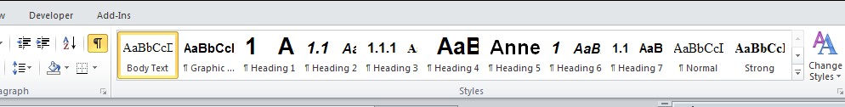

You should not need to use this as the styles are pre-set in the template, but to apply a style, just click on it in the Quickstyle gallery. To view a style without applying it, just mouse over that style in the gallery.

Features
Features are boxes, figures, maps, photographs and tables. These can appear in any chapter including the executive summary, introduction and conclusions. Features should be numbered sequentially according to where they appear in the report, i.e. the executive, the chapters or the annexes, and should include a caption.

To number features and add a caption, you should follow the following instructions:

- Select the object (box, figure, map, photograph, table) that you want to add a caption to.
- On the References tab, in the Captions group, click Insert Caption.
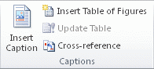
- In the Label list, select the label that best describes the object, e.g. figure or map. If the list doesn't provide the label you want, click New Label, type the new label in the Label box, and then click OK.
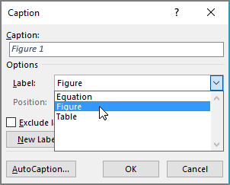
- Type your caption text after the label.
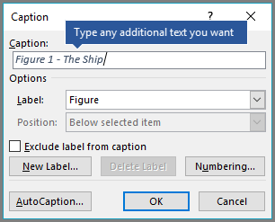
- Click OK.
Note that the labels and captions are styled as using the ‘Caption’ style. For EEA reports, the numbering of features follows the ‘Chapter No, feature No’ convention, beginning at 1.1 (i.e. Figure 1.1, Map 1.1 etc.). Numbering in the executive summary and conclusions follow the same procedure, but labels will be as follows: Figure ES1, Figure A1.1. Numbering will continue sequentially. Note also, that for photographs, the caption will appear below rather than above the feature.

- Notes should appear immediately after the feature. Notes use the ‘Graphic source/notes’ style:
Note: Note text

- Sources appear after the notes and also use the ‘Graphic source/notes’ style:
Source: Source name (Surname, initial., (Year)).

End of instructions. Delete up to here.

Report Title

Subtitle

Version: version #
Date:
EEA activity:

Author:
From:

Contributors: co-authors, or delete line
From: organisation

Document History (optional)

Version | Date | Author(s) | Remarks

Contents
How to use the EEA report template 1
Styles and numbering 1
Heading 1 (Calibri (Body), 22. Bold) 1
Heading 2 (Calibri (Body), 14. Bold) 2
Heading 3 (Calibri (Body), 12. Bold, italic) 2
Features 3
Report Title 5
Contents 6
Foreword/Preface 7
Acknowledgements 8
Key messages (1 page) 9
Executive summary (2 pages) 10
1 Chapter 1 (Repeat sequentially for all chapters up to conclusions) 11
1.1 First level subheading 11
1.1.1 Second level subheading 12
2 Chapter title (Repeat sequentially for all chapters up to conclusions) 13
2.1 First level subheading 13
2.1.1 Second level subheading 13
Conclusions (Final chapter) 14
List of abbreviations 15
References 16
Annex 1 (repeat sequentially for subsequent annexes) 17

Foreword/Preface (Only in exceptional cases and in agreement with COM)
Text here

Acknowledgements
Text here

Key messages (1 page)
- Key message here

- Key message here

- Key message here

Executive summary (2 pages)
Text here

Map ES. 1 Insert your caption here (delete feature and insert your feature)
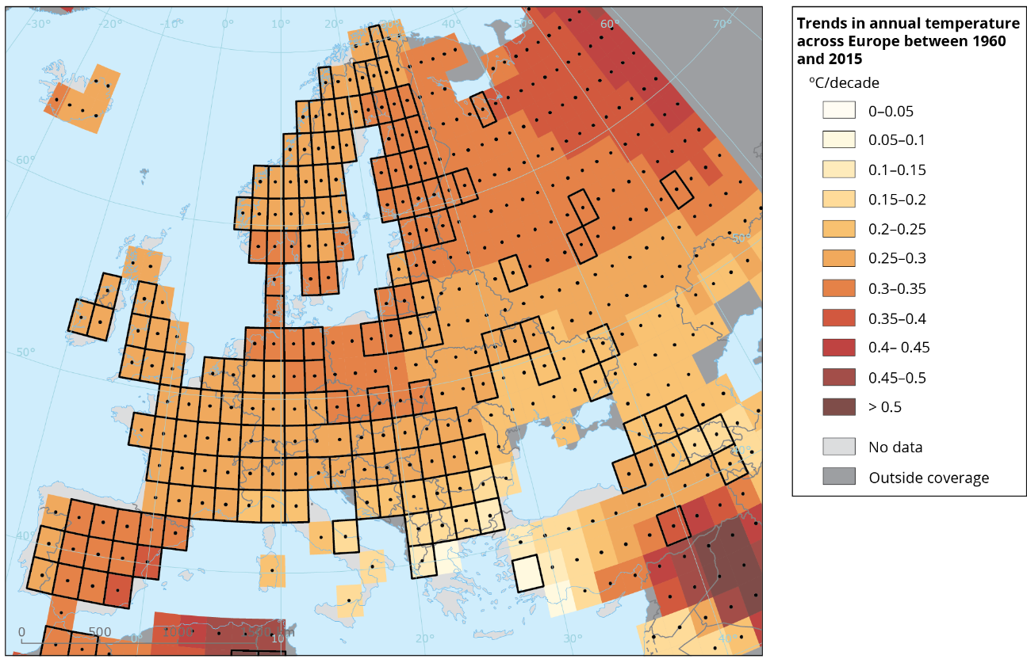

Notes: Insert notes here

Source(s): Insert source here

Chapter 1 (Repeat sequentially for all chapters up to conclusions)
Text here

First level subheading
Text here

Map 1.1 Insert your caption here (delete feature and insert your feature)

Notes: Insert notes here

Source(s): Insert source here

Second level subheading
Text here

Map 1.2 Insert your caption here

Notes: Insert notes here

Source(s): Insert source here

Third level subheading (note no numbering)

Text here

Chapter title (Repeat sequentially for all chapters up to conclusions)
Text here

Map 2.1 Insert your caption text here (delete feature and insert your feature)

Notes: Insert notes here

Source(s): Insert source here

First level subheading
Text here

Second level subheading
Text here

Third level subheading (note no numbering)
Text here

Conclusions (Final chapter)
Text here

Map C. 1 Insert your caption text here (delete feature and insert your feature)

Notes: Insert notes here

Source(s): Insert source here

List of abbreviations
Abbreviation | Name | Reference
EEA | Eureopean Environment Agency | www.eea.europa.eu

References
- For print references use the following format:
- Author’s surname, author’s initial(s)., year of publication, Title of reference work (where appropriate include edition number), publisher, place of publication, relevant page numbers if necessary.

- For online references use the following format:
- Author’s surname, author’s initial(s)., year of publication, Title of reference work (where appropriate include edition number), publisher, (URL) accessed ../../….

Annex 1 (repeat sequentially for subsequent annexes)
- Text here
Figure/Map/ Table/Box A1.1 Caption
Insert feature here. For figures, maps and photos insert as .jpeg, .png file.
Photo A1.1 Caption (for photos only, the caption comes under the feature)

Figure/Map/ Table/Box A1.2 Caption
Insert feature here. For figures, maps and photos insert as .jpeg, .png file.
Photo A1.2 Caption (for photos only, the caption comes under the feature)

