EEA briefing template and guidelines

IMPORTANT: Please read this section then delete before submitting your report.

About online briefings
Online briefings provide decision-makers with a summary of the main points concerning a topic. They are approximately four A4 pages in length including visuals (at least one) and come with a PDF print function.

Online briefings exist in both HTML (web page) and pdf format. In most cases, the pdf is generated automatically but in some exceptional cases COM1 can produce it using InDesign.

Examples of online briefings:
- NEC Directive: https://www.eea.europa.eu/themes/air/national-emission-ceilings/nec-directive-reporting-status-2019
- Land systems: https://www.eea.europa.eu/themes/landuse/land-systems/land-system-at-european-level
- TERM: https://www.eea.europa.eu/themes/transport/term/term-briefing-2018

We apply strict character counts for briefings, so that they fit the online format:
- Introduction — no more than 500 characters without spaces;
- Key messages — maximum of four or five bullet points, for a total of approximately 750 characters without spaces;
- Main text — no more than 8 000 characters without spaces.

Please see Annex 2 of the EEA Publishing guide (p. 41) for the briefing workflow.

About writing for the web
Online briefings are designed to be read on the screen. Readers have different expectations of online text than they do of printed reports. Reading online is also harder and therefore slower than reading on paper. Please keep the following advice in mind when writing your text:

- Offer readers a next step to help them on their way i.e. links to other reports or articles, data visualisations, background data, etc.
- Use words the general public understand and avoid EU terminology and jargon, where possible.
- Use short, functional prose and simple, accessible language.
- Use plenty of meaningful subheadings to break up the text, but show how different sections link to each other.
- Keep paragraphs short. Three or four lines is a good length. Your paragraphs should each contain one well-formed idea.
- Use bullet lists or tables when listing three or more items.
- Make it easier for search engines to find your page by using short, meaningful keywords, preferably at the beginning.
- Include a clear title.
For more information about writing from the web, please see p. 35 of the EEA Writing manual.

References
Long lists of references do not look good on web pages. There are two types of source in online briefings and we treat them as follows:
- Links to EEA products.
It is good practice to put as many links as possible to other EEA products in the text. It helps readers dig deeper and it highlights the reliability of the content. It also increases the content’s ranking by search engines.
Links should be made directly on the relevant text. For example:
‘A qualitative overview of the measures reported by Member States is available in an online data viewer.’

- References to external sources:
When another institution, convention or body is mentioned, a link to its website should be provided directly in the text. For example:
‘Consistent with a similar procedure agreed by Parties under the Gothenburg Protocol of the LRTAP Convention…’

When referencing published content, the EEA style guide applies. Source material should be cited in the text and a full bibliographic reference provided in the relevant section of the briefing.

For more information on referencing, please pp. 12-15 of the EEA Writing manual.

Picture
Each briefing is illustrated by a picture, which is displayed between the introduction and the body text. It also appears in listings elsewhere in the website, along with the briefing title.
COM2 will select a picture with the appropriate copyright. If there is a picture you would like to use, you are welcome to propose it. It should be in landscape orientation, at least 1 200 pixels wide and free to use for non-commercial purposes.

How to use the EEA briefing template
This is the EEA briefing template. You should use it to prepare your briefing before submitting it for editing and web layout. The template provides the structure to be used as you develop your briefing.

Before starting to work in the template, you should save the file under the name of your briefing.

Styles and numbering
Predefined Word styles are used in the template for all headings, body text, feature (figures/maps/tables/boxes/photos) captions, notes and sources. These styles set fonts and font sizes. When writing your report, simply replace the existing text with your own text (e.g. chapter titles, headings, subheadings) without altering the predefined styles.

The following styles are used in EEA briefings:

Title

The briefing title takes the ‘Title’ style.

Headings are styled as follows:

Heading 2 (Calibri (Body), 14. Bold)
This is used to number sections.

Heading 3 (Calibri (Body), 12. Bold, italic)
This is used to number sub-sections. As a rule, briefings do not have sub-sections, but in exceptional cases, Heading 3 should be used for sub-sections.

Figure heading (h4, create new style)

Headings are not numbered in briefings.

The Quickstyle gallery, found under the ‘Home’ tab displays all the styles used in this template:
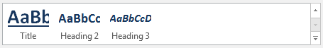

You should not need to use this as the styles are pre-set in the template, but to apply a style, just click on it in the Quickstyle gallery. To view a style without applying it, just mouse over that style in the gallery.

Features
Features are boxes, figures, maps, photographs and tables. These can appear in any section of the briefing except the key messages. Features should be numbered sequentially and should include a caption. It is recommended to have no less than three and no more than five features in a briefing. The ‘cover photograph’ is separate and does not need to be include a caption.
This briefing will be layouted in one column of approximately 90 characters. Therefore very wide tables with many columns, as well as big, very detailed visuals, will be difficult to read. You should keep tables and visuals to a limited size.

To number features and add a caption, you should follow these instructions:

- Select the object (box, figure, map, photograph, table) that you want to add a caption to.
- On the References tab, in the Captions group, click Insert Caption.
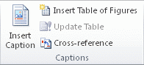
- In the Label list, select the label that best describes the object, e.g. figure or map. If the list doesn't provide the label you want, click New Label, type the new label in the Label box, and then click OK.
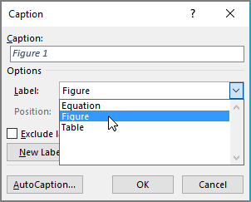
- Type your caption text after the label.
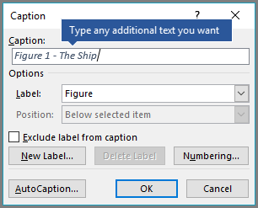
- Click OK.
Note that the labels and captions are styled as using the ‘Caption’ style. For photographs, the caption will appear below rather than above the feature.

- Notes should appear immediately after the feature. Notes use the ‘Graphic source/notes’ style:
Note: Note text

- Sources appear after the notes and also use the ‘Graphic source/notes’ style:
Source: Source name (Surname, initial., (Year)).

End of instructions. Delete up to here.

Briefing title

Version: version #
Date:
EEA activity:

Author:
From:

Document History (optional)

Version | Date | Author(s) | Remarks

Metadata
Please provide the following:

- Geographical coverage (for example: EEA-33, EU-28 + Switzerland, etc.)
- Time coverage: which period does the briefing covere? (for example 2000-2019)
- Keywords: please suggest at least three keywords relevant to this briefing (preferably not topic names or words that are already present in the title).
- Code: management plan system level 3 code (for example: 1.2.3)

Title

Introduction
Text here. This should introduce a motivated non-expert to the topic and outline the context i.e. answering this question: ‘Why is this important to me the reader, at this time?’ It should not be a rewording of the key messages and should be less than 500 characters without spaces. It is displayed as a single paragraph of bold text, and cannot include links.

Key messages
- Key message here

- Key message here

- Key message here

Your key messages should take the form of a maximum of four or five bullet points, for a total of approximately 750 characters without spaces.

Main body text
Text here. The main body text should be no more than 8 000 characters without spaces. This number may vary depending on how many features are included in the briefing. It is recommended to have no more than three or four sections. The content is up at the author’s discretion but may include policy context, state of play, EEA activities, conclusions, solutions etc.
Feature 1 Insert your caption here (delete feature and insert your feature)
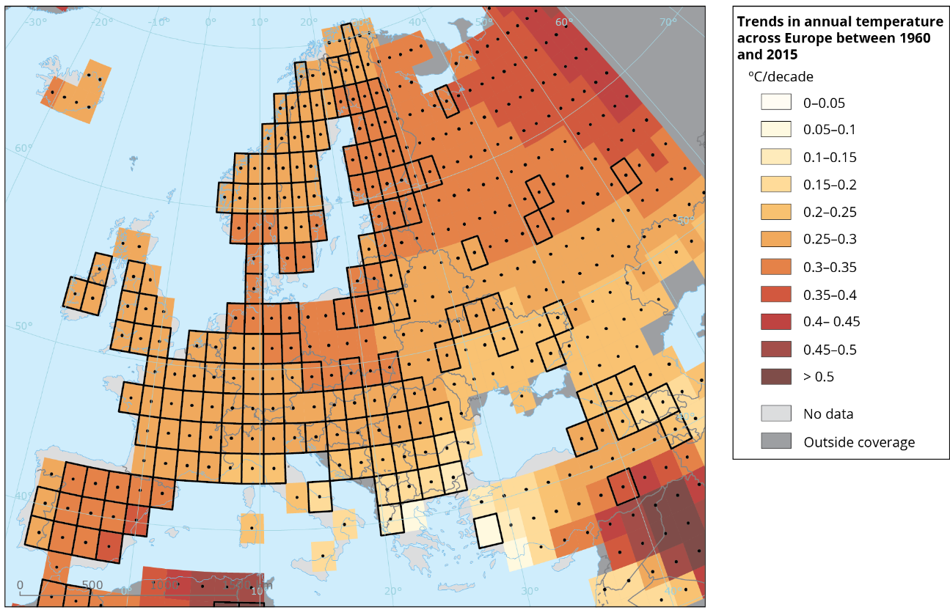

Notes: Insert notes here

Source(s): Insert source here

The European Environment Agency (EEA) is an agency of the European Union. The EEA aims to support sustainable development and to help achieve significant and measurable improvement in Europe’s environment, through the provision of timely, targeted, relevant and reliable information to policymaking agents and the public. For more information, visit: eea.europa.eu.

© European Environment Agency, XXXX

Sign up to receive EEA reports in your area of interest (print and/or electronic) and quarterly e-newsletter: http://eea-subscriptions.eu/subscribe

