Natura 2000 data flow document

Natura 2000 data flow document

Document History

Version | Date | Author(s) | Remarks
 | 08/12/2011 | Brian MacSharry, Jérôme Bailly Maitre, Sabine Roscher | ETC/BD delivery to the EEA (Rania Spyropoulou)
 | 10/12/2013 | Sabine Roscher | ETC/BD delivery to the EEA (Rania Spyropoulou)
 | 29/01/2015 | Natalia Orio (Bilbomatica), Mette Lund | Links to technical documentation in OneNote library. Other updates mainly to section 2, 4 and 5.
 | 18/11/2016 | Laura Gavilan, Natalia Orio, Rene Deprez, Mette Lund | Mini-check and Union List sections updated. Many smaller updates throughout the document.
 | 17/03/2017 | Mette Lund | Comments from November 2016 progress meeting integrated
 | 25/04/2017 | Mette Lund | Comments from March 2017 progress meeting integrated
 | 19/06/2017 | René Deprez, Laura Gavilan | Updated information on notifications, acceptance and Union Lists
 | 31/10/2017 | Joanna Karlsen | Document in EEA template and light English editing
 | 10/01/2018 | Mette Lund | Update on Natura 2000 viewer, comments from Nov 2017 progress meeting Integrated

Contents
Natura 2000 data flow document 2
Foreword/Preface 4
1 The Member States databases 5
1.1 Content of the database – the Standard Data Form (SDF) 5
1.2 Structure of the database 6
1.3 Spatial data 6
1.4 XML Schema 7
2 Natura 2000 software: the SDF manager 8
3 Upload of data via ReportNet 9
3.1 Requirements for the upload of data 9
3.2 Notifications and official acceptance of the delivery 10
3.2.1 The mini-check Overview Table 11
3.2.2 Files saved in WebDav 12
4 The production of the European Natura 2000 database 14
4.1 Transfer of data from Reportnet to the common workspace 14
4.2 Compilation of the Natura 2000 databases 16
4.2.1 ‘Cleaning up’ process 17
4.2.2 Filter for sensitive data 17
4.2.3 Technical documentation 17
5 Products of Natura 2000 18
5.1 Primary products 18
5.1.1 Tabular data 18
5.1.2 Spatial data 19
5.2 Secondary products 19
5.2.1 Validation reports 19
5.2.2 Maps 19
5.2.3 Statistics 19
5.2.4 The Union lists 20
5.2.5 Natura 2000 Internal Viewer 21
5.2.6 Natura 2000 Public Viewer 22
5.2.7 Overview of map viewers 23
Annex 1 Description of the clean-up processes 24
Annex 2 Entity-Relationship Diagram Natura 2000 Database template used by Member States for data transfer 25
Annex 3 Natura 2000 reference portal 26
Annex 4 Natura 2000 database production work flow 27
Annex 5 Natura 2000 web application 28
Annex 6 Statistics produced by the EEA and ETCs for Natura 2000 31
Annex 7 Cross-walk previous -> current Natura 2000 database template 32

Foreword/Preface
The Natura 2000 data flow document is continuously updated as the data flow is maturing, tools developed and the automation of the data processing becoming more complete.

Updated sections in this version of the document is the Notifications and official acceptance of the delivery and The Union Lists and the results of decisions reached in the Natura 2000 progress of meetings between DG ENV B3, ETC/BD, EEA and its contractor (Bilbomatica) during 2016-2017.

The Member States databases

Content of the database – the Standard Data Form (SDF)
The Standard Data Form (SDF) defines the data to be provided by the Member States to the Commission. The first version of the SDF was published in 1997; the revised version was published in Official Journal on 30 July 2011.

The revised version withdrew some fields which were either not used or not considered to give added value. On the other hand, one field has been added to the new revised SDF

• Percentage of marine area in the site (2.3)

The majority of data categories of the revised SDF have been restructured in order to make the resulting data better to use for analysis as required by the policy process. Thereof the ecological information (data on species and habitat types) and the information on threats and pressures with impact on the site are the most relevant.

The revision process did also take into account the standardisation process carried out in the context of the revision of the reporting sheets for the Habitats Directive Article 17 reporting and the Birds Directive Article 12 reporting as well as INSPIRE data specifications.

Overview on the content of the actual SDF

The SDF includes the following information categories:

- Site identification (Site type, code, name, designation date, respondent, update date)
- Site location (coordinates, area, length, administrative units, biogeographical regions, percentage marine area )
- Ecological information
  - Habitat types present on the site and site assessment for them
  - Species covered by the Birds and Habitats Directives
  - Other important species of flora and fauna (e.g. HD Annex IV and V species, red list species)
- Site description
  - General character, importance, ownership, documentation
  - Impacts and activities with effect on the site (positive and negative impacts, with ranking in high, medium, low impact)
- Site protection status (designation types, relation to other sites)
- Site management (existence of management plans, link to management plans)
- Maps (incl. Inspire ID)

The full text of the SDF and explanatory notes can be found here:

Commission Implementing Decision of 11 July 2011 concerning a site information format for Natura 2000 sites (notified under document C(2011) 4892)

Structure of the database
For the delivery of data according to the SDF, the ‘Natura 2000 Database template’ was developed in the relational database management system MS-Access. The preferred transfer format is however now an XML file as xml allows for immediate automatic QAs to be executed on the uploaded data. The XML schema is available in the Data Dictionary. Although MS Access database format (mdb; accdb) is still accepted as well.

The ’Natura 2000 database template’ contains :

- Tables to store data related to the Natura 2000 sites
- major entities are sites, habitats, species, impacts on site, management, ownership
- for a complete list see the ER diagram in Annex 2

- Tables that contain code lists (‘reference’ tables)
  - Biogeographical regions and marine regions
  - Species and Bird species code lists
  - National Designation codes (same code list as for CDDA dataflow)
  - Habitat types (as listed in the Annex of the Habitats Directive)
  - Impacts (same code list as for Habitats Directive Article 17 reporting)
  - NUTS regions

A cross-walk between the structure of the old database template and the new one is shown in Annex 7.

Spatial data
The spatial data consists of boundaries of the sites with accompanying attribute information which enables the boundaries to be linked to the tabular data. All spatial data is to be geometrically valid and have a projection. The exact specifications are available from the Natura 2000 reference portal, see section 3.1.
The site code allows joining the descriptive data to the spatial objects. Furthermore the SDF contains a field for the INSPIRE ID, that links to spatial objects which will in future be delivered by INSPIRE service.

XML Schema
Taken into account the well-known advantages of XML and basic principles of ReportNet, an XML schema has been developed in order to allow for upload of Member States data as XML document (alternative to the current often used data base file .mdb). The structure of the schema reflects the seven major information items of the SDF and the data base template. XML documents that are uploaded to ReportNet must validate against the XML schema. The Natura 2000 software uses the same XML schema to validate user entries and export format.

The XML schema is downloadable from the Natura 2000 reference portal (http://bd.eionet.europa.eu/activities/Natura_2000/reference_portal).

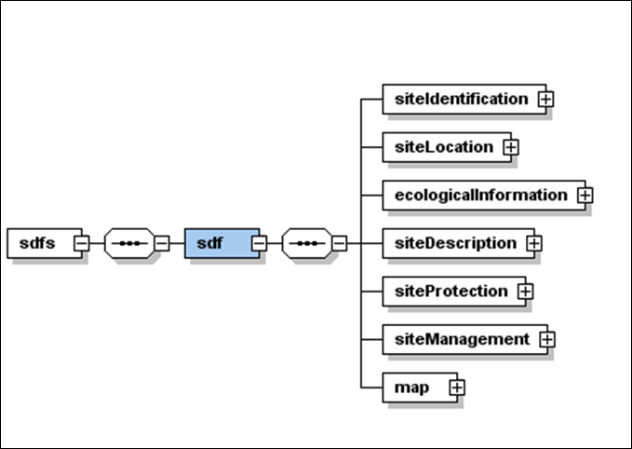
Figure 1 - Main elements of the XML schema

Natura 2000 software: the SDF manager
In order to support Member States in the management of the SDF data and its import according to the agreed transfer formats, a software was provided by the EEA. A first version (beta release) of the software was introduced in December 2011 and since 2012 the software is maintained by the EEA.

The software package together with release notes and user manual is available in the Natura 2000 Reference Portal.

In 2014 the software (now referred to as the SDF manager) was adapted to serve in parallel the twin process of reporting for the Emerald network. The Natura 2000 and the Emerald networks are complementary responses to the Bern Convention. The Emerald network is implemented by European countries not members of the EU. The SDF of the Emerald reporting is aligned to the SDF of the Natura 2000 reporting in order to streamline reporting and facilitate re-use of tools.

Since 2015 the source code for the SDF manager is available in GitHub, https://github.com/eea/eionet.nat2000.sdfmanager/releases.

The main functionalities of the SDF manager are:

• Manage SDFs
Allow users to edit already imported sites and create new sites based on the new SDF
• Import SDFs
Allow users to import in the application for future processes SDFs from the following formats:
  - Old Access Database schema
  - New Database Schema
  - New XML schema
• Export SDFs
Allow users to export one or many SDFs in the following formats:
  - Old Access Database schema (.mdb)
  - New Database Schema
  - New XML schema
• Perform Checks
Allow users to perform a quality assurance on the data registered in the application.

Upload of data via ReportNet
The Member States data coordinators upload the Natura 2000 data (tabular and spatial data) on Reportnet Central Data Repository (CDR). The requirements for the upload of data have been discussed between DG Environment and the EEA. The following sections deal with the upload of the standard data form and are based upon the relevant reference documents on the reporting of Natura 2000 that are found on the Natura 2000 Reference portal, Documentation section.

Figure 2- Overview on the data transfer formats for the tabular data which can be used by Member States to upload data to ReportNet. If both xml and MS Access formats are available, the xml file is seen as the master delivery.

Requirements for the upload of data
The general principles for uploading data to CDR were agreed between DG Environment, Member States and the EEA (Doc Hab 09-02/06, Note to the attention of the Habitats Committee, Brussels, 5.2.2009). These are progressing over the time, always adapting to new knowledge and technical evolution.

Submitting electronic Natura 2000 datasets via ReportNet principles

- For descriptive data, the complete dataset in electronic format has to be provided when a change in the area of the site or species or habitats information have been modified. Descriptive data have to be provided in one single database. The SDF can be provided in .pdf or .doc for new or modified sites, but this is not mandatory.
- For spatial data, the complete dataset in electronic format has to be provided for each modification. Pdf maps can be provided for new or modified sites but they will not replace the spatial data.
- Descriptive data have to be delivered according to the agreed SDF format (see the Natura 2000 Reference Portal for the officially agreed data base template or XML schema).
- Member States should only submit the latest updated complete national datasets. The consistency of data from different regions, particularly in the case of Member States with federal structure, must be ensured.
- Member States should always provide both descriptive and spatial datasets.
- Member States should submit a single descriptive database including both SPA's and SCI's.
- Each submission must be accompanied by a document explaining/justifying the changes which have occurred in the datasets.
- The official status of the data submitted should be confirmed by a letter of the Permanent Representation. Only then datasets will be taken into account and validated.

Further details for the Natura 2000 electronic data deliveries are given in the guidelines available in the Natura 2000 Reference Portal.

Notifications and official acceptance of the delivery
The Reportnet service for sending notifications and for providing feedback to the reporters on their deliveries is used for the Natura 2000 data flow. After the upload of a data delivery, an automatic acknowledgement receipt is sent back to the national data coordinators who forward this, through their Permanent Representation, to DG Environment in order to formalise the delivery.

All data are then retrieved from ReportNet and put on a common storing environment from where they are processed overnight to get QAQC Reports the day after. These reports are then uploaded as feedback to the Member States.

The status of data deliveries is documented by DG ENV by means of a standardized excel table, the so called Mini-check Overview Table (MCOT). This MCOT is mainly designed for DG ENV internal use and for allowing increased traceability of the uploaded files to Reportnet and the workflow for each file. The MCOT testifies the Natura 2000 upload activity during one year. Each data upload on ReportNet is represented in one line.

The mini-check Overview Table
An annual excel table, the so called 'Mini-check Overview Table' (MCOT), exists and keeps track of the dataflow. The manual mini-check is still performed now but has less importance since the QAQC is generated overnight. Anyhow, should obvious shortcomings or missing elements be identified since the upload, then this will be immediately reported back to the MS's correspondent and the QAQC will not be performed. Issues that e.g. block the further treatment of data would be missing explanatory notes or missing projection files.

Once the data has passed through the initial stages of the mini-check and the automated report is generated, DG ENV makes a decision on the acceptance on a data delivery. If changes of any form to the data delivery have been discussed in a separate official correspondence, this must be notified in this document too, either by copying it here or by referring to it (provide ARES registration number).

The table (see below) has the following structure:
- Member State
- Date of upload on ReportNet
- Registration number in EC internal registry of notification email (ARES)
- Date of the official confirmation Letter from the Permanent Representation
- Registration number in EC internal registry of Perm Rep Letter (ARES)
- The content is spatial and/or tabular? Normally it should be complete but exceptions are still likely to exist
- Basic appreciation of first check: 'ok/no' 'follow-up?'
- 4 columns for QAQC: descriptive (i.e. tabular) data, spatial data, comparative data (each with number of pdf pages), date of upload on ReportNet
- "QA/QC passed?": 'ok' or 'no'. If 'no', MS needs to submit a new dataset.
- url of ReportNet upload
- Remarks
- (as example we can say that for the year 2015, 19 MS have submitted new data, for 54 uploads on ReportNet)

Table 1 - Example of the table "Mini-check overview table" (MCOT)
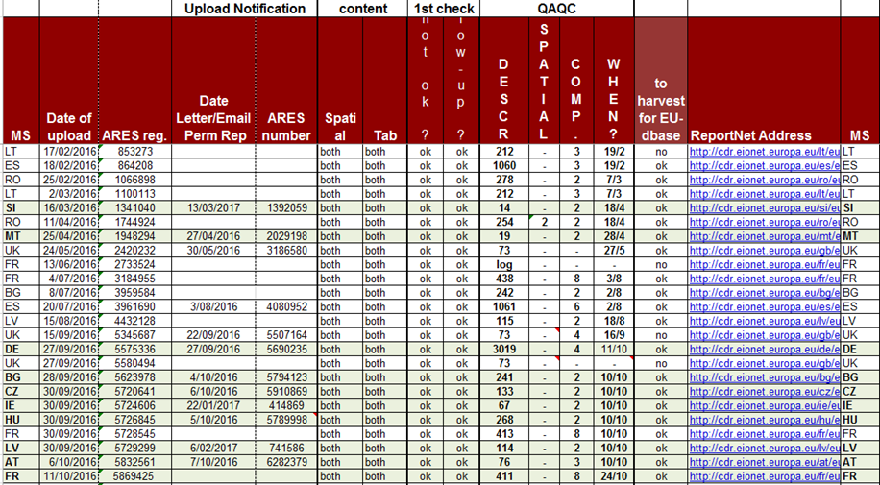

For the final EU wide database and its connected products, only the last submitted upload of a MS is taken into account, as it is supposed to represent the most up-to-date Natura 2000 data that the national Authorities own.

Files saved in WebDav
In parallel to the MCOT, where the approach is made on an annual basis, another table has been created to allow to keep track in one glance databases that have been provided by each Member State over the time. So, this table has a MS oriented approach.

It has the following structure:
- DATE section
  - Date of upload (in ReportNet) or of the CD or disquette
  - Date of the Officialisation Letter from Permanent Representation
  - Date of annexed pieces or communications
- DESCRIPTIVE DATA section
  - Content (n2k, sci or spa)
  - Format: xml/mdb (this column has been added at a later stage)
  - Completeness: c or p are depending on the content; if the content is a complete SPA dataset of the MS, than 'c' is marked here
  - If partial, which part ?
  - Number of sites
- SPATIAL DATA section
  - Content
  - C / P
  - If P, which part ?
- Maps & SDF: sometimes, though this is not obligatory, MS provide maps and/or sdf in pdf, jpg or word format. This is indicated in this column
- Carriers (CD, disquette, floppy) or Upload from ReportNet
- Date of the congregated EU wide dataset for which the respective national datasets were used

Comments to the structure:

- The date marked in bold corresponds to the file name (in webdav, always YYYY-MM-DD)
- Initially the letter of the Permanent Representation has always been THE date we had to refer to when mentioning a dataset. The reference date had to be changed due to the automation of the data handling process
- Experience has shown that a third date column was necessary, as some MS mainly referred to the date of the internal communication, more than to the letter sent by the Permanent Representation, or the date of upload. This column was not in the prototype of this table, it has been added afterwards, this explains why some boxes still need to be filled in

Table 2 - Example of the table "Files saved on WebDav", here 'The Netherlands'
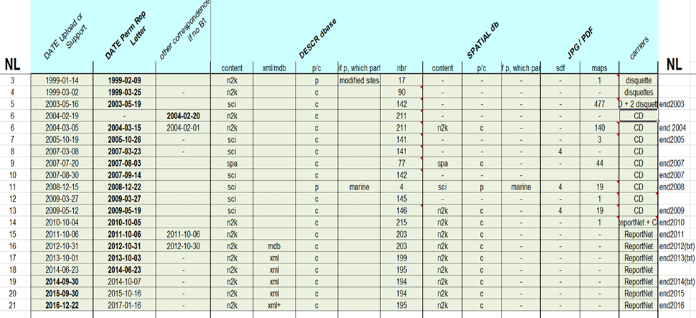

These tables, the MCOT and the WebDav overview table, have been created for internal use, enabling a fast reply to all kind of requests to DG ENV.

The production of the European Natura 2000 database
The Natura 2000 processing system includes an online data management application, “the Natura 2000 web app” (http://nature.eea.europa.eu/), which allows DG ENV unit D3 to control the production of the European Official and Public databases at any time. The application offers the option to select which delivered files to be used for the production of a European database. In the following sections and in the Annex 5 the processes available via the Natura 2000 web app are described.

Transfer of data from Reportnet to the common workspace
The datasets (tabular and spatial data) are downloaded by DG Environment from ReportNet to a common workspace maintained by the EEA. This common workspace, known as the Natura 2000 WebDav, is shared between EEA, ETC/BD and DG Environment.

The Natura2000 processing system, developed by Bilbomatica on behalf of the EEA, screens the WebDav for new files. Two processes are launched automatically every night.

The first one, called Data Preparation tool, unzips files, looks for all required files and data, and copies files from the WebDav to the work directory. The second one, called Import Tool, manages and checks the information (tabular and spatial) of the files.

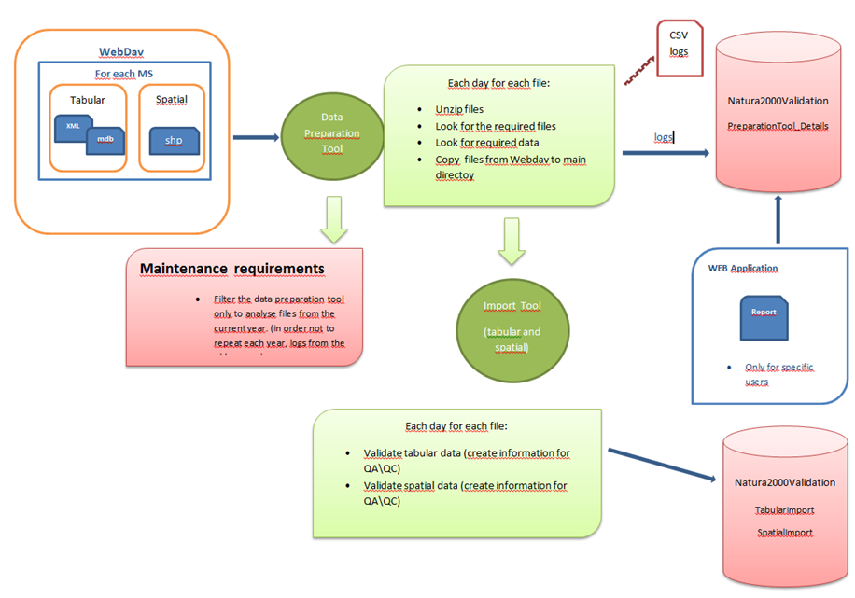
Figure 3 – Transfer of data files from the WebDav to the Natura 2000 system

The Natura2000 processing system compiles the data delivery change reports with the logs of these two processes.

To see technical documentation of these processes go to the OneNote library.

The following schema gives an overview on the Natura 2000 processing system.

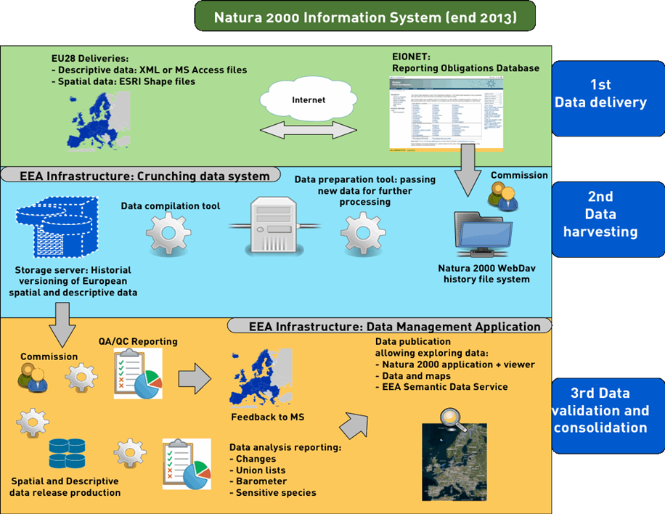
Figure 4 - Schema taken from presentation given by Bilbomatica in November 2013

Compilation of the Natura 2000 databases
The Release Maintenance manages the three kinds of releases:

- Temporary release - This intermediate database is the basis for the QA/QC reports (Descriptive, Spatial and Comparative)
- Official release – The consolidated final internal European database incl. sensitive information
- Public release – The consolidated final public European database excl. sensitive information

Release maintenance is described in the OneNote library.
All data (tabular and spatial) submitted by Member States are subjected to an automated validation check, which is used to produce quality assessment and control reports (QA/QC). The QA/QC process focuses on three aspects, 1) consistent representation of the site in both the tabular and spatial datasets, 2) the position of the centroid of the boundary, as calculated using GIS, is compared to the latitude and longitude values supplied in the tabular data and 3) the area, as calculated using GIS, is compared to the values supplied in the tabular data. Once the data has passed the QA/QC process it is reprojected to the European projection (ETRS LAEA 5210) and the datasets merged together to form the European dataset.

Once the data is validated, quality checked and approved, a consolidated EU-wide database is produced. This database is known as the Official release. It contains the original data as sent by Member States. It is used for internal analysis, the dataset is referred to as the ‘internal’ dataset, and decision-making but is not shared with the outside world. In order for the data to be made publicly available (the Public release) it must undergo two more operations: the filtering of its sensitive information and the clean-up of flagrant spelling errors and duplications.

‘Cleaning up’ process
In order to create the consolidated European public database, some corrections to the original data, as sent by Member States, are made. These corrections are necessary in order for the Member State data to meet the technical requirements of the European database and to enhance its usability. The original data, as delivered, are kept and any corrections necessary do not change the content of the data but are purely technical in nature. The cleaning up is carried out automatically; the following corrections are made:

- Clean up duplicates records in all tables
- Empty strings, fields containing only spaces are all converted into NULL
- Non UTF16 Codes creating XML issues are replaced by their Hex Code
- A species name field is created that removes 90% of the syntax errors in the species names (For search purposes)

For an explanation of the different parts of the clean-up process see Annex 1.

Filter for sensitive data
For some species there is a need for confidentiality as a protection against collecting which may be a significant threat. Therefore it was agreed by the Habitats Committee that sensitive data on species will not be given to the outside; the Commission has to guarantee that the datasets, which will be shared with other organisations (including other Commission services, researchers, international organisations, etc.) or the public do not contain these sensitive data.

The revised SDF contains a field, where Member States can indicate information on species as sensitive (‘sensitive information flag’).

Technical documentation
All the technical documentation is available in the EEA OneNote library. It contains information about the infrastructure and the workflows of the Natura2000 processing system: OneNote Library

Products of Natura 2000
Products derived from the Natura 2000 process are divided into primary and secondary products. The secondary products are derived from the primary products.

Primary products

Tabular data
The tabular data consists of the quality assured merged version of the Member State datasets and covers all 28 EU countries. The database consists of 12 tables which are linked as illustrated below.

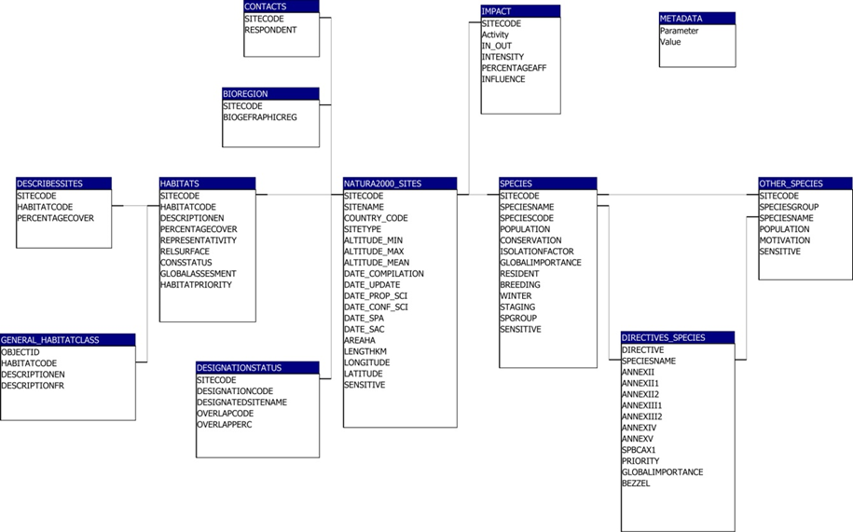
Figure 5 - Relationship diagrams of the tabular data

The Official internal database consist of all records incl. those of sensitive species, while the Public database has the sensitive species filtered out. It should be stressed that it is the internal database that all parties should use when working on Natura 2000 and that the specific version of the database should be clearly mentioned on all subsequent analysis.

The internal version as well as the public version of the database is available in MS Access database (.mdb) format via the Natura 2000 web app while the public version of the database can also be freely downloaded from the EEA web site.

Spatial data
The spatial data consists of the quality assured Member State data being merged into an EU wide dataset in the ETRS LAEA 5210 projection. The spatial dataset contains the following attributes.

Attribute
SITECODE | Unique identifier; used to link to the tabular data
SITENAME | Name of the site; can be used to link to the tabular data
SITETYPE | Denotes whether the site is an SCI, SPA or both
RELEASE_DA | Release date
MS | Member State

The spatial dataset is generalised to a scale of 1:100 000, therefore the boundaries of the sites in this dataset will not be as precise as the boundaries in the Member States supplied dataset.
The data is available as shape files via the Natura 2000 web app or as shape and sqlite files from the EEA website.

Secondary products

Validation reports
The QA/QC reports for the tabular and spatial data per Member State and per reporting period are available via the Natura 2000 web app. These reports identify errors in the data. See also Annex 5.

Maps
A series of maps are generated for each Member State and for Europe as a whole. The maps show the sites designated under the Birds Directive, Habitats Directive and those sites covered by both Directives (the ‘C types’ sites).

Statistics
The Natura 2000 barometer includes Natura 2000 area statistics on SPA and SCI/SCA by MS and EU.

Since 2016 the process of the Barometer has been automated and it can be executed from the Natura 2000 web application. With the web app the barometer can be generated for a selected release, see also Annex 5 and 6.
For more technical information please visit the OneNote library.

The Union lists
The Union Lists are official lists of SCI (Sites of Community Importance designated under the Habitats Directives) by biogeographical region. There are nine Union Lists, one for each biogeographical region (Alpine, Atlantic, Black Sea, Boreal, Continental, Macaronesian, Mediterranean, Pannonian and Steppic).

The information included in the Lists is site code, site name, area, coordinates of the site centroid, and priority (highlight the presence of a priority habitat type or species). These lists are updated annually in order to include (or not) all changes in the above fields (name, area, coordinates and priority). Member States revise changes in the Union Lists and the Habitats Committee subsequently approve the Union Lists. After approval, the Lists are published in the Official Journal of the European Union.

The steps involved in the creation of the Union lists are (see also Figure 6):
- Union List database
The provisional Union Lists are automatically generated in mdb format through the Natura 2000 web application based on the latest Official database (Get Natura 2000 Data Products > Export of the union list data of Natura 2000). Using this database as a basis, the ETC/BD reviews the lists, adding marine sites to the corresponding terrestrial biogeographical list, ensuring all sites indicate the biographical region(s), etc.
- Production of the Union Lists Changes Reports
On one hand, a changes table between the Official database and the previous Official database is automatically generated by the Natura 2000 web application (it can be exported in different formats such as pdf or xml).
On the other hand, ETC/BD produces manually documents showing changes in sites added or deleted, changes in area, name, coordinates and priority features by biogeographical region and by Member State. These documents are called Union Lists Changes reports.
Likewise, ETC/BD ensures that all changes included in the changes reports are properly explained by the Member States and, when it is not the case, specific question are addressed to the Member States (normally submissions of official data are accompanied by a document explaining/justifying the changes which have occurred in the datasets). ETC/BD pays special attention to sites deleted, area reduction (mainly when it is bigger than 5% of the SCI area) and deletion of priority features.
- Comparison of draft Union Lists with the previous official Union Lists
These draft lists prepared by the ETC/BD are compared with the previous Union Lists officially approved by the Habitats Committee through a comparison software. This comparison is a parallel process to the production of the Union List Changes Report in order to facilitate the identification of changes in the area, length, coordinates and priority. All changes between the previous official Union Lists and the current draft Union Lists must be reflected in the Union Lists Changes Reports by Member State and by biogeographical region.
- Consultation period
The draft Union Lists are subject to a consultation period with Member States. The ETC/BD sends the draft Union Lists along with the changes reports that justify all changes to DG ENV (D3, Frank Vassen). After their perusal, DGENV D3 send them out to the Member States. All changes need to be properly explained by MS in the documents that accompany the official deliveries. When this is not the case, MS are asked for explanations in the Union Lists Changes Report. Based on the consultation period, the Union Lists are modified where necessary. After taking into account MS’s comments and amendments, the Final Draft Union Lists are again sent to Member States.
- Last minutes changes
ETC/BD considers last minute changes to all modifications asked by the Member States after the Final Draft Union Lists.

In 2017 it was decided that priority features with non-significant “representativity” (for habitats) and non-significant “population” (for species) will no longer be considered a priority. Non-significant representativity/population is indicated with the D category in the Standard Data Form.

Two change reports generated by the Natura 2000 web app (see Annex 5) are used for the Union List work:
      - Descriptive Data Delivery Change report
      - Union Lists Change Report

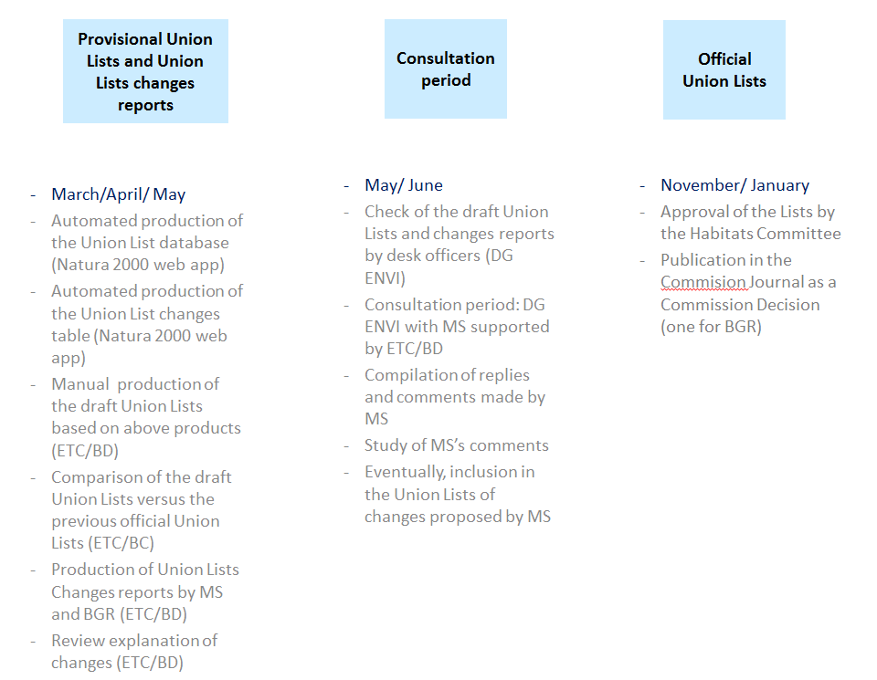
Figure 6 - Overview on the Union Lists workflow

Natura 2000 Internal Viewer
The ‘internal’ Natura 2000 viewer is similar to the public viewer but with added functionality in terms of visualising statistics, enhanced searches and a site boundaries historical viewer. Information about sensitive species is available. The dataset used by the viewer is the Official dataset. This viewer is accessible to the DG Environment, the EEA and the ETC/BD.

Natura 2000 Public Viewer
The Natura 2000 public viewer enables the user to visualise the Natura 2000 network and search for sites, habitats and species. Information about sensitive species is not available in the public viewer. The data shown via the public viewer is the Public dataset.

The main search and display functions are
- search a Natura 2000 site (by name or code)
- search all sites for a species (by name or code)
- search all sites for a habitat type (by name or code)
- search EU distribution area (for a species or a habitat type)
- search EU breeding distribution area (for a bird species)

There are three display options for species:
standard dots / type of site use / population size
There are three display options for habitat types:
standard dots / habitat area / degree of conservation

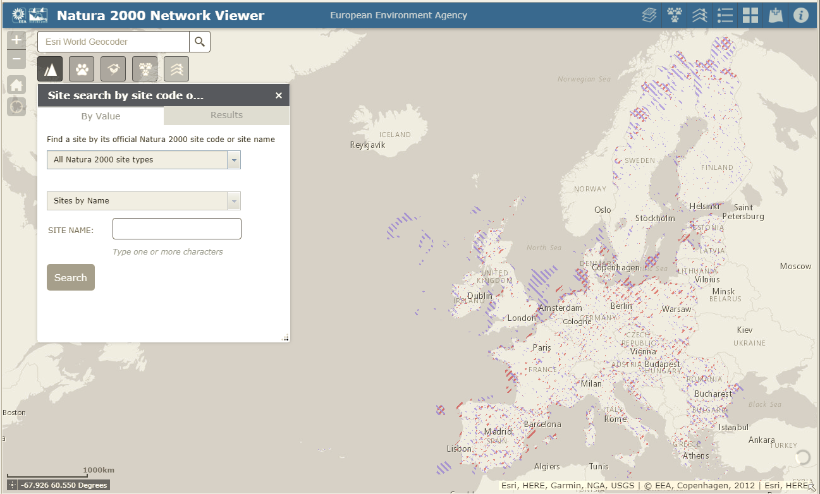
Figure 7 - The Natura 2000 public viewer
The Natura 2000 viewer includes as well:
- Article 17 and 12 distributions, conservation status, area coverage and population
- Biogeographical regions, Land parcels purchased with LIFE co-funding.
- The possibility to add data to the map by searching for layers in ArcGIS Online, entering URLs, or uploading local files in different formats (SHP, CSV, GPX and GeoJSON).
- Users with an EEA organisational ArcGIS Online account can save their maps including additional layers. Other users cannot save their mashups.

For more information in relation with viewer please visit the OneNote library.

Overview of map viewers
An overview of Natura 2000 viewers are available at
http://eea.maps.arcgis.com/apps/PublicGallery/index.html?appid=4f9dafe066884d96b6f1298ef21e38cb

The map viewers are
- Natura 2000 map viewer (in production)
- Barometer viewer (close to ready)
- Natura 2000 and Corine land cover viewer (draft)
- Natura 2000 historical viewer (draft)

Annex 1 Description of the clean-up processes

Clean up duplicates records in all tables
Some datasets sent by Member State contain duplicate records meaning that there are identical repetition of entries e.g. for a site. These duplicates are removed inter alia to guarantee the correct calculation of statistics.

Empty strings, fields containing only spaces are all converted into NULL
‘Empty fields’ within the tables often contain spaces, these are removed, in addition the empty strings are set to NULL which explicitly means that the value is non-existent.

Non UTF16 Codes creating XML issues are replaced by their Hex Code
UTF16 is a character encoding capable of encoding the entire Unicode repertoire. In some cases the databases contains other character encodings, these are replaced by their Hexadecimal Code in order to allow for the conversion to XML.

A species name field is created that removes 90% of the syntax errors in the species names (For search purposes). The steps are
Step 1 : Remove front and back spaces
Step 2 : Remove all -/v, -/v, -/st, -/sh, -/e ...etc
Step 3 : Remove all with some name date at the end of the line
Step 4 : Remove numbers,>, A-?
Step 5 : Remove duplicated spaces, '-', ' ', '[', ']'
Step 6 : Replace odd content,(Roem. & Schult.,",’,A,ì,*,=...)
Step 7 : Remove leading spaces once more
Step 8 : Set lower/upper case
Step 9 : Fix ('l.'To'L.'),
Step 10 : Remove all doubles, finish with ‘,’
Step 11 : Remove ., &,(,)
Step 12 : Replace oa,au,ea,ae,ui,eu,eo,ia,ei,ea,oe,i=y

Annex 2 Entity-Relationship Diagram Natura 2000 Database template used by Member States for data transfer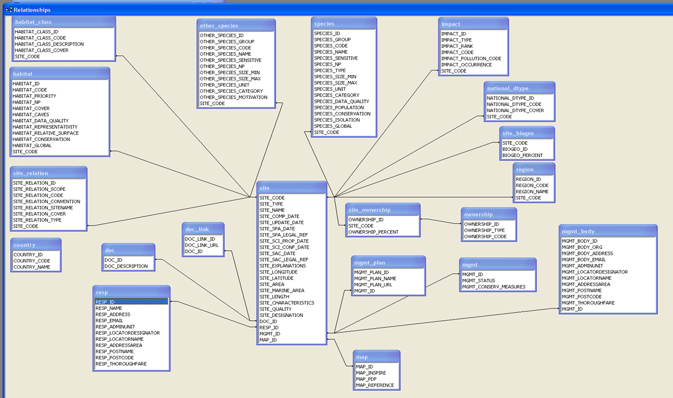

Annex 3 Natura 2000 reference portal

The Natura 2000 reference portal is an aid to the Standard Data Form. This portal provides a set of code list used in the Standard Data Form.

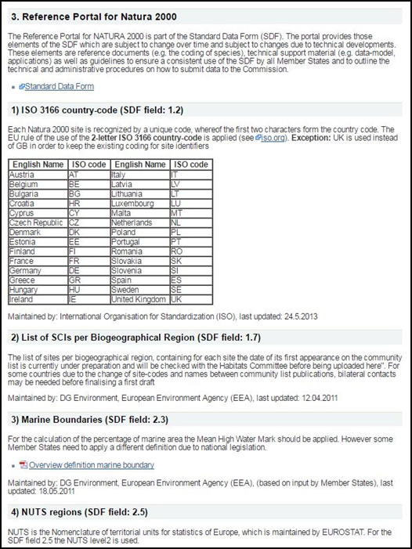

A number of these code lists are subject to change over time due to technical developments. The reference portal allows Member States to easily find these code lists. The code lists are maintained by the various actors, ETC/BD, EEA and DG Env and placed in the BDC. A number of user front-ends, such as the Natura 2000 reference portal, the Article 17 reference portal and the Article 12 reference portal, link to these code lists.

Annex 4 Natura 2000 database production work flow
The workflow is available from https://svn.eionet.europa.eu/repositories/Natura2000/Documentation/Natura2000%20WorkFlow_final.pdf
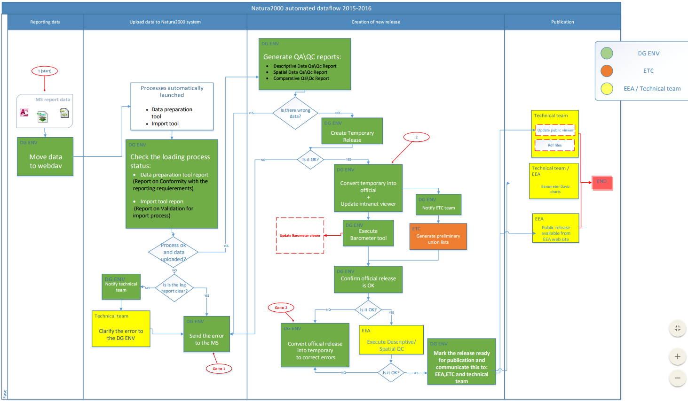

Annex 5 Natura 2000 web application
The Natura 2000 data processing system has a user interface called the Natura 2000 web application, http://nature.eea.europa.eu/. It is meant for data operations and report generation by staff in DG ENV, ETC/BD and to a limited extent EEA staff. The DG ENV and the EEA has an intranet access, while ETC/BD colleagues have access via the internet and a specific role assigned to their Eionet login.

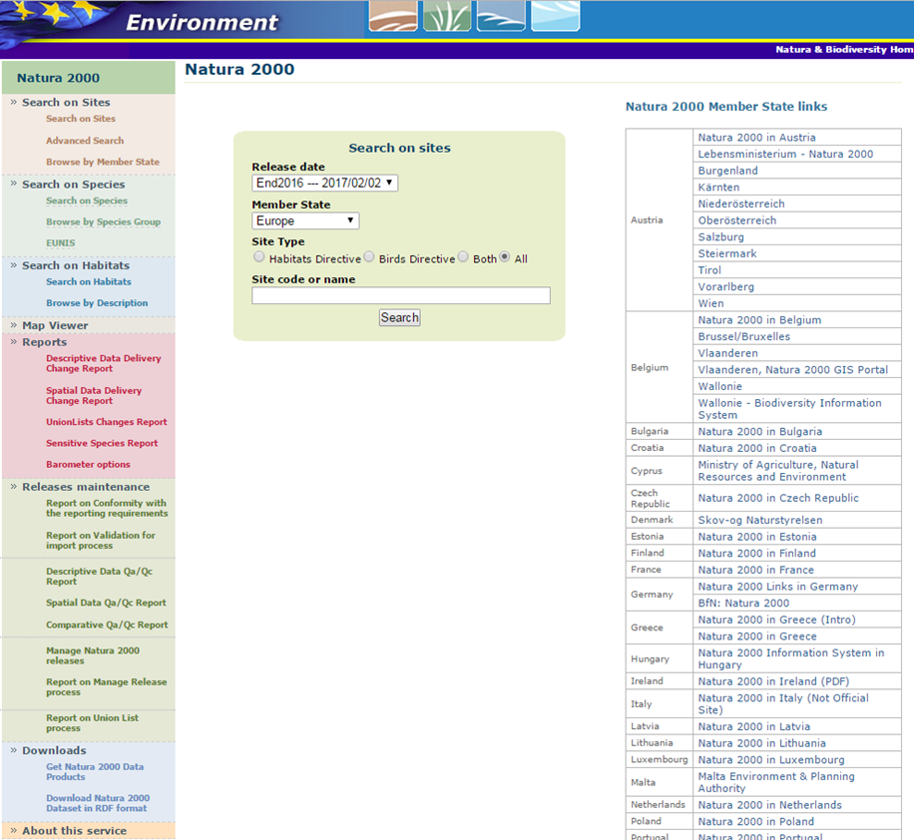
Screen shot of the Natura 2000 web app (March 2017)

The sections of the web application are listed below. Where reports are generated, the rationale behind the reports is explained in the report introductions.

Search on sites

Search on species

Search on habitats

Map viewer (the internal version including sensitive species)

REPORTS:
- Descriptive Data Delivery Change Report: This is a quick check performed to identify differences between different database versions submitted by a Member State. Its purpose is to help verify, at an early stage, if changes affecting a database have been duly justified. For any in-depth look at the data highlighted in this report, please consult the original databases. To check if these changes have been correctly justified by MS, please consult the accompanying explanatory notes in the MS's Reportnet folder. For any anomalies in the present report, please consult DG ENVIRONMENT: Frank Vassen, frank.vassen@ec.europa.eu , or René Deprez, rene.deprez@ec.europa.eu.
- Spatial Data Delivery Change Report: This is a quick check performed to identify differences between different database versions submitted by a Member State. Its purpose is to help verify, at an early stage, if changes affecting a database have been duly justified. For any in-depth look at the data highlighted in this report, please consult the original databases. To check if these changes have been correctly justified by MS, please consult the accompanying explanatory notes in the MS's Reportnet folder. For any anomalies in the present report, please consult DG ENVIRONMENT: Frank Vassen, frank.vassen@ec.europa.eu, or René Deprez, rene.deprez@ec.europa.eu.
- CHANGE REPORT between version X and version Y (UnionLists changes report): The change report will allow the comparison of the Natura 2000 Union Lists of two selected releases. In case of questions please contact: refportnatura2000@mnhn.fr
- Sensitive Species Report (Introduction missing)
- Barometer Report (Introduction missing)

RELEASE MAINTENANCE
- Report on Conformity with the reporting requirements: The purpose of this document is to check whether the information in the national data delivery reported by member states are well-formed and follow the guidelines of reporting as outlined in the Commission Implementing Decision 2011/484/EU. On the basis of information included in this document, the national authorities are invited to correct and if necessary to resubmit their national databases. In case of questions please contact: refportnatura2000@mnhn.fr
- Report on Validation for import process: The purpose of this document is to check whether the information in the national data delivery reported by member states are well-formed and follow the guidelines of reporting as outlined in the Commission Implementing Decision 2011/484/EU. On the basis of information included in this document, the national authorities are invited to correct and if necessary to resubmit their national databases. In case of questions please contact: refportnatura2000@mnhn.fr
- Descriptive data QA/QC report)- Conformity with Natura 2000 Standard Data Form: The purpose of this document is to check whether the information in the national data delivery is conform to the technical requirements as outlined in the Commission Implementing Decision 2011/484/EU. The list of QA/QC checks performed only covers the most important aspects of data quality, completeness and consistency and should therefore not be considered as being exhaustive. On the basis of information included in this document, the national authorities are invited to correct and if necessary to resubmit their national databases. In case of questions please contact: refportnatura2000@mnhn.fr
- SPATIAL QA/QC Report: Conformity with Natura 2000 Standard Data Form: The purpose of this document is to check whether the information in the national data delivery is conform to the technical requirements as outlined in the Commission Implementing Decision 2011/484/EU. The list of QA/QC checks performed only covers the most important aspects of data quality, completeness and consistency and should therefore not be considered as being exhaustive. On the basis of information included in this document, the national authorities are invited to correct and if necessary to resubmit their national databases. In case of questions please contact: refportnatura2000@mnhn.fr
- COMPARATIVE QA/QC Report: Conformity with Natura 2000 Standard Data Form: The list of QA/QC checks performed only covers the most important aspects of data quality, completeness and consistency and should therefore not be considered as being exhaustive. On the basis of information included in this document, the national authorities are invited to correct and if necessary to resubmit their national databases. In case of questions please contact: refportnatura2000@mnhn.fr
- Report on Manage Release process: (Introduction missing?)
- Report on Union List process: The purpose of this document is to check whether the information in the national data delivery reported by member states are well-formed and follow the guidelines of reporting as outlined in the Commission Implementing Decision 2011/484/EU). In case of questions please contact: refportnatura2000@mnhn.fr

Downloads

Annex 6 Statistics produced by the EEA and ETCs for Natura 2000

Background
The EEA and ETC/BD and ETC/ICM produce statistics regularly on Natura 2000 data. The statistics are used as a basis for different indicators, the biodiversity baseline and for the preparation of discussions and meetings with the Member States. They are an important tool for decision making and for supporting environmental policy.

1) The Barometer
Introduction from the DGENV web site:
http://ec.europa.eu/environment/nature/natura2000/barometer/index_en.htm

Data visualisations from the EEA:
Daviz visualisation
Tableau visualisation
The Barometer viewer

The Barometer calculations from the Natura 2000 web application:
http://nature.eea.europa.eu/BarometerOptions.aspx
The Barometer methodology document

2) SEBI indicators
Complementarity between European designations (Natura 2000 and Emerald networks) and national designations by share of terrestrial area (figure 3 of SEBI007)

Sites designated under the EU Habitats and Birds Directives (SEBI008)

3) Coverage of Corine land cover classes in Natura 2000 aggregated by NUTS 3 regions
The data is available the EEA web site:
https://www.eea.europa.eu/data-and-maps/data/natura2000-clc-by-nuts
The methodology document

3) Marine Natura 2000 sites by marine sub-region

EEA marine indicator: Marine protected areas in Europe's seas

The annual update on coverage of marine Natura 2000 sites by MFSD sub-region is not yet available online, but it will be linked e.g. from this page:
https://www.eea.europa.eu/themes/biodiversity/europe-protected-areas

Annex 7 Cross-walk previous -> current Natura 2000 database template

Previous Access Data Base | Current Access Data Base | Comments from ETC/BD
Biotop.SITECODE | Site.SITE_CODE
Biotop.TYPE | Site.SITE_TYPE
Biotop.DATE | Site.SITE_COMP_DATE
Biotop.UPDATE | Site.SITE_UPDATE_DATE
Biotop.DATE_PROP | Site.SITE_SCI_PROP_DATE
Biotop.DATE_CON | Site.SITE_SCI_CONF_DATE
Biotop.SPA_DATE | Site.SITE_SPA_DATE
Biotop.SAC_DATE | Site.SITE_SAC_DATE
Biotop.RESPONDENT | Site.RESP_ID,  Resp.RESP_NAME,  Resp.RESP_ADDRESS,  Resp.RESP_EMAIL  Resp.RESP_ADMINUNIT*  Resp.RESP_LOCATORDESIGNATOR*  Resp.RESP_LOCATORNAME*  Resp.RESP_ADDRESSAREA*  Resp.RESP_POSTNAME*  Resp.RESP_POSTCODE*  Resp.RESP_THOROUGHFARE* | The link has to be done with the ID.  *These fields are to enter Addresses, structured according to Inspire data specification
Biotop.MANAGER | Site. MGMT_ID, mgmt_body.MGMT_BODY_ID, mgmt_body.MGMT_BODY_ORG, mgmt_body.MGMT_BODY_ADDRESS, mgmt_body.MGMT_BODY_EMAIL  Mgmt_body.MGMT_ADMINUNIT*  Mgmt_body.MGMT LOCATORDESIGNATOR*  Mgmt_body.MGMT LOCATORNAME*  Mgmt_body.MGMT ADDRESSAREA*  Mgmt_body.MGMT POSTNAME*  Mgmt_body.MGMT POSTCODE*  Mgmt_body.MGMT THOROUGHFARE* | The link has to be done with the ID.  *These fields are to enter Addresses, structured according to Inspire data specification
Biotop.SITE_NAME | Site.SITE_NAME
Biotop.AREA | Site.SITE_AREA
Biotop.LENGTH | Site.SITE_LENGTH
Biotop.LON_EW | Site.SITE_LONGITUDE | Replaced by one field in the new version. Format for coordinates changed to decimal degrees
Biotop.LON_DEG | Site.SITE_LONGITUDE
Biotop.LON_MIN | Site.SITE_LONGITUDE
Biotop.LON_SEC | Site.SITE_LONGITUDE
Biotop.LAT_DEG | Site.SITE_LATITUDE | Replaced by one field in the new version. Format for coordinates changed to decimal degrees
Biotop.LAT_MIN | Site.SITE_LATITUDE
Biotop.LAT_SEC | Site.SITE_LATITUDE
Biotop.LAT_NZ | Site.SITE_LATITUDE
Biotop.ALT_MEAN |  | Field deleted in the revised SDF
Biotop.ALT_MAX |  | Field deleted in the revised SDF
Biotop.ALT_MIN |  | Field deleted in the revised SDF
Biotop.QUALITY | Site.SITE_QUALITY
Biotop.VULNAR |  | This field has been replaced by the ‘section’ “Threats, pressures and activities with impact on the site”
Biotop.DESIGN | Site.SITE_DESIGNATION
Biotop.DOCUM | Site.DOC_ID, doc.DOC_DESCRIPTION, doc_link.DOC_LINK_ID, doc_link.DOC_LINK_URL | Link with 2 tables. The link has to be done with the ID.
Biotop.CHARACT | Site.SITE_CHARACTERISTICS
Biotop.MANAGPL | Site.MGMT_ID, mgmt.MGMT_STATUS, mgmt.MGMT_CONSERVATION_MEASURES, mgmt_plan.MGMT_PLAN_ID, mgmt_plan.MGMT_PLAN_NAME, mgmt_plan.MGMT_PLAN_URL | Link with 2 tables. The link has to be done with the ID.
Biotop.PHOTOS |  | Field deleted in the revised SDF
Biotop.MAPSINCL | Site.MAP_ID, map.MAP_INSPIRE, map.MAP_PDF, map.MAP_REFERENCE | The link has to be done with the ID.
Biotop.ALPINE | Site_biogeo. BIOGEO_ID | Codes from reference table. REF_BIOGEO
Biotop.ATLANTIC | Site_biogeo. BIOGEO_ID | Codes from reference table. REF_BIOGEO
Biotop.CONTINENT | Site_biogeo. BIOGEO_ID | Codes from reference table. REF_BIOGEO
Biotop.MACARONES | Site_biogeo. BIOGEO_ID | Codes from reference table. REF_BIOGEO
Biotop.MEDITERR | Site_biogeo. BIOGEO_ID | Codes from reference table. REF_BIOGEO
Biotop.BOREAL | Site_biogeo. BIOGEO_ID | Codes from reference table. REF_BIOGEO
Biotop.OWNER | Siteownership.OWNERSHIP_PERCENT, ownership.OWNERSHIP_ID, ownership.OWNERSHIP_TYPE | Link with 2 tables. The link has to be done with the ID.
Amprep.SITECODE | Species.SITE_CODE
Amprep.SPECNUM | Species.SPECIES_CODE
Amprep.TAX_CODE |  | Field deleted in the revised SDF
Amprep.SPECNAME | Species.SPECIES_NAME
Amprep.RESIDENT | Species.SPECIES_TYPE
Amprep.BREEDING | Species.SPECIES_TYPE
Amprep.WINTER | Species.SPECIES_TYPE
Amprep.STAGING | Species.SPECIES_TYPE
Amprep.POPULATION | Species.SPECIES_POPULATION
Amprep.CONSERVE | Species.SPECIES_CONSERVATION
Amprep.ISOLATION | Species.SPECIES_ISOLATION
Amprep.GLOBAL | Species.SPECIES_GLOBAL
Amprep.ANNEX_II |  | Information concerning Annexes will be available in the reference table called REF_SPECIES
Bird.SITECODE | Species.SITE_CODE
Bird.SPECNUM | Species.SPECIES_CODE
Bird.TAX_CODE |  | Field deleted in the revised SDF
Bird.SPECNAME | Species.SPECIES_NAME
Bird.RESIDENT | Species.SPECIES_TYPE
Bird.BREEDING | Species.SPECIES_TYPE
Bird.WINTER | Species.SPECIES_TYPE
Bird.STAGING | Species.SPECIES_TYPE
Bird.POPULATION | Species.SPECIES_POPULATION
Bird.CONSERVE | Species.SPECIES_CONSERVATION
Bird.ISOLATION | Species.SPECIES_ISOLATION
Bird.GLOBAL | Species.SPECIES_GLOBAL
Bird.ANNEX_II |  | Information already available in the table called REF_BIRDS
Fishes.SITECODE | Species.SITE_CODE
Fishes.SPECNUM | Species.SPECIES_CODE
Fishes.TAX_CODE |  | Field deleted in the revised SDF
Fishes.SPECNAME | Species.SPECIES_NAME
Fishes.RESIDENT | Species.SPECIES_TYPE
Fishes.BREEDING | Species.SPECIES_TYPE
Fishes.WINTER | Species.SPECIES_TYPE
Fishes.STAGING | Species.SPECIES_TYPE
Fishes.POPULATION | Species.SPECIES_POPULATION
Fishes.CONSERVE | Species.SPECIES_CONSERVATION
Fishes.ISOLATION | Species.SPECIES_ISOLATION
Fishes.GLOBAL | Species.SPECIES_GLOBAL
Fishes.ANNEX_II |  | Information concerning Annexes will be available in the reference table called REF_SPECIES
Invert.SITECODE | Species.SITE_CODE
Invert.SPECNUM | Species.SPECIES_CODE
Invert.TAX_CODE |  | Field deleted in the revised SDF
Invert.SPECNAME | Species.SPECIES_NAME
Invert.RESIDENT | Species.SPECIES_TYPE
Invert.BREEDING | Species.SPECIES_TYPE
Invert.WINTER | Species.SPECIES_TYPE
Invert.STAGING | Species.SPECIES_TYPE
Invert.POPULATION | Species.SPECIES_POPULATION
Invert.CONSERVE | Species.SPECIES_CONSERVATION
Invert.ISOLATION | Species.SPECIES_ISOLATION
Invert.GLOBAL | Species.SPECIES_GLOBAL
Invert.ANNEX_II |  | Information concerning Annexes will be available in the reference table called REF_SPECIES
Mammal.SITECODE | Species.SITE_CODE
Mammal.SPECNUM | Species.SPECIES_CODE
Mammal.TAX_CODE |  | Field deleted in the revised SDF
Mammal.SPECNAME | Species.SPECIES_NAME
Mammal.RESIDENT | Species.SPECIES_TYPE
Mammal.BREEDING | Species.SPECIES_TYPE
Mammal.WINTER | Species.SPECIES_TYPE
Mammal.STAGING | Species.SPECIES_TYPE
Mammal.POPULATION | Species.SPECIES_POPULATION
Mammal.CONSERVE | Species.SPECIES_CONSERVATION
Mammal.ISOLATION | Species.SPECIES_ISOLATION
Mammal.GLOBAL | Species.SPECIES_GLOBAL
Mammal.ANNEX_II |  | Information concerning Annexes will be available in the reference table called REF_SPECIES
Plant.SITECODE | Species.SITE_CODE
Plant.SPECNUM | Species.SPECIES_CODE
Plant.TAX_CODE |  | Field deleted in the revised SDF
Plant.SPECNAME | Species.SPECIES_NAME
Plant.POPULATION | Species.SPECIES_POPULATION
Plant.CONSERVE | Species.SPECIES_CONSERVATION
Plant.ISOLATION | Species.SPECIES_ISOLATION
Plant.GLOBAL | Species.SPECIES_GLOBAL
Plant.ANNEX_II |  | Information concerning Annexes will be available in the reference table called REF_SPECIES
Spec.SITECODE | Other_species.SITE_CODE
Spec.TAXGROUP | Other_species.OTHER_SPECIES_GROUP
Spec.TAX_CODE |  | Field deleted in the revised SDF
Spec.SPECNUM | Other_species.OTHER_SPECIES_CODE
Spec.SPECNAME | Other_species.OTHER_SPECIES_NAME
Spec.POPULATION | Other_species.OTHER_SPECIES_SIZE_MIN, Other_species.OTHER_SPECIES_SIZE_MAX, Other_species.OTHER_SPECIES_UNIT, Other_species.OTHER_SPECIES_CATEGORY | Splitted in 4 fields in the new SDF
Spec.MOTIVATION | Other_species.OTHER_SPECIES  _MOTIVATION
area.LANDAREA | Site.SITE_AREA
area.MARINEAREA | Site.SITE_MARINE_AREA
Actvity.SITECODE | Impact.SITE_CODE
Actvity.ACT_CODE | Impact.IMPACT_CODE
Actvity.IN_OUT | Impact.IMPACT_OCCURENCE | Table link modified.
Actvity.INTENSITY | Impact.IMPACT_RANK
Actvity.COVER |  | Field deleted in the revised SDF
Actvity.INFLUENCE | Impact.IMPACT_TYPE
desigc.SITECODE | national_dtype.SITE_CODE
desigc.DESICODE | national_dtype.NATIONAL_DTYPE_CODE
desigc.COVER | national_dtype.NATIONAL_DTYPE_COVER
desigr.SITECODE | Site_relation.SITE_CODE | Table link modified.
desigr.DESICODE | Site_relation.SITE_RELATION_CODE | Table link modified.
desigr.DES_SITE | Site_relation.SITE_RELATION_SITENAME | Table link modified.
desigr.OVERLAP | Site_relation.SITE_RELATION_TYPE | Table link modified.
desigr.OVERLAP_P | Site_relation.SITE_RELATION_COVER
Habit1.SITECODE | Habitat.SITE_CODE
Habit1.HBCDAX | Habitat.HABITAT_CODE
Habit1.COVER | Habitat.HABITAT_COVER
Habit1.REPRESENT | Habitat.HABITAT_REPRESENTATIVITY
Habit1.REL_SURF | Habitat.HABITAT_RELATIVE_SURFACE
Habit1.CONSERVE | Habitat.HABITAT_CONSERVATION
Habit1.GLOBAL | Habitat.HABITAT_GLOBAL
Habit2.SITECODE | habitat_class.SITE_CODE
Habit2.HABCODE | habitat_class.HABITAT_CLASS_CODE
Habit2.COVER | habitat_class.HABITAT_CLASS_COVER

Commission Implementing Decision of 11 July 2011 concerning a site information format for Natura 2000 sites (2011/484/EU)
http://dd.eionet.europa.eu/schema/natura2000/sdf_v1.xsd/view;jsessionid=99C31FD2C18A4596BB2B81D4823005CC
http://bd.eionet.europa.eu/activities/Natura_2000/N2000_software
https://bd.eionet.europa.eu/activities/Natura_2000/reference_portal
https://www.eea.europa.eu/themes/biodiversity/document-library/natura-2000/reporting-guidelines-for-natura-2000/reference-documents-relevant-for-the/habcomm2009-submitting-electronic-natura-2000habcomm2009-submitting-electronic-natura-2000 (please copy-paste the link to your browser)
http://bd.eionet.europa.eu/activities/Natura_2000/Folder_Reference_Portal/Reporting%20guidelines%20update%201.3-March%202012.pdf
http://www.eea.europa.eu/ds_resolveuid/DAT-68-en
http://www.eea.europa.eu/ds_resolveuid/DAT-68-en
http://www.eea.europa.eu/ds_resolveuid/3B09AE16-6E15-427B-93BF-148583C06475
http://ec.europa.eu/environment/nature/natura2000/biogeog_regions/index_en.htm
http://natura2000.eea.europa.eu/
A string is a sequence of symbols that are chosen from a set or alphabet
Null is a character with the value zero.
16-bit UCS/Unicode Transformation Format is a variable-length character encoding for Unicode. Unicode is a industry standard which allows the representation of and manipulation of text as expressed in most of the worlds writing systems.
http://biodiversity.eionet.europa.eu/activities/Natura_2000/reference_portal

