Calculating the Natura 2000 network area in Europe: The GIS approach



Author(s) | Alberto Telletxea
Reviewer(s) | Mette Palitzsch Lund, Frank Vassen, René Deprez and Sabine Roscher
Version | V8.0
Date | 16 December 2014

1. INTRODUCTION

A precise area calculation is needed to check verify to what extent Member States have designated Natura 2000 sites across the territories. To check the ‘netto’ coverage of the Natura 2000 network by Member State, one can only apply geographic information to properly delimit and calculate the Natura 2000 surface. The following paragraphs will explain how this surface area is calculated and which shortcomings should be taken into account when interpreting these results.

The Natura 2000 data is delivered by the Member States (MS) through Reportnet (http://www.eionet.europa.eu/reportnet). The MS deliveries are aggregated into one single European dataset, consisting of a spatial part (in ESRI Shape format) and a tabular part (the ‘descriptive’ part – in MS Access format or XML format).

2. SURFACE AREA CALCULATION

The general methodology consists of five GIS processing steps and a final sixth step for the creation of the final Barometer table.

- Step1: Filtering the spatial data base on site type categories
- Step 2: Making a distinction between terrestrial and marine Natura 2000 area
- Step 3: Filter out sites with less than 5 % terrestrial or marine area
- Step 4: Dissolve marine and terrestrial geometrical features by field “MS” for the terrestrial and marine area calculations at country level
- Step 5: Creating an overview table with the area (km2) and number of sites.

Step1: Filtering spatial data base on site type categories

The extraction of the spatial data is done through selection criteria based on querying the descriptive data at the site type level. In the descriptive data, Member States deliver the site type category for each unique Natura 2000 site code.
First, the spatial data are filtered out from the European database using two main Natura 2000 categories: the A-types, SPAs (Special Protection Areas - Birds Directive) and the B-types, SCIs (Sites of Community Importance – Habitats Directive). The third category, the C-types, are Natura 2000 sites that are designated both as SCI and SPA.
The categorisation of the Natura 2000 sites stands as follows:
- Site type SPA: Site type A + C
- Site type SCI: Site type B + C

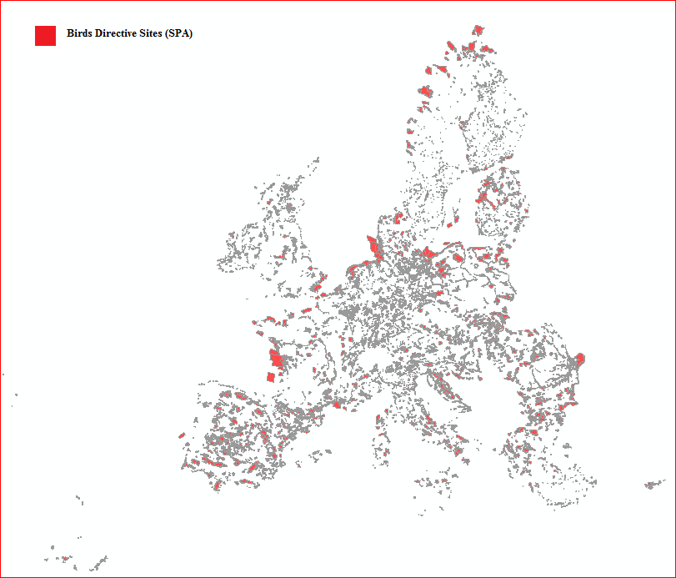
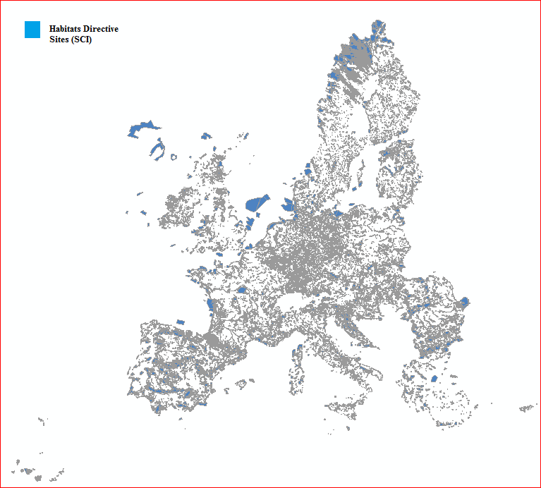

Figure 1: Extracting the two main Natura 2000 site type categories, SPAs and SCIs
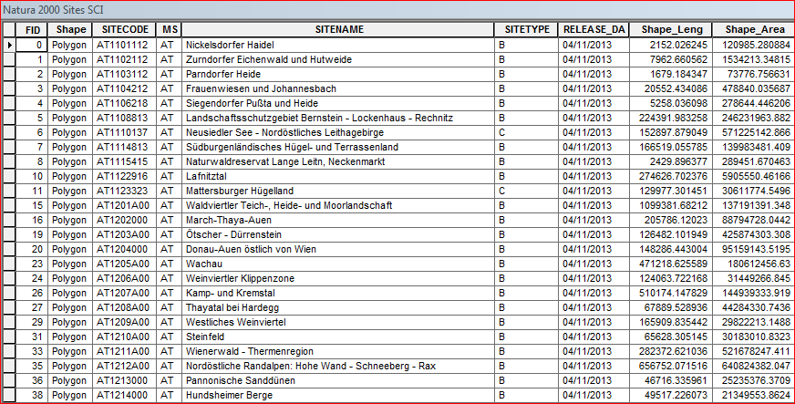

Figure 2: Table extraction with a filter on site type for the SCI sites

After the finalisation of step 1, three datasets are available for the further calculations: the complete Natura 2000 sites data set (“total Natura 2000 sites”), the Birds Directive Natura 2000 sites data set (“SPA sites”), and the Habitats Directive Natura 2000 sites data set (“SCI sites”).

Data used for the process:

The input dataset used for the filtering is the Natura 2000 data set; it can be downloaded from EEA Data and maps: http://www.eea.europa.eu/data-and-maps/data/natura-5 (this url points to the 2013 version).

Step 2: Making a distinction between terrestrial and marine Natura 2000 area

This step creates terrestrial and marine Natura 2000 data sets.

Step 2.1: Extraction of terrestrial areas for the total Natura 2000 sites, for SPA sites and for SCI sites: Intersection of geometric features

For the extraction of terrestrial sites, intersection is the GIS process used. The intersection computes the geometric area intersected between Natura 2000 dataset and the EEA coastline polygon. The areas which overlap/intersect from the input spatial data will be written to an output dataset.

Step 2.2: Extraction of marine areas for the total Natura 2000 sites, for SPA sites and for SCI sites: Erase of geometric features

For the extraction of marine sites, disjoint/erase is the GIS process used. The erase computes the geometric area that is falling outside EEA coastline polygon. The areas will be written to an output dataset.

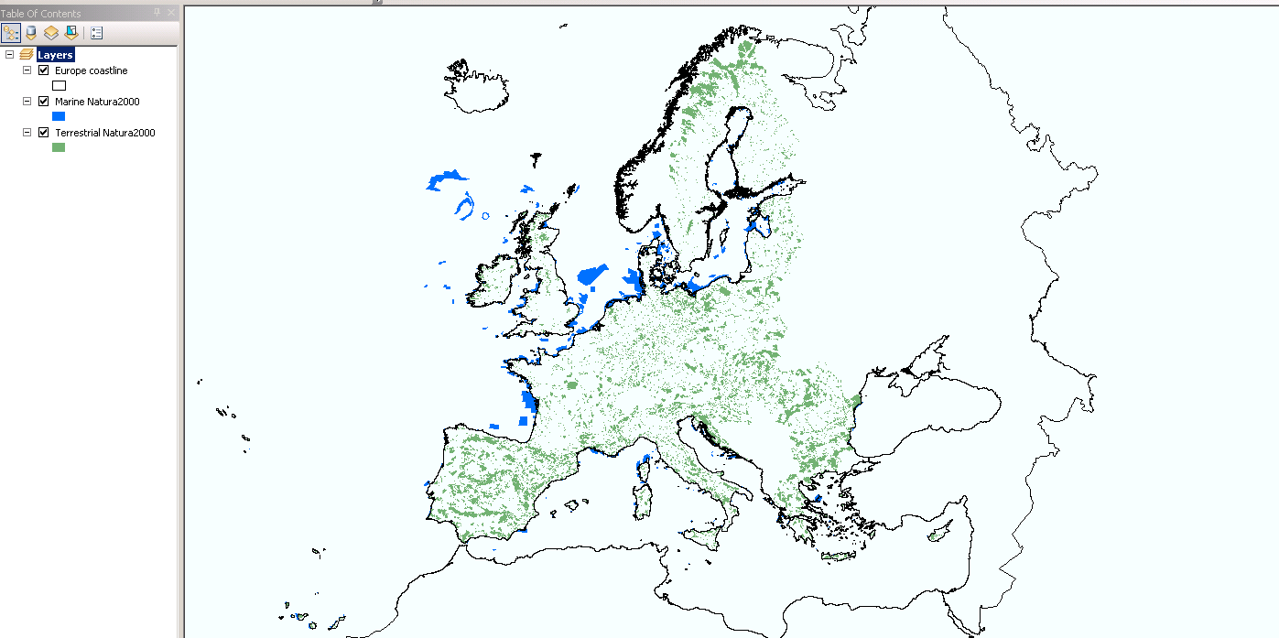

Figure 3: View of the coastline polygon data with the Natura 2000 sites dataset. The terrestrial sites are shown in green and the marine sites in blue.

Data used for these GIS calculations (get terrestrial and marine area):

The input datasets are:
- Total Natura 2000, SCI and SPA spatial data as output from step 1.
- EEA Coastline for analysis (2012), polygon layer. The EEA coastline for analysis is created for highly detailed analysis, e.g. 1:100,000, for geographical Europe. The criteria for defining the coastline are the line separating water from land. The EEA coastline is a product derived from two sources: EU-Hydro and GSHHG. The dataset is available at http://www.eea.europa.eu/data-and-maps/data/eea-coastline-for-analysis
Both datasets use the ETRS89 LAEA as the spatial reference system that guarantees that area calculations will be consistent for all European latitudes.

Step 3: Filter out sites with less than 5 % terrestrial or marine area

This step provides an estimate of the number of marine and terrestrial sites for the total Natura 2000, the number of marine and terrestrial SPA sites and the number of marine and terrestrial SCI sites.

The spatial features extracted into a terrestrial and marine data set in step 2 are joined against the original Natura 2000 sites by the unique sitecode field. A percentage calculation takes place between the terrestrial and marine area and their respective original site area. The calculation is:

Area percentage = (terrestrial or marine area/original site area) x 100

The 5 % rule is then applied as follows:
- Sites having a terrestrial component covering more than 5% of their total area are counted as terrestrial sites.
- Sites having a marine component covering more than 5% of their total area are counted as marine sites.
In practise, there is double counting of sites attributed to both terrestrial and marine categories, e.g. when a site is 50 % terrestrial and 50 % marine area (or 6 % terrestrial and 94 % marine area).

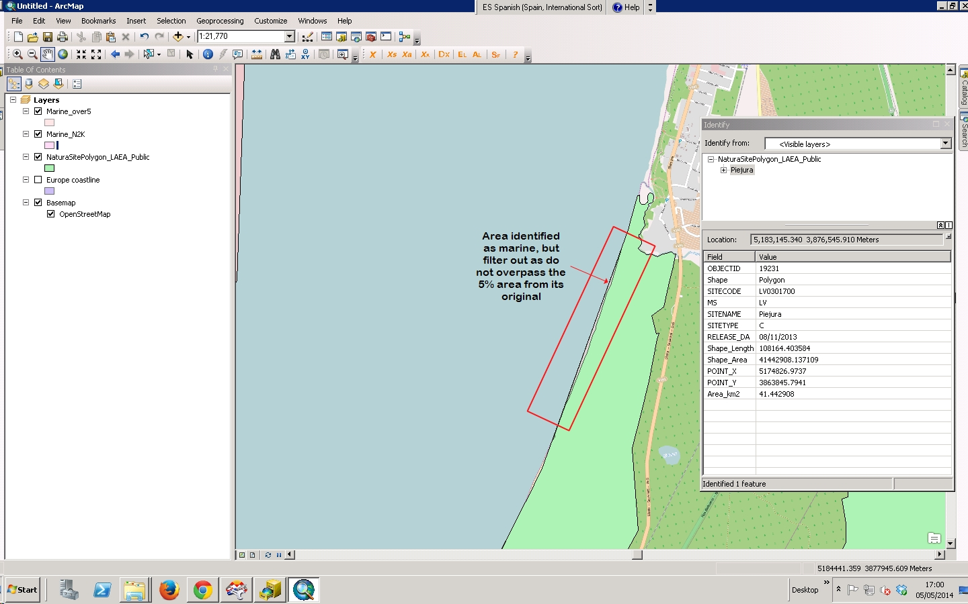

Figure 4: Illustration of a Natura 2000 site (light green) having a minor marine extent (inside the red box). The site is not taken into account as a marine site as its marine area is less than or equal to 5% of the total area of the site.

Data used for these calculations:

The input datasets are:
- Terrestrial and marine data sets for total Natura 2000 sites, SCI sites and SPA sites from step 2.

Step 4: Dissolve marine and terrestrial geometrical features by field “MS” for the terrestrial and marine area calculations at country level
Once the intersection in steps 2.1 and 2.2 has taken place a dissolve operation is used to summaries features based on a specified attribute. In this calculation, the terrestrial and marine data sets for total Natura 2000 and SCI and SPA sites are dissolved by country. Polygons with the same country code are aggregated (dissolved) into a single, either terrestrial or marine, feature. The dissolved features summarise the shape area and the number of site records. After applying this operation we know for each type of category (total terrestrial and marine Natura 2000 sites, terrestrial and marine SCI sites and terrestrial and marine SPA sites) the number of sites and the area by Member State.

Data used for these GIS calculations:

The input datasets are:
- Terrestrial and marine for total Natura 2000, SCI and SPA spatial data from the steps 2.1 and 2.2.

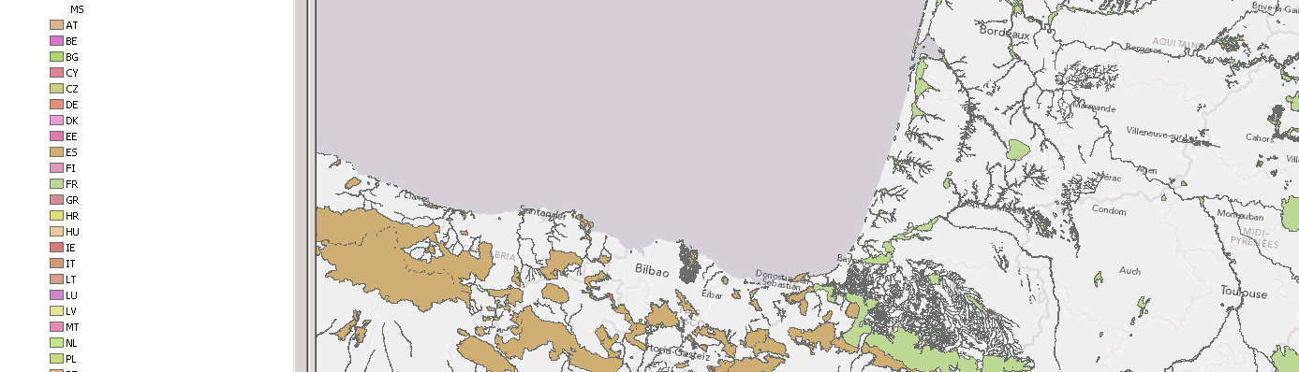

Figure 6: After the dissolve operation, it is obtained 28 multipolygons one per country, see Spain (brown) and France (green).

Step 5: Creating an overview table with the area (km2) and number of sites.

All the output is consolidated in three final summary tables showing the resulting area calculations by country:
- Total Natura 2000 sites including (Table 1):
  - Terrestrial:
    - Natura 2000 terrestrial area (km²) – obtained through step 2 and 4
    - Natura 2000 / National terrestrial area (%) – obtained through step 2 and 4
    - Number of Terrestrial Natura 2000 sites – obtained through step 3
  - Marine:
    - Natura 2000 Marine area (km²) – obtained through step 2 and 4

    - Natura 2000 Marine / Total Natura 2000 area – obtained through step 2 and 4
    - Number of Marine Natura 2000 sites – obtained through step 3
  - All:
    - Number of sites – obtained through step 3
    - Total Natura 2000 area km² – obtained through step 2 and 4
- Total SCI sites including (Table 2):
  - Terrestrial:
    - Natura 2000 SCI terrestrial area (km²) - obtained through step 2 and 4
    - Natura 2000 SCI area/ National terrestrial area (%)- obtained through step 2 and 4
    - Number of SCI sites – obtained through step 3
  - Marine:
    - Natura 2000 SCI Marine area (km²) - obtained through step 2 and 4
    - Natura 2000 Marine / Total SCI Natura 2000 area - obtained through step 2 and 4
    - Number of SCI sites – obtained through step 3
  - All:
    - Number of SCI sites – obtained through step 3
    - Total Natura 2000 SCI area (km²) obtained through step 2 and 4
- Total SPA sites including (Table 2):
  - Terrestrial:
    - Natura 2000 SPA terrestrial area (km²) - obtained through step 2 and 4
    - Natura 2000 SPA area/ National terrestrial area (%) - obtained through step 2 and 4
    - Number of SPA sites – obtained through step 3
  - Marine:
    - Natura 2000 SPA Marine area (km²) - obtained through step 2 and 4
    - Natura 2000 Marine / Total SPA Natura 2000 area - obtained through step 2 and 4
    - Number of SPA sites – obtained through step 3
  - All:
    - Number of SPA sites – obtained through step 3
    - Total Natura 2000 SPA area (km²) - obtained through step 2 and 4

All the figures above are given in km². The unit of the spatial datasets is given in m² as ETRS 89 LAEA is the spatial reference. A conversion from m² to km² is required for the final figures provided in the summary table.

3. SUMMARY OF SURFACE AREA CALCULATION PROCESS

The graph below summarises the overall process followed for the surface area calculation process for Natura 2000 (presented in three pages).

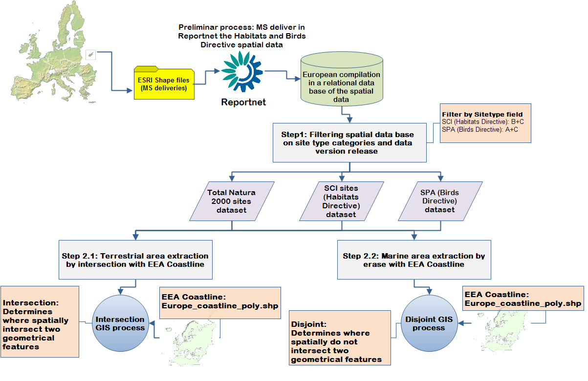
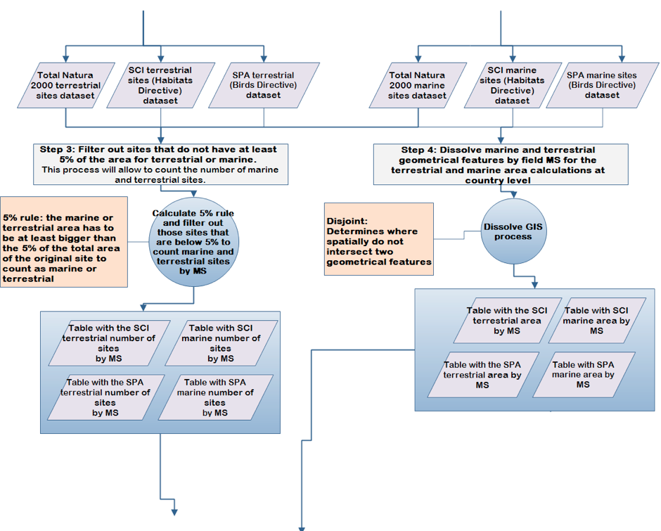
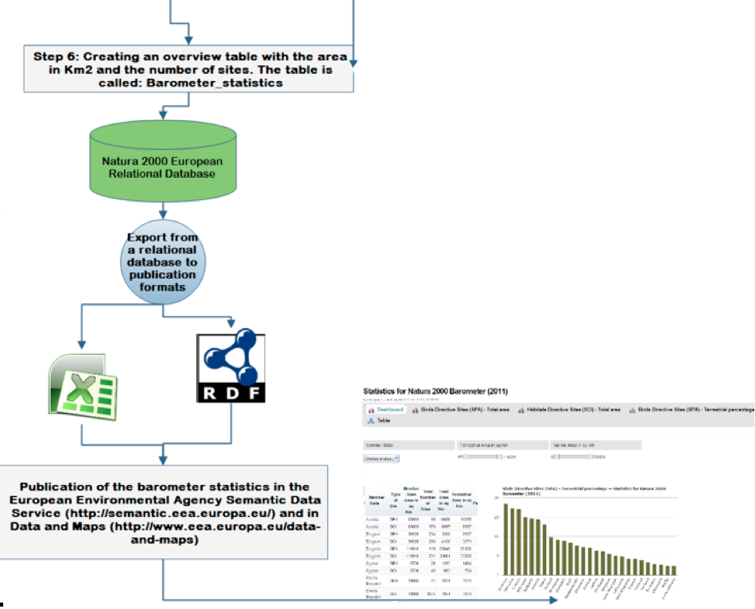

4. Final publication

The overview table created from the figures of a specific year are stored in the Natura 2000 master database. From this repository an RDF format is exported to be harvested by the Semantic Data Service (SDS) of the EEA. The figures are published as graphs and tables at EEA web site section Data & Maps (http://www.eea.europa.eu/data-and-maps/daviz/natura-2000-barometer).

SUMMARY

Depending on the calculation approach (descriptive versus spatial area), the outcome can be quite different. Therefore, special attention needs to be paid when comparing statistics resulting from different calculation methods. Data sources, versions and approaches should always be mentioned when publishing results.

