

Calculating the Natura 2000 network area in Europe:

The GIS approach

INTRODUCTION

A precise area calculation is needed to check to what extent member states have designated Natura 2000 sites of their territory. To check the ‘netto’ coverage of the Natura 2000 network by member state, one can only apply geographic information to properly delimit and calculate the Natura 2000 surface. The following paragraphs will explain how this surface area is assessed and which shortcomings should be taken into account when interpreting these results.

SURFACE AREA CALCULATION

The general methodology consists of 5 major steps. It starts with the retrieval of spatial data from the member states that together with the descriptive data collected by the European Topic Centre on Biological Diversity (ETC/BC) are consolidated in one single spatial database.

1) Extracting spatial data
First, the spatial data are extracted from the database according 3 main ‘Natura 2000’ categories: SPAs (Special Protection Areas - Birds Directive), SCIs (Sites of Community Importance – Habitats directive) and a third category i.e. C-types (Natura 2000 sites that are designated both as SCI and SPA). Next to it, also a spatial dataset containing the European coast line is extracted from the GISCO Country version 2006 dataset (Eurostat - Geographic Information System for the Commission).

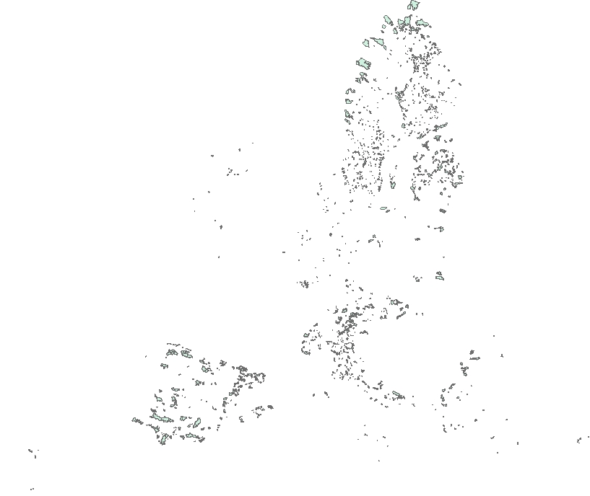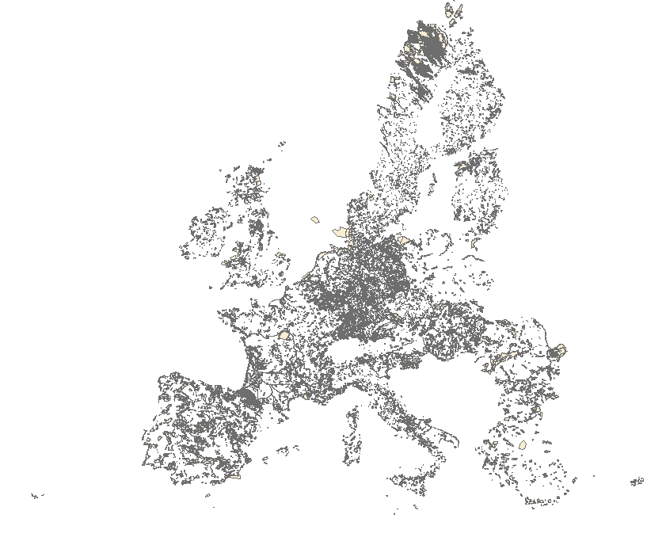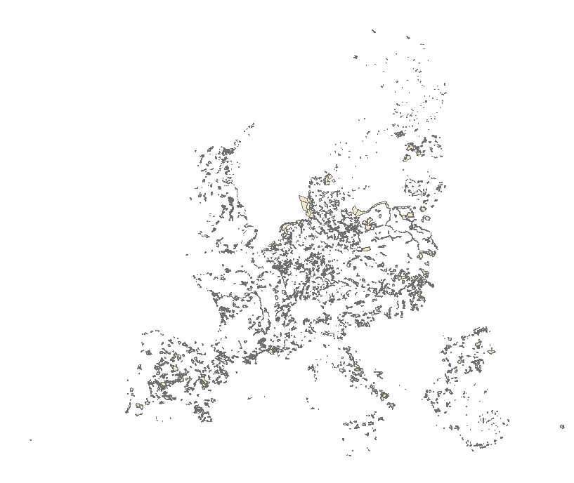
C-type
pSCI
SPA
Figure 1: Extracting 3 main categories

2) Making a distinction between terrestrial and marine Natura 2000 area
A GIS overlay operation with the GISCO country dataset is been executed to separate the terrestrial from the marine surface. This operation results in 6 datasets: a marine and terrestrial part for each of the three categories (SPAs, SCIs, C-types).

Figure 2: Distinguish between terrestrial and marine area

3) Dissolving the 6 categories
A dissolve operation is used to aggregate features based on a specified attribute. In this calculation, each main category is dissolved by country. Polygons with the same country code are aggregated (dissolved) into a single feature. As part of the dissolve process, the aggregated features include a summary of some attributes i.e. the shape area has been summed up and the number of sites has been counted. After applying this operation we know for each type of category (SCI, SPA and C-type) the number of sites and the total area by country, as well for the terrestrial as for the marine sites.

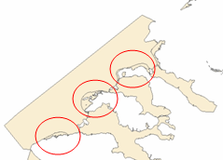  Before dissolve | 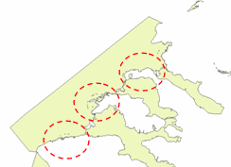  After dissolve
Figure 3: Dissolve operation

4) Deducting the overlapping area between SCI and SPA
In this step the total area is being corrected by deducting the overlap areas. After all, it occurs that SCI sites are partially or even completely overlapping with SPA sites, namely the sites with site code type F, G, H, I, J and K. To get these numbers, we intersect the SCI and SPA sites as well for terrestrial as for marine sites. The intersect operation calculates the geometric intersection of the SCI and SPA sites. The polygons that are common to both categories are exported to a new dataset containing the overlapping areas. Next, we summarize again by summing up the areas of the polygons for each country. Finally, the results are exported to a separate column in the overview table.
Figure 4: Defining and calculating overlap area

5) Creating an overview table
All the output is consolidated in a final summary table showing the resulting area calculations by country. There are 3 major columns: Terrestrial, Marine and a third one showing the overall result by country. The terrestrial column is split up in different sub-columns showing the outcome as well as absolute values (km²) as surface area percentages related to the national terrestrial area. Results for the marine area are only showed as absolute numbers. Both major columns provide also the resulting figures for the amount of overlap between SCI and SPA (in km² and in %). The number of sites and the total Natura 2000 area are showed in the last column.
NATURA 2000 (GIS CALCULATED VALUES)
Data of Dec. 2007 provided by MS
 | Terrestrial |  |  |  |  | Marine |  |  | All
 | National Terrestrial area (km²) | Natura 2000 terrestrial area (km²) | Natura 2000 / national terrestrial area (%) | Overlap between SPAs and SCIs (km²) | Overlap between SPAs and SCIs (in %) | Natura 2000 Marine area (km²) | Overlap between SPAs and SCIs (km²) | Overlap between SPAs and SCIs (%) | Number of sites | Total Natura 2000 area (km²)
AT | 83.859 | 11.529 | 13,7 | 1.977 | 17,1 | - | - | - | 214 | 11.529 | AT
BE | 30.528 | 3.862 | 12,6 | 1.570 | 40,7 | 429 | 89 | 20,7 | 457 | 4.291 | BE
BG | 110.910 | 31.960 | 28,8 | 7.402 | 23,2 | 121 | 8 | 6,4 | 286 | 32.081 | BG
CY | 5.736 | 1.003 | 17,5 | 245 | 24,4 | 51 | 0 | 0,0 | 38 | 1.054 | CY
CZ | 78.866 | 10.532 | 13,4 | 3.657 | 34,7 | - | - | - | 896 | 10.532 | CZ
DE | 357.031 | 48.422 | 13,6 | 12.933 | 26,7 | 23.380 | 13.525 | 57,9 | 5.094 | 71.802 | DE
DK | 43.093 | 3.868 | 9,0 | 2.079 | 53,8 | 12.850 | 6.608 | 51,4 | 344 | 16.718 | DK
EE | 45.226 | 7.985 | 17,7 | 2.475 | 31,0 | 6.622 | 2.410 | 36,4 | 524 | 14.607 | EE
ES | 504.782 | 134.150 | 26,6 | 30.036 | 22,4 | 7.892 | 206 | 2,6 | 1.723 | 142.042 | ES
FI | 338.145 | 48.912 | 14,5 | 453 | 0,9 | 6.839 | 757 | 11,1 | 1.858 | 55.751 | FI
FR | 549.192 | 68.109 | 12,4 | 20.673 | 30,4 | 6.995 | 2.348 | 33,6 | 1.705 | 75.104 | FR
GR | 131.940 | 25.067 | 19,0 | 6.321 | 25,2 | 6.356 | 720 | 11,3 | 358 | 31.423 | GR
HU | 93.030 | 19.682 | 21,2 | 6.190 | 31,4 | - | - | - | 512 | 19.682 | HU
IE | 70.280 | 4.496 | 6,4 | 346 | 7,7 | 3.158 | 257 | 8,1 | 480 | 7.654 | IE
IT | 301.333 | 57.374 | 19,0 | 13.590 | 23,7 | 4.463 | 228 | 5,1 | 2.561 | 61.837 | IT
LT | 65.301 | 9.106 | 13,9 | 1.471 | 16,2 | 897 | 4 | 0,5 | 339 | 10.004 | LT
LU | 2.597 | 462 | 17,8 | 76 | 16,5 | - | - | - | 60 | 462 | LU
LV | 64.589 | 7.135 | 11,0 | 0 | 0,0 | 561 | 0 | 0,0 | 336 | 7.696 | LV
MT | 316 | 38 | 12,1 | 6 | 15,3 | 11 | 0 | 2,0 | 33 | 49 | MT
NL | 41.526 | 5.776 | 13,9 | 2.112 | 36,6 | 5.445 | 4.136 | 76,0 | 211 | 11.220 | NL
PL | 312.685 | 51.700 | 16,5 | 13.289 | 25,7 | 7.254 | 3.494 | 48,2 | 479 | 58.954 | PL
PT | 91.990 | 18.740 | 20,4 | 3.295 | 17,6 | 1.416 | 375 | 26,5 | 135 | 20.155 | PT
RO | 238.391 | 31.472 | 13,2 | 0 | 0,0 | 1.351 | 0 | 0,0 | 273 | 32.823 | RO
SE | 414.864 | 56.354 | 13,6 | 443 | 0,8 | 3.140 | 489 | 15,6 | 4.061 | 59.494 | SE
SI | 20.273 | 7.203 | 35,5 | 3.813 | 52,9 | 2 | 0 | 4,1 | 286 | 7.205 | SI
SK | 48.845 | 14.116 | 28,9 | 3.861 | 27,4 | 3.116 | 0 | 0,0 | 420 | 17.232 | SK
UK | 244.820 | 17.011 | 6,9 | 7.066 | 41,5 | 13.321 | 2.461 | 18,5 | 841 | 30.332 | UK
EU27 | 4.290.148 | 696.064 | 16,2 | 145.379 | 20,9 | 115.669 | 38.115 | 33,0 | 24.524 | 811.733 | EU27
Table 1: Summary table for the GIS area calculation

COMMENTS & SHORTCOMINGS

When interpreting the procedure and the results of this summary table, the reader should be aware of the details of this approach and possible resulting shortcomings. This paragraph will give additional detailed information about the calculation procedure to explain the differences compared to the area information that is stored in the descriptive database.

1) Different data processing
The data layers that are currently available in the GIS for Natura 2000 are stored in two different ways: a descriptive and a spatial database, however a considerable difference can be observed between both of them. Because the descriptive and spatial data are been collected and processed by 2 different administrations, the updates for both databases do not occur at the same time. In reality, the spatial database shall always contain fewer sites than there are available in the descriptive database.

2) Sites near the coast
Some 100% defined terrestrial sites are located near the coastline. When a site has not been digitized accurately, a very small area (‘sliver’) of this site could be located in marine area. Therefore, this small area is counted as marine surface and will decrease the amount of terrestrial area.

3) Dissolving sites
Although it is not allowed by the Natura 2000 guidelines, it can occur that there is an overlap between 2 SCI or SPA sites within a spatial dataset. It is very important to understand that the dissolve operation shall eliminate this overlap area. Therefore, the resulting overall Natura 2000 area will again be lower than assessed when adding the area values of the descriptive database.

4) Overlap between different countries
In this calculation we only consider the overlaps between SCI and SPA within one single country. It also occurs that a SCI site of country x overlaps with a SPA site of country y. The total overlapping area in this case was checked, but the result is only a very small percentage of the total overlapping area and therefore could be neglected.

SUMMARY

Depending on the calculation approach (descriptive versus spatial area), the outcome can be quite different. Therefore, special attention needs to be paid when comparing statistics resulting from different calculation methods. Data sources, versions and approaches should always be mentioned when publishing results.

