CDDA version 14 (2016)

Prepared by / compiled by: Manuel Löhnertz
Organisation: ETC/BD – space4environment
EEA project manager: Mette.Lund@eea.europa.eu
Task Manager: Sabine Roscher/roscher@mnhn.fr
Work Package n°:1.7.2.A

Contents
1 Background & Introduction 3
1.1 CDDA 3
1.2 Definition of terms 3
2 Delivery of datasets 5
2.1 The CDDA v14 delivery 5
3 European CDDA dataset production 9
4 Verification 10
4.1 Verification overview 10
4.2 Verification steps tabular data 11
4.3 Verification steps spatial data 11
4.4 European CDDA layer production and verification 12
5 QA 13
5.1 Semantic check 13
5.2 Comparison of the new CDDA with the previous version 15
5.3 Major ecosystem information 17
5.4 IUCN management category information 18
5.5 Designation boundaries 19
6 Concluding remarks 21

Background & Introduction

The present document describes the activities and procedures for verification of the CDDA version 14 (2016).

CDDA
The Nationally designated areas inventory (CDDA) is an Eionet core data flow and holds information about protected areas and the national legislative instruments, which directly or indirectly create protected areas. The dataset contains data on individual nationally designated sites and designations in EEA member and collaborating countries.

Definition of terms
Before going into further detail on the QA/QC process of the CDDA database, please consider the following definitions of important terms and key activities of the process. These reflect the terminology used within the present report.

Table 1-1 Definition of terms
Validation / Quality control (QC) | Validation is the process by which the accuracy and consistency of products are evaluated and the associated uncertainties are quantified (Justice et al., 2000).  Product accuracy is assessed by a comparison with independent data sources such as ground-based measurements, more detailed data or well-calibrated models.  Inter-comparison with other equivalent products is also part of the validation process allowing building up a community reference product when no or not enough independent data are available.  Quality control, or QC for short, is normally carried out after the end of the production and aims at providing the user with measurable / quantitative information how well the product meets the pre-defined specifications.
Verification / Quality assurance (QA) | The act of reviewing, inspecting, testing, checking, auditing, or otherwise establishing and documenting whether items, processes, services, or documents conform to specified requirements.  Verification is a qualitative process in which intermediate or final results of the production process are commented and potential deviations from the specifications are highlighted. The verification will be performed during the course of production and is meant to increase data and production quality.  Quality Assurance (QA) is a way of preventing mistakes or defects in products and avoiding problems when delivering solutions or services to customers.  QA is applied to physical products in pre-production to verify what will be made meets specifications and requirements, and during manufacturing production by validating whether lot samples meet specified quality controls.  QA is also applied to software to verify that features and functionality meet business objectives, and that code is relatively bug free prior to shipping or releasing new software products and versions.

The QA/QC process described in the current report is a verification process, as the output does not provide quantitative results about the database quality and is used an element of a process to correct and improve the latest integrated European database version.

Delivery of datasets
The following tabular and spatial European datasets have been uploaded to: https://svn.eionet.europa.eu/repositories/Workdata/CDDA/cdda_ver14/

The CDDA v14 delivery
The latest version of the CDDA, version 14 from 2016, covers the entire geographical area of the 33 EEA member countries and its six cooperating countries. It includes the full geographical area under the responsibility of European countries as well as other States and Territories related to key initiatives in the European region.

The resulting data covers the 39 countries as well as Greenland (Denmark) and the French Overseas Departments and Territories and Overseas Collectives (Map 2-1, French DOMs not shown).

Map 2-1 Extent of the CDDA dataset (DOM/TOMs are not shown here)
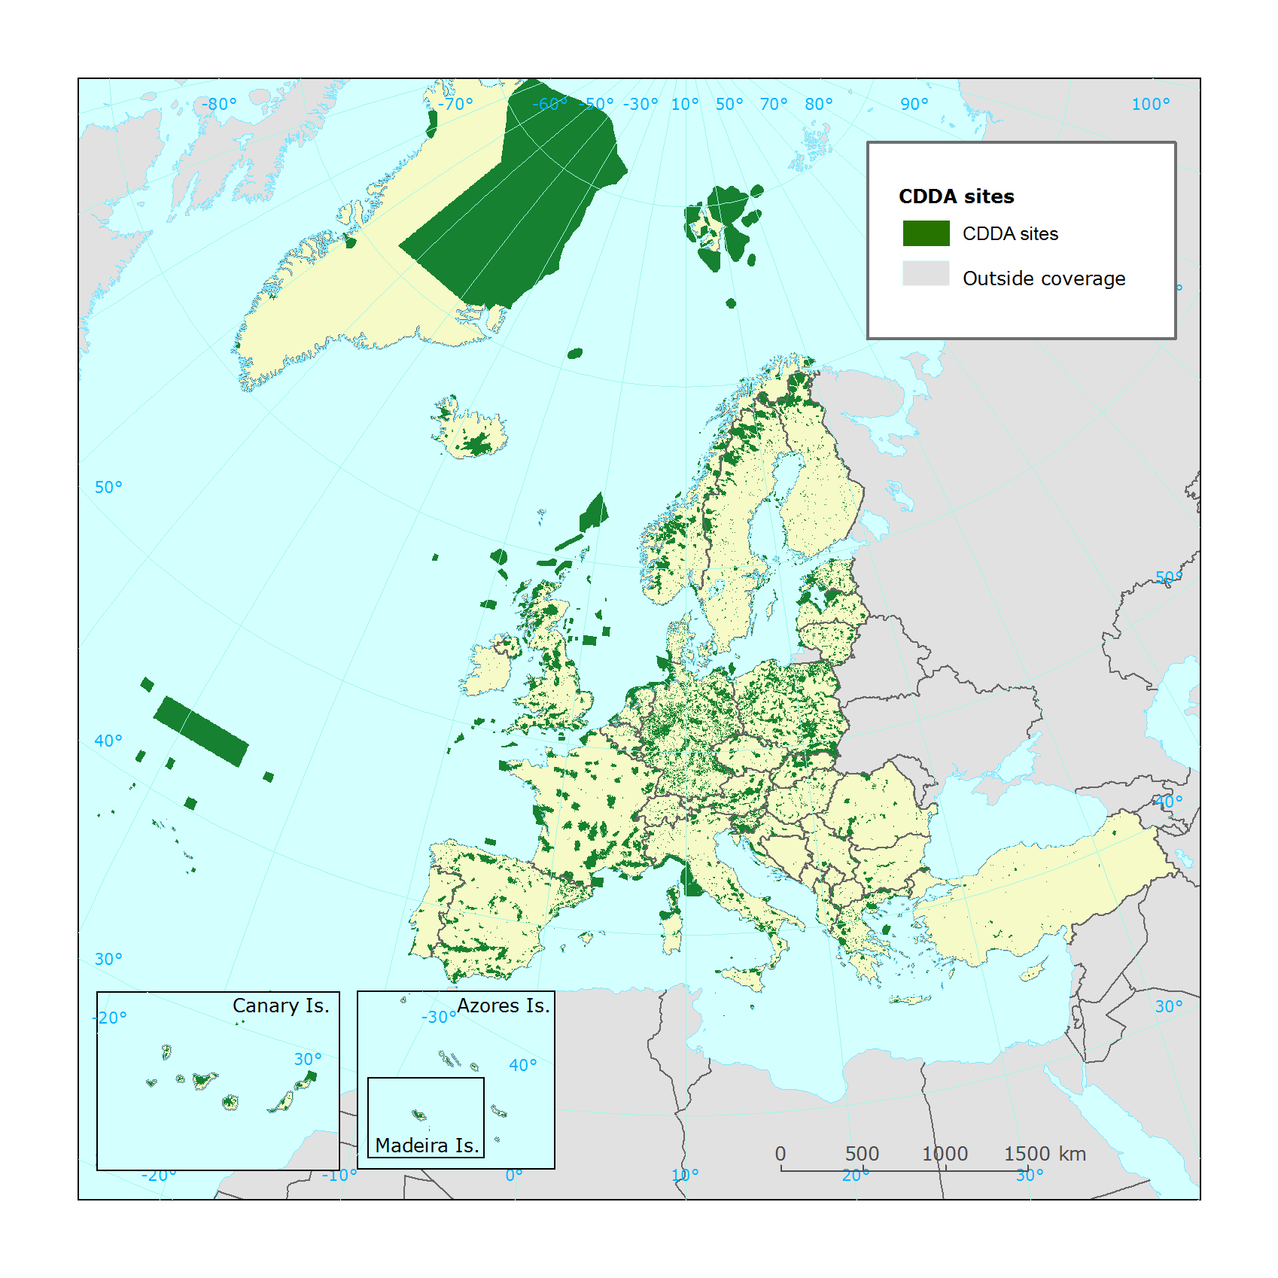

35 countries delivered new tabular and spatial data in 2016, which had to be included into version 14 of CDDA. The four countries BA, CY, LI and LT did not deliver any data.
All datasets were subjected to a series of quality assurance (QA) checks. Once the data passed these tests it was combined with data from those countries which did not submit data in 2016. For these particular countries data was extracted from the previous CDDA dataset, version 13.
The combined and integrated dataset (i.e. 2016 CDDA, version 14) covers 39 countries, and consists of a total of 101 736 records in the tabular database and 99 004 spatial records.

Table 2-2-1 Number of tabular and spatial records in the different CDDA versions
CDDA version | tabular | Spatial
Version 2016 v_14 | 101 736 | 99 004
Version 2015 v_13 | 100 181 | 97 752
Version 2014 v_12 | 98 367 | 95 109

The following map presents the countries, which provided data for the CDDA version 14.

Map 2-1 Countries that delivered data in 2016
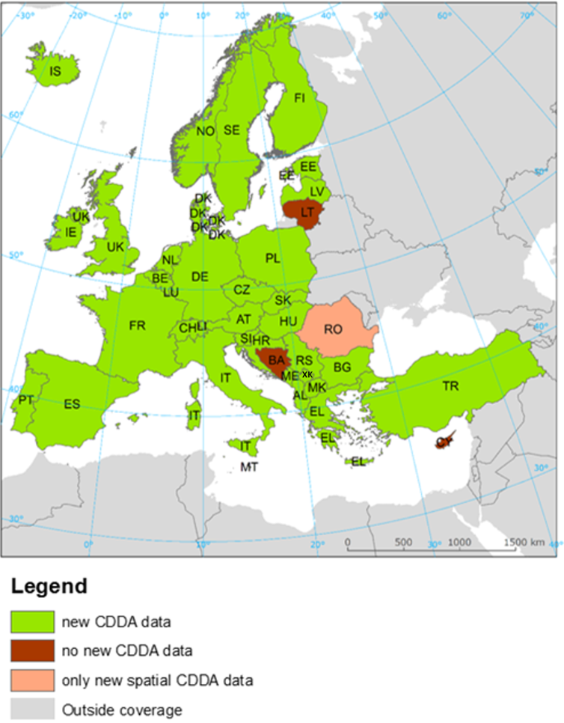
A more detailed overview is given in the following table. The cells marked with yellow show countries which did not deliver data for various reasons (e.g. no new national CDDA). Cells coloured in light blue represent country deliveries which did not contain new data for the corresponding reporting. In these cases where no changes in the datasets where reported or proposed by the country the datasets from the previous reporting (all version 12, 2014) have been used.

Table 2-2 Data deliveries and data updates for CDDA version 13 & 14, respectively (tabular & spatial)
Name | ISO - 2 digit | ISO - 3 digit | Version 13 | Version 14
 |  |  | 2015 | 2016
Albania | AL | ALB | no new data | yes
Austria | AT | AUT | yes | yes
Bosnia - Herzegovina | BA | BIH | no | no
Belgium | BE | BEL | yes | yes
Bulgaria | BG | BGR | yes | yes
Switzerland | CH | CHE | yes | yes
Czech Republic | CZ | CZE | yes | yes
Cyprus | CY | CYP | no new data | no
Germany | DE | DEU | yes | yes
Denmark | DK | DNK | no | yes
Estonia | EE | EST | yes | yes
Spain | ES | ESP | yes | yes
Finland | FI | FIN | yes | yes
France | FR | FRA | yes | yes
Greece | GR | GRC | yes | yes
Croatia | HR | HRV | yes | yes
Hungary | HU | HUN | no new data | yes
Ireland | IE | IRL | yes | yes
Iceland | IS | ISL | yes | yes
Italy | IT | ITA | yes | yes
Liechtenstein | LI | LIE | no new data | no
Lithuania | LT | LTU | no | no
Luxembourg | LU | LUX | yes | yes
Latvia | LV | LVA | yes | yes
FYROM | MK | MKD | yes | yes
Malta | MT | MLT | yes | yes
Montenegro | ME | MNE | yes | yes
Netherlands | NL | NLD | yes | yes
Norway | NO | NOR | yes | yes
Poland | PL | POL | yes | yes
Portugal | PT | PRT | yes | yes
Romania | RO | ROU | yes | yes
Serbia | RS | SRB | yes | yes
Sweden | SE | SWE | yes | yes
Slovakia | SK | SVK | yes | yes
Slovenia | SI | SVN | yes | yes
Turkey | TR | TUR | yes | yes
United Kingdom | UK | GBR | yes | yes
Kosovo (UNSCR 1244/99) | XK | XKX | yes | yes

The national CDDA data was delivered as tabular and spatial dataset.

Tabular data:
EEA provides the different national institutes with an MS-Access CDDA template database and technical specifications via the Central data repository (CDR: http://cdr.eionet.europa.eu).

Figure 2-1 CDDA MS-Access data model & technical specification document
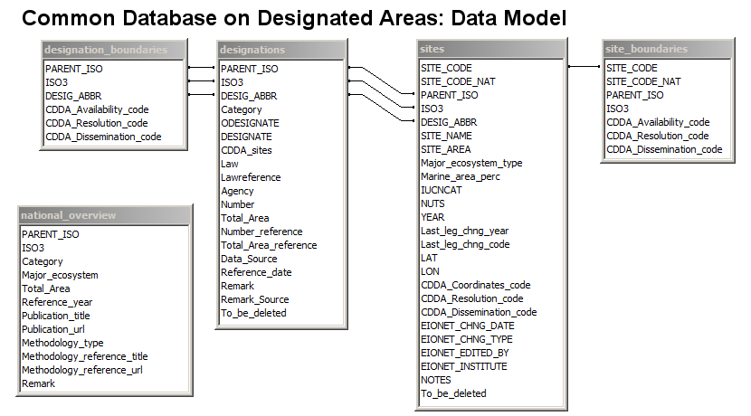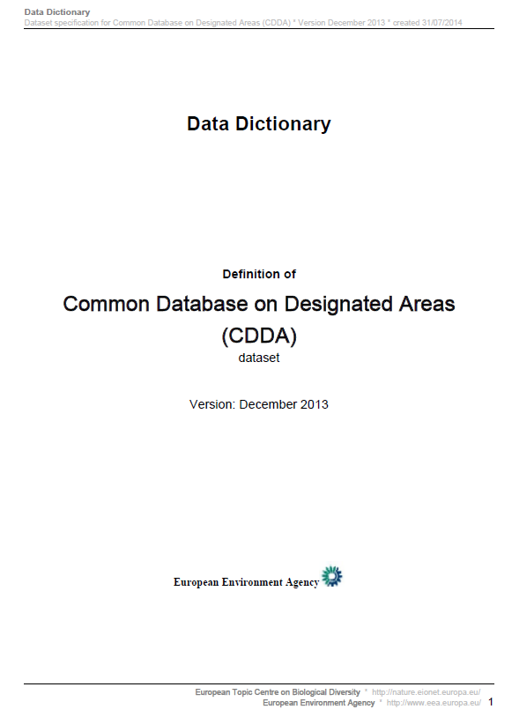

Using the template and the specification the countries update the table with the national CDDA information. After the national update, the database is uploaded again to the CDR.

Spatial boundary data:
Next to the tabular data the countries are asked to update their spatial CDDA data and to upload the data to the CDR.

European CDDA dataset production
The final CDDA v14 dataset is the union of all single national tabular databases & spatial datasets.

TABULAR:
After passing quality checks without errors, the single country tables were imported to a new MS-Access database.

SPATIAL:
Once the data deliveries passed the quality check without errors, the individual national vector data files were merged to one national spatial dataset. In a next step, all merged spatial datasets were used for the construction of the final European CDDA dataset.

Figure 3-1 Workflow spatial map production
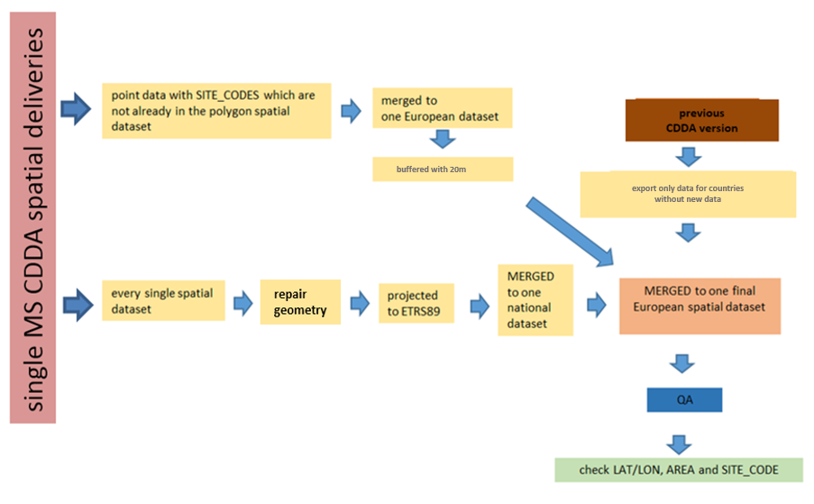

Verification
The spatial and tabular data were checked by ETC/BD at different points during the CDDA v14 production workflow. First, the single country deliveries were checked for completeness. Subsequently, different QA tests of the single deliveries were performed by EEA and ETC/BD.
Once the spatial and tabular checks were complete the single datasets were merged to one European spatial and one tabular dataset. This final CDDA dataset was checked by EEA before publication.

Verification overview
Tabular and spatial data were checked using different QA methods:

Tabular:
The countries uploaded the national CDDA v14 MS-Access versions on the CDR. An automatic QA, which is integrated in the database, performed semantic checks of the different tables. Errors were analysed and corrected. If necessary, e.g. where information was missing, the countries were requested to update the data.
After a successful quality check of the deliveries, the single tables were imported to the CDDA-v14 database template (provided by the EEA). Afterwards final QA checks were conducted using the integrated QA tool.

Figure 4-1 Tabular data verification overview, version 13
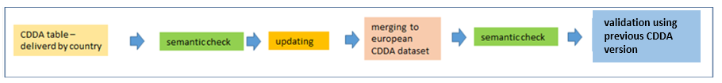

Spatial:
The countries delivered various kinds and quantities of spatial data. Some countries delivered one polygon vector file, others more than 2 different polygon and point vector files.

Figure 4-2 Example: spatial delivery by one country
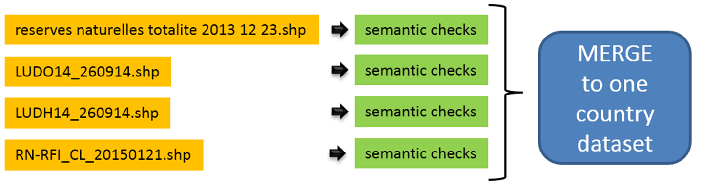

Therefore the first step of the verification was to check each spatial dataset prior to merging to one national dataset.
After the data passed the semantic check (projection, format, …) without errors, all data was merged into one European CDDA dataset in a file-geodatabase. If a country did not deliver new data, the most recent data available to the EEA was imported.
If spatial data was delivered as point dataset the points were buffered using a 20m buffer and merged with the polygon layer. With this operation the final spatial dataset only consisted of polygon vector layers.

Figure 4-3 Spatial data verification overview for version 14
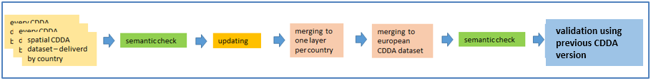

Verification steps tabular data
The verification of the tabular data was done following the specifications provided in the CDDA call (https://www.eionet.europa.eu/news/cdda2016).

The automatic QA checks following data quality indicators:
- check that all the relevant fields are filled out correctly (compare field type, name & content with the specifications)
- check for duplicates in SITE_CODE
- check that the dissemination codes in the ‘sites’ and ‘site_boundaries’ tables are the same
- if countries have officially asked for the calculation of coordinates this should be conducted by the ETC/BD.
- check that all coordinates are located in the country
- check coordinates of marine sites are located in marine regions
- check coordinates of terrestrial sites are located in terrestrial regions
Most of the checks listed above are executed by running an automatic FME (Feature Manipulation Engine – Software, using EEA common workspace) script on each of the separate national deliveries. The script loads the relevant database entries from the tabular database as well as the attributes and geometries from the spatial component to perform the checks. Within different sub-steps, information such as the number of sites, potential double-assigned site codes or the comparison between the number of tabular and spatial sites is derived and checked. The QA results for each separate country are recorded in a separate database, which contains information on all encountered inconsistencies identified during the checks.

Verification steps spatial data
In the following chapter the verification of the spatial data will be explained.
Most countries that submitted spatial data in the 2016 delivered shape files. Only a few exemptions used another form of delivery such as sqlite-databases or a WFS (which is so far not compliant with the CDDA specifications).
The spatial validation consisted of the following stages:
- Projection validation
- Geometry validation
  - Geometry must be valid - if not repair geometry.
  - Singlepart polygons with same SITE_CODE are not allowed – if this is the case: dissolve features by SITE_CODE
- Geographical and Attribute validation
  - Data must lie within the country extent (terrestrial + marine).
  - Attribute validation, check that each feature has a SITE_CODE, if not link by another field, if not possible check site name and try to link using site name, grid coordinates, area
  - Calculate coordinates for each polygon and compare them to the coordinates as supplied by country. (The coordinates of the centroid of each CDDA site in LAT/LON;WGS84)
  - Comparison of the Area, area calculated using GIS and compared to that supplied by the Country.
Also for the QA of the spatial CDDA data FME scripts were used which were stored on the common workspace.

European CDDA layer production and verification
Once the spatial and tabular checks were complete, the single datasets were merged to one European spatial and one tabular dataset.
If sites are represented in form of a spatial point layer, the single points were buffered by 20m to form polygons and added to the polygon data sets. Subsequently, all single files were merged to one spatial CDDA dataset in File-Geodatabase format by ETC/BD and uploaded to the EEA SVN server. Finally, the uploaded CDDA dataset was checked by EEA before publication.

Figure 4-4 Workflow: merging single spatial datasets (point & polygons)
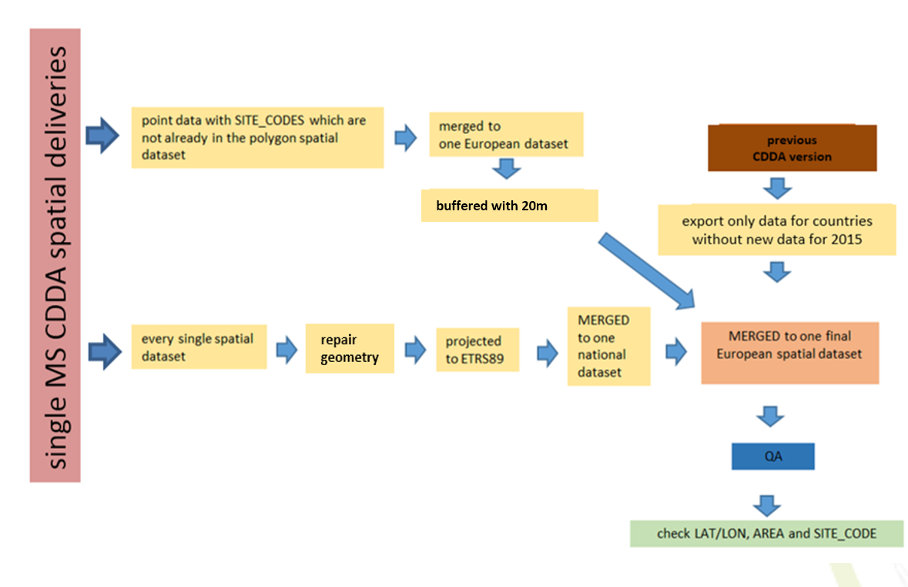

QA
In this chapter a selection of information and results about the new CDDA dataset will be presented.

Semantic check
In the following table a selection of comments on the single CDDA deliveries are presented.

Table 5-1 Selection of semantic check results and information
Country | ISO3 | Comment
Albania | ALB | - no national site codes defined  - for some marine-terrestrial sites the marine percentage is missing
Austria | AUT | - double use of a site code
Bosnia - Herzegovina | BIH | - no data was uploaded
Belgium | BEL | - no comments
Bulgaria | BGR | - no comments
Switzerland | CHE | - national site codes used instead of European site code  - reintroduction of site already deleted before
Cyprus | CYP | - no data was uploaded
Czech Republic | CZE | - no comments
Germany | DEU | - 933 sites shows a site area differing for more than 1ha from the previous CDDA version
Denmark | DNK | - spatial site without corresponding tabular information  - table is not named correctly  - missing SITE_CODE_NAT  - some double SITE CODES found  - Marine area percentage not filled for marine-terrestrial sites
Estonia | EST | - 2 shapefiles were merged with buffered point layer
Spain | ESP | - no comments
Finland | FIN | - no comments
France | FRA | - the designation categories “B” and “C” are not included in the “national overview table”
Greece | GRC | - the marine percentage values are not correct some values are larger 100%
Croatia | HRV | - no comments
Hungary | HUN | - small geometric shift between the spatial datasets CDDA_v14 and CDDA_v13
Ireland | IRL | - no comments
Iceland | ISL | - no comments
Italy | ITA | - designation boundaries are delivered in EPSG-projection 4258  - site area defined as 0 although spatial boundaries have been reported stating an area >0 ha
Liechtenstein | LIE | - no data was uploaded
Lithuania | LTU | - no data was uploaded
Luxembourg | LUX | - no comments
Latvia | LVA | - no comments
FYROM | MKD | - some LAT/LON values are missing
Malta | MLT | - in the “site boundary –table “ for one site the boundary information is missing
Montenegro | MNE | - one site was delivered only spatially – no corresponding tabular information found
Netherlands | NLD | - more than on spatial dataset was delivered for the protected sites  - wrong projection
Norway | NOR | - Multipart polygons representing same site have been reported separately multiple use of same site code
Poland | POL | - no comments
Portugal | PRT | - no comments
Romania | ROU | - spatial data was downloaded from Romania map service (WFS) as GML file  - the spatial dataset do not correspond to the CDDA specifications  - no tabular data was uploaded to CDR no automatic quality assurance checks have been performed on the envelope  - as no new tabular data has been uploaded inconsistencies identified in previous version still persist
Serbia | SRB | - one site was only delivered spatially – no corresponding tabular information found  - some shifts between previous and current spatial version identified
Sweden | SWE | - no comments
Slovakia | SVK | - in the “designations table the designation ”SK13” marked “no CDDA sites” but used for one site
Slovenia | SVN | - no comments
Turkey | TUR | - spatial data has been delivered in four separate datasets  - site code information are missing for multiple sites  - major ecosystem information are missing for all sites  - double use of site code
United Kingdom | GBR | - some shifts between previous and current spatial version identified  - major ecosystem information for some sites are missing  - relevant information in the “national overview table” are missing  - coordinates for multiple sites missing
Kosovo (UNSCR 1244/99) | XKK | - wrong xml file format were uploaded to CDR  - in the “designations table the designation ”XK07” marked “no CDDA sites” but used for one site  - multiple use of single site code

Comparison of the new CDDA with the previous version
Another output of the semantic checks is the comparison of the site count as well as the site area between the new spatial CDDA version and the previous version 13 from 2015.

Table 5-2 CDDA site count comparison: CDDA_v13 vs CDDA_v14 (spatial datasets)
Country | count  2015 | count  2016 | Difference | Difference | INFO
 |  |  | 2016-2015 | 2016-2015 [%points]
Albania | 54 | 54 | 0 | 0,0 | no changes
Austria | 1199 | 1199 | 0 | 0,0 | no changes
Bosnia - Herzegovina | 33 | 33 | 0 | 0,0 | no new data
Belgium | 1396 | 1421 | 25 | 1,8 | increase
Bulgaria | 1015 | 1014 | -1 | -0,1 | decrease
Switzerland | 5884 | 5890 | 6 | 0,1 | increase
Czech Republic | 2552 | 2594 | 42 | 1,6 | increase
Cyprus | 16 | 16 | 0 | 0,0 | no new data
Germany | 17289 | 17423 | 134 | 0,8 | increase
Denmark | 1923 | 1929 | 6 | 0,3 | increase
Estonia | 11618 | 11693 | 75 | 0,6 | increase
Spain | 1580 | 1783 | 203 | 12,8 | increase
Finland | 11719 | 12102 | 383 | 3,3 | increase
France | 2973 | 2994 | 21 | 0,7 | increase
Greece | 799 | 803 | 4 | 0,5 | increase
Croatia | 416 | 408 | -8 | -1,9 | decrease
Hungary | 218 | 307 | 89 | 40,8 | increase
Ireland | 309 | 309 | 0 | 0,0 | no changes
Iceland | 114 | 114 | 0 | 0,0 | no changes
Italy | 871 | 871 | 0 | 0,0 | no changes
Liechtenstein | 41 | 41 | 0 | 0,0 | no new data
Lithuania | 360 | 360 | 0 | 0,0 | no new data
Luxembourg | 104 | 113 | 9 | 8,7 | increase
Latvia | 707 | 707 | 0 | 0,0 | no changes
Macedonia, Replublic of | 75 | 75 | 0 | 0,0 | no changes
Malta | 203 | 204 | 1 | 0,5 | increase
Montenegro | 4 | 4 | 0 | 0,0 | no changes
Netherlands | 250 | 251 | 1 | 0,4 | increase
Norway | 2896 | 2941 | 45 | 1,6 | increase
Poland | 2017 | 2027 | 10 | 0,5 | increase
Portugal | 220 | 221 | 1 | 0,5 | increase
Romania | 866 | 943 | 77 | 8,9 | increase
Serbia | 185 | 312 | 127 | 68,6 | increase
Sweden | 14111 | 14456 | 345 | 2,4 | increase
Slovakia | 1172 | 1174 | 2 | 0,2 | increase
Slovenia | 2046 | 2046 | 0 | 0,0 | no changes
Turkey | 1225 | 839 | -386 | -31,5 | decrease
United Kingdom | 9274 | 9298 | 24 | 0,3 | increase
Kosovo (UNSCR 1244/99) | 29 | 35 | 6 | 20,7 | increase

The tabular database contains more CDDA sites than the spatial dataset. Therefore the area statistic based on the tabular dataset varies from the area statistic based on the spatial data (not shown):

Table 5-3 CDDA area comparison: CDDA_v13 vs CDDA_v14 (tabular datasets)
Country | PARENT_ISO | AREA [km²] 2015 | AREA [km²] 2016 | Difference 2016-2015 | Difference 2016-2015 [%pts] | INFO
Albania | ALB | 4648 | 4648 | 0 | 0,00 | no changes
Austria | AUT | 26312 | 26312 | 0 | 0,00 | no changes
Belgium | BEL | 8340 | 8394 | 54 | 0,65 | increase
BosniaHerzegovina | BIH | 391 | 391 | 0 | 0,00 | no new data
Bulgaria | BGR | 15158 | 15169 | 11 | 0,07 | increase
Croatia | HRV | 8078 | 8064 | -13 | -0,17 | decrease
Cyprus | CYP | 3789 | 3789 | 0 | 0,00 | no changes
Czech Republic | CZE | 13178 | 13690 | 512 | 3,88 | increase
Denmark | DNK | 995884 | 996448 | 564 | 0,06 | increase
Estonia | EST | 23716 | 23811 | 95 | 0,40 | increase
Finland | FIN | 35322 | 35529 | 207 | 0,59 | increase
France | FRA | 299801 | 304694 | 4893 | 1,63 | increase
Germany | DEU | 133801 | 144209
Greece | GRC | 38130 | 38103 | -28 | -0,07 | decrease
Hungary | HUN | 11319 | 14194 | 2875 | 25,40 | increase
Iceland | ISL | 20089 | 20089 | 0 | 0,00 | no changes
Ireland | IRL | 2006 | 2006 | 0 | 0,00 | no changes
Italy | ITA | 60227 | 60227 | 0 | 0,00 | no changes
Kosovo | XKX | 1241 | 1300 | 59 | 4,78 | increase
Latvia | LVA | 16856 | 16851 | -5 | -0,03 | decrease
Liechtenstein | LIE | 82 | 82 | 0 | 0,00 | no new data
Lithuania | LTU | 10933 | 10933 | 0 | 0,00 | no new data
Luxembourg | LUX | 1279 | 1520 | 241 | 18,87 | increase
Macedonia, | MKD | 2297 | 2297 | 0 | 0,00 | no changes
Malta | MLT | 340 | 343 | 2 | 0,73 | increase
Montenegro | MNE | 1314 | 1314 | 0 | 0,03 | increase
Netherlands | NLD | 12800 | 12862 | 62 | 0,49 | increase
Norway | NOR | 182332 | 182582 | 250 | 0,14 | increase
Poland | POL | 103886 | 103837 | -49 | -0,05 | decrease
Portugal | PRT | 121884 | 121990 | 106 | 0,09 | increase
Romania | ROU | 20354 | 20328 | -26 | -0,13 | decrease
Serbia | SRB | 5727 | 5520 | -208 | -3,62 | decrease
Slovakia | SVK | 12224 | 12225 | 1 | 0,01 | increase
Slovenia | SVN | 28109 | 28104 | -6 | -0,02 | decrease
Spain | ESP | 79682 | 102179 | 22497 | 28,23 | increase
Sweden | SWE | 57964 | 58271 | 308 | 0,53 | increase
Switzerland | CHE | 3479 | 3485 | 6 | 0,17 | increase
Turkey | TUR | 111538 | 111546 | 8 | 0,01 | increase
United Kingdom | GBR | 162741 | 173640 | 10900 | 6,70 | increase

The total tabular CDDA area increased from 2 637 251 km² to 2 824 777 km² between versions 13 and 14. That´s an increase of 187 526 km².

Major ecosystem information
One important CDDA information is the “Major ecosystem type” - http://dd.eionet.europa.eu/dataelements/69878. For every CDDA site the major ecosystem type: marine, marine-terrestrial or terrestrial should be specified.

The following table shows the overview of delivered major ecosystem type information by country.

Table 5-2 Major ecosystem type information by country [count of sites]
Country | PARENT_ISO | no type info | Marine | Marine/terrestrial | Terrestrial
Albania | ALB | 798 | 0 | 0 | 0
Austria | AUT | 0 | 0 | 0 | 1217
Belgium | BEL | 0 | 2 | 15 | 1665
Bulgaria | BGR | 0 | 1 | 3 | 1039
Bosnia -Herzegovina | BIH | 156 | 0 | 0 | 0
Switzerland | CHE | 0 | 0 | 0 | 5891
Cyprus | CYP | 45 | 0 | 0 | 0
Czech Republic | CZE | 0 | 0 | 0 | 2552
Germany | DEU | 206 | 4 | 4 | 17083
Denmark | DNK | 0 | 0 | 5 | 2268
Spain | ESP | 0 | 24 | 86 | 1470
Estonia | EST | 0 | 23 | 324 | 11345
Finland | FIN | 0 | 21 | 914 | 10784
France | FRA | 0 | 29 | 32 | 2917
United Kingdom | GBR | 5569 | 77 | 48 | 3580
Greece | GRC | 0 | 3 | 40 | 799
Croatia | HRV | 0 | 2 | 20 | 395
Hungary | HUN | 0 | 0 | 0 | 279
Ireland | IRL | 0 | 2 | 49 | 258
Iceland | ISL | 115 | 0 | 0 | 0
Italy | ITA | 0 | 33 | 5 | 833
Liechtenstein | LIE | 41 | 0 | 0 | 0
Lithuania | LTU | 0 | 2 | 2 | 356
Luxembourg | LUX | 0 | 0 | 0 | 108
Latvia | LVA | 0 | 7 | 0 | 700
Macedonia | MKD | 0 | 0 | 0 | 86
Malta | MLT | 0 | 5 | 0 | 198
Montenegro | MNE | 0 | 0 | 0 | 72
Netherlands | NLD | 0 | 4 | 3 | 244
Norway | NOR | 0 | 3 | 950 | 1944
Poland | POL | 0 | 0 | 15 | 2002
Portugal | PRT | 0 | 43 | 15 | 162
Romania | ROU | 0 | 1 | 1 | 949
Serbia | SRB | 0 | 0 | 0 | 260
Slovakia | SVK | 0 | 0 | 0 | 1214
Slovenia | SVN | 0 | 6 | 15 | 2025
Sweden | SWE | 0 | 1 | 791 | 13498
Turkey | TUR | 1313 | 0 | 0 | 0
Kosovo | XKX | 0 | 0 | 0 | 115

In the current CDDA version there are still 8 countries which did not deliver information on the major ecosystem type for any reported sites.

IUCN management category information
Another important CDDA information is the IUCN management category of the site,
http://dd.eionet.europa.eu/dataelements/74678.
The following table shows the count of sites classified by their IUCN category.

Table 5-3 IUCN management categories by country [count of sites]
Country | Ia | Ib | II | III | IV | V | VI | NA | UA | NULL
Albania | 2 |  | 15 | 749 | 23 | 5 | 4
Austria | 3 | 4 | 9 | 212 | 641 | 344 | 3 |  | 1
Belgium |  |  | 10 |  | 988 |  | 278 | 406
Bulgaria | 55 |  | 3 | 349 | 35 | 11 | 562 | 28
Bosnia - Herzegovina |  |  |  | 2 |  | 1 |  |  |  | 153
Switzerland | 546 |  |  |  | 5345
Cyprus | 1 | 1 | 14 | 6 | 17 | 3 | 3
Czech Republic | 2 | 7 | 3 | 618 | 1885 | 37
Germany |  |  | 16 |  | 8150 | 8505 |  |  |  | 626
Denmark | 6 | 14 | 10 | 23 | 307 | 1616 |  | 297
Spain | 10 | 61 | 97 | 259 | 176 | 311 | 43 | 623
Estonia | 29 | 1221 |  | 1231 | 908 | 856 | 808 | 6639
Finland | 20 | 123 | 38 | 2 | 394 | 3 | 15 | 11124
France | 55 | 1 | 7 | 13 | 2832 | 68 |  |  | 2
United Kingdom |  |  | 18 | 343 | 8549 | 107 |  | 198 | 59
Greece | 10 |  | 25 | 71 | 622 | 4 | 73 | 37
Croatia |  | 2 | 8 | 85 | 77 | 97 |  | 148
Hungary |  |  | 5 |  | 156 | 57 |  | 61
Ireland | 73 |  | 6 |  | 230
Iceland | 2 | 2 | 5 | 46 | 19 | 28 | 13
Italy | 116 |  | 24 | 55 | 491 | 185
Liechtenstein |  | 9 |  |  | 31 | 1
Lithuania | 6 |  | 5 |  | 287 | 32 | 30
Luxembourg |  | 44 | 2 |  | 62
Latvia |  | 4 | 45 | 355 | 293 | 10
Macedonia | 2 |  | 3 | 67 | 12 | 1 | 1
Malta | 9 | 75 | 7 | 53 | 19 | 1 | 1 | 38
Montenegro | 7 |  | 5 | 54 |  | 5 |  |  | 1
Netherlands |  |  | 20 |  | 231
Norway | 2126 | 1 | 44 | 96 | 229 | 138 |  |  | 263
Poland |  |  | 16 |  | 1435 | 121 |  |  | 445
Portugal | 13 | 25 | 1 | 21 | 66 | 45 | 49
Romania | 45 |  | 13 | 206 | 671 | 16
Serbia | 3 | 1 | 2 | 80 | 29 | 26 | 2 | 117
Slovakia | 350 | 23 | 8 | 326 | 406 | 15 |  | 86
Slovenia | 6 | 50 | 1 | 1164 |  | 44 |  | 781
Sweden | 2760 | 157 | 23 | 315 | 1245 | 302 |  | 9488
Turkey |  |  |  |  |  |  |  |  | 1313
Kosovo | 8 | 2 | 2 | 99 |  | 4

The tables shows that for the most sites IUCN category information is available. Only two countries delivered sites without any IUCN information (NULL).

Designation boundaries
The designation boundaries concept is used for the reporting of areas protected by a designation type which does not create individual sites that can be identified by a SITE_CODE. Designation boundaries are always reported as a spatial dataset
http://dd.eionet.europa.eu/tables/9117

Only Italy and Netherlands delivered designation boundaries.

Italy delivered eight separate spatial datasets instead of one dataset combining all designation boundaries:

Figure 5-1 Spatial designation boundary delivery from Italy
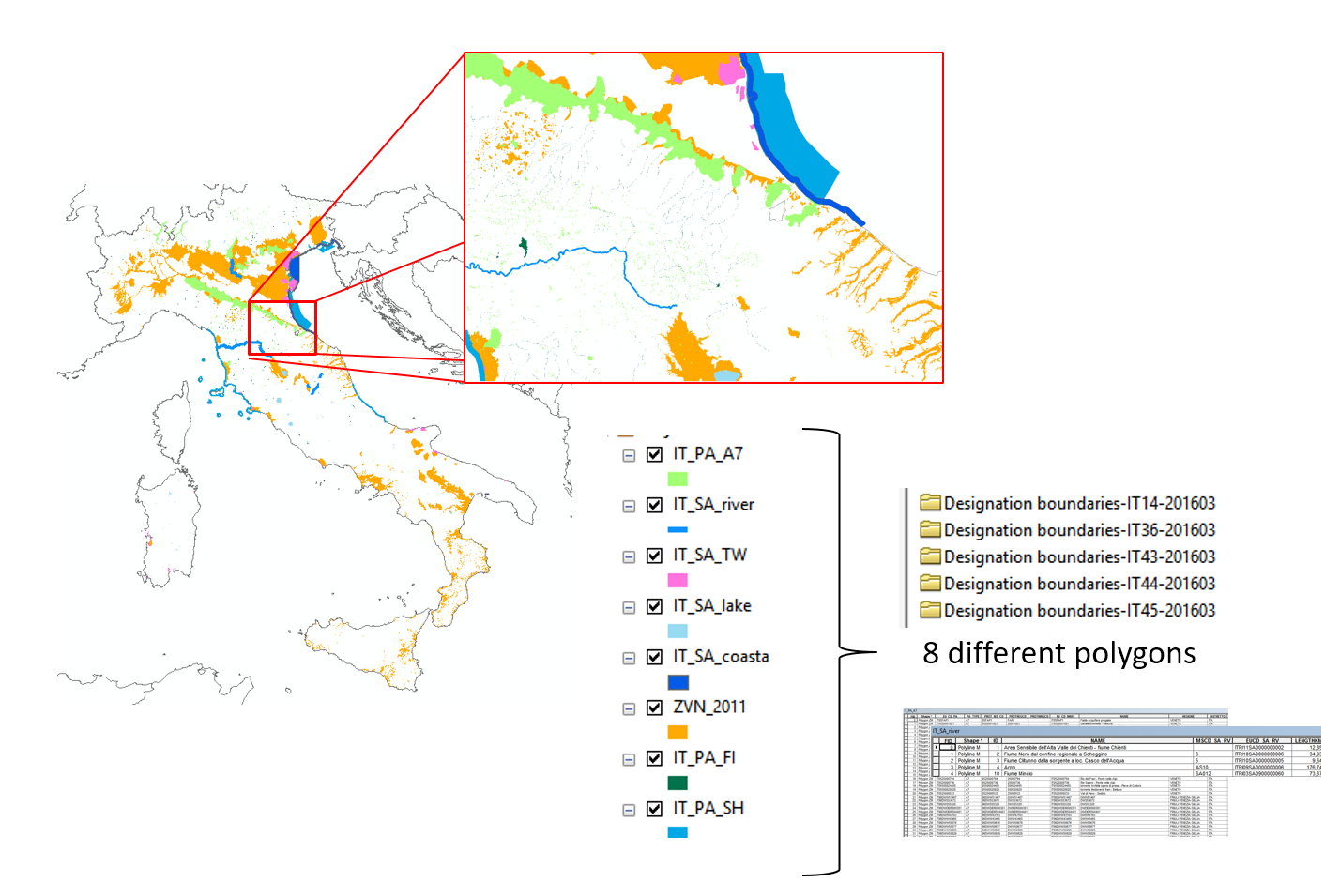

The Netherlands delivered one designation boundary dataset covering the designation type NL21.

Figure 5-2 Designation boundary delivery from the Netherlands
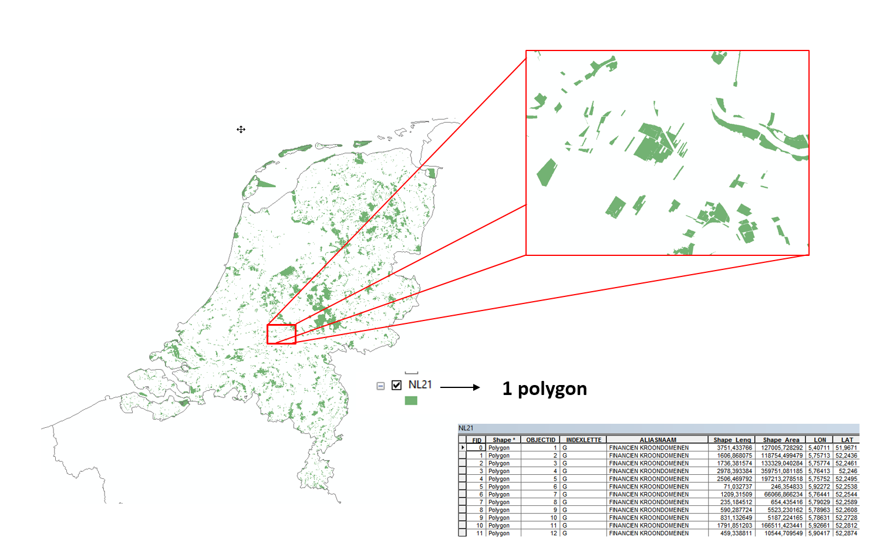

Concluding remarks
While the majority of the data delivered under the CDDA reporting cycle is of a high quality, there are still some problematic issues for data processing:

- wrong xml-file format or no xml-file uploaded to EIONET –> no automatic QA possible
- LAT/LON coordinates outside the country
- Unnecessary fields added to tabular/spatial dataset and/or different spelling of field names
- Many countries have delivered only tabular information to indicate the presence of designation boundaries, but where such a delivery is not accompanied by a spatial file the areas cannot be included under the designation boundaries concept. An improved description of the designation boundaries concept will be provided before the next CDDA reporting.
- Marine area percentages in some cases are not correct
- Spatial datasets reported in the wrong projection

