Article 17 dataset (description of the tabular and spatial dataset)

Jérôme Bailly-Maitre, Sabine Roscher, Želmíra Šípková-Gaudillat, Manuel Loehnertz, Michelle Watson, Pablo Bolanos

2020
Context:
The Topic Centre has prepared this Technical paper in collaboration with the European Environment Agency (EEA) under its 2020 work programme as a contribution to the EEA’s work on Nature Directives reporting

Disclaimer:
This European Topic Centre on Biological Diversity (ETC/BD) Technical Paper has not been subject to a European Environment Agency (EEA) member country review. The content of this publication does not necessarily reflect the official opinions of the EEA. Neither the ETC/BD nor any person or company acting on behalf of the ETC/BD is responsible for the use that may be made of the information contained in this report.

`The withdrawal of the United Kingdom from the European Union did not affect the production of the report.
Data reported by the United Kingdom are included in all analyses and assessments contained herein, unless otherwise indicated.

Contents
1 Introduction 3
2 Overview on the tabular data 4
2.1 Content of the EU tabular dataset 4
2.2 Structure of the EU tabular dataset 5
2.3 Selection of reports for statistics 11
2.4 Additional queries 12
2.5 Description of methods for fields where the value has been calculated by ETC from the information reported by Member States. 13
3 Overview on the spatial data 14

Introduction
Article 11 of the Habitats Directive requires Member States to monitor the habitats and species listed in Annexes present in their territory. Under Article 17, Member States have to report every six years, according to a standard format, on the conservation status of all targeted species and habitats occurring in each biogeographical region/ marine region in that Member State territory.
The current Article 17 reports cover the reporting period 2013-2018; Member States uploaded their reports on EIONET Central Data Repository CDR under the obligation “Habitats Directive: Report on Implementation Measures (Article 17, Habitats Directive)”.
The European Commission itself have to report on the overall implementation of the Habitats (and the Birds) Directives at the EU level. As part of this, an assessment of the conservation status of targeted species and habitats at the level of EU biogeographical and marine region is elaborated. The latest EU assessments were carried out by the EEA/ETC_BD experts, between October 2019 and February 2020; followed by a public consultation.
The current EU Article 17 dataset includes the latest data submitted from Member States as their national Article 17 reports and latest results from the EU biogeographical and marine assessments. The purpose of this note is to document the structure of the EU Article 17 datasets covering both tabular and spatial data.
The following resources are useful to understand the assessments of conservation status at the EU biogeographical level as well as the data reported from Member States:
- Article 17 biogeographical assessments-Methodology This is a background document on the assessments of conservation status.
- Article 17 web tool This is the web tool used for the biogeographical assessments of the conservation status of species and habitats under Article 17 of the Habitats Directive
- Reference portal for reporting under Article 17 of the Habitats Directive provides links to all reference documents guiding Member States in preparation of their national reports.

Overview on the tabular data
The tabular data are located in ONAGER: NatureArt17
An extract of the tabular data had been created as MS Access database (S:\Common workspace\Bio\00_DATA_DELIVERABLES\ART17\ART17_data_delivery\f02_data\eea_art17_tabular_database_2013_2018\EEA_art17_dataset_20201013)

Content of the EU tabular dataset
The following data elements have been compiled for this EU Article 17 tabular dataset:
- Data on Member State level
- Data on status and trends of habitats and species reported by Member States
- Overall conservation status (CS) and trend (as reported by MS in the previous reporting period) and the nature of change in CS and trend between the two reporting periods (as reported by MS in the current reporting period)
- Area calculations from the GIS data set on distribution
- Pressures and threats reported by Member States
- Information related to conservation measures, including the detailed list of measures reported by Member States
- Information related to Natura 2000 coverage reported by Member States
- Information related to taking and exploitation of Annex V species (Art. 14) reported by Member States
- Species and habitats checklists, including cross linkage of species name used by Member States and the species name used for the European level as well as the information in which Annexes of the Habitats Directive the species and habitats are listed.
- Data on European level (EU28)
- Underlying information for the assessments of the conservation status at EU biogeographical level
- Overall conservation status (CS) and trend
- Overall conservation status (CS) and trend from the previous reporting period and nature of change in CS and trends between the two reporting periods as assessed by the experts
- Contribution to Target 1 of the European Biodiversity Strategy as assessed by the experts

The detailed listing of all tables and their content is provided in the separate excel file. Where the data result directly from the reports delivered by the Member States this Annex provides the mapping for each table data field to the corresponding section in the report format.
A detailed overview of the methods used to produce Assessments of conservation status at the EU biogeographical level (EU level data) can be found in the Article 17 biogeographical assessments-Methodology.

Structure of the EU tabular dataset
The schema in Figure 1-1 shows a schematic overview of the available information “Species regions MS level” and “Habitats regions MS level” contains data reported by Member States for a habitats or species within a Member States’ biogeographical or marine region such as conservation status or trends. The entity “Pressures & Threats” corresponds to a table with information on pressures and threats reported by Member States for species or habitat types within a biogeographical or marine region. For European level the table “Species regions EU level” contains information resulting from the EU biogeographical assessments. The “checklist” provides inter alia information on how the species names used in the national reports are cross-linked to the species name which is used for the European assessment. The entity diagram corresponding to this structure is provided in the Figure 1-2. Table 1-1 provides the descriptions of the data tables.

Figure 1-1 Schematic overview on data structure
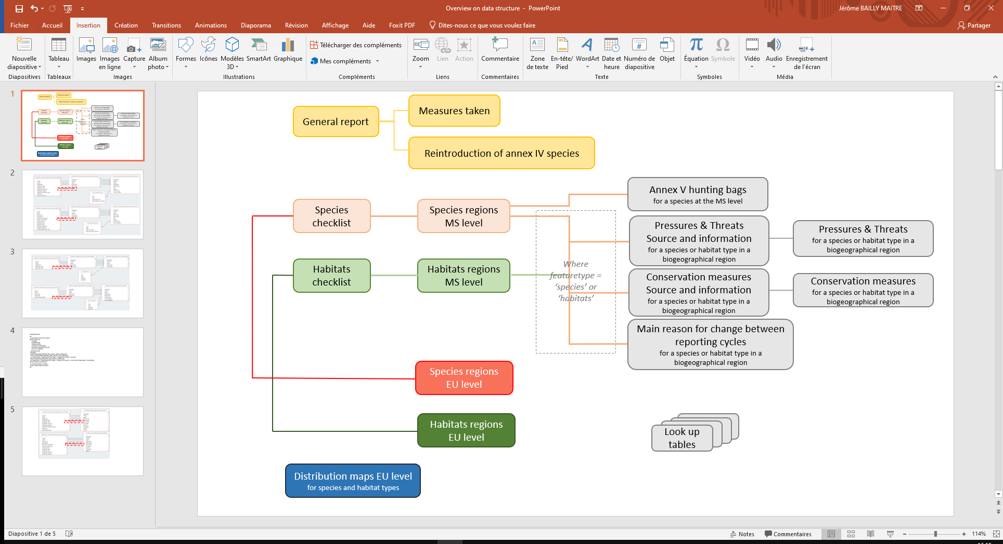

Table 1-1 List of tables
Table name | Description
data_greport | General report format (Article 17), main table
data_greintroduction_of_species | General report format (Article 17), information on re-introduction of Annex IV species
data_gmeasures | General report format (Article 17), information on Measures taken in relation to approval of plans & projects
habitats_check_list | Occurrence of the habitat in biogeographical region in Member State
species_check_list | Occurrence of the species in biogeographical region in Member State
data_habitats_regions | Report format on the 'main results of the surveillance under Article 11' for Annex I habitat types, main table
data_species_regions | Report format on the 'main results of the surveillance under Article 11' for Annex II, IV and V species, main table
data_species_annexV | Information related to exploitation of Annex V species (Art. 14)
data_change | Change and reason for change between reporting periods for overall assessment of conservation status, overall trend in conservation status and values reported for habitats and species parameters
data_measures_info | Information related to main conservation measures
data_measures | Conservation measures - list of measures taken for each habitat or species in Member States’ biogeographical regions
data_pressures_threats_info | Information related to main pressures and threats
data_pressures_threats | Main pressures and threats - list of main pressures for each habitat or species in Member States’ biogeographical regions
habitatsEUassessment | Assessments of conservation status at the EU biogeographical level for habitats
speciesEUassessment | Assessments of conservation status at the EU biogeographical level for species

Detail list of data fields is provided in the separate excel file
Figure 1-2 Entity relationship diagram
- General report
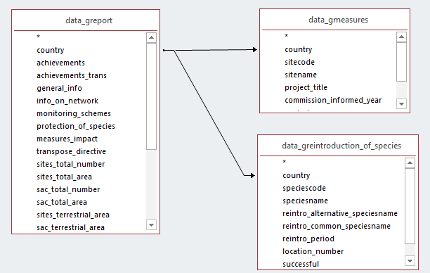

- Relation between checklists and biogeographical reports
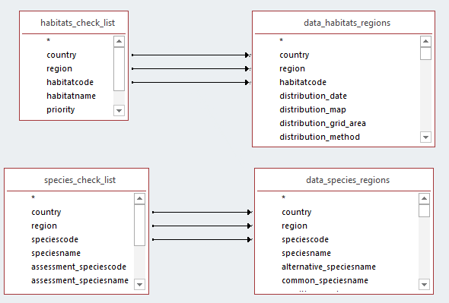

- Relation between biogeographical reports and pressures/threats
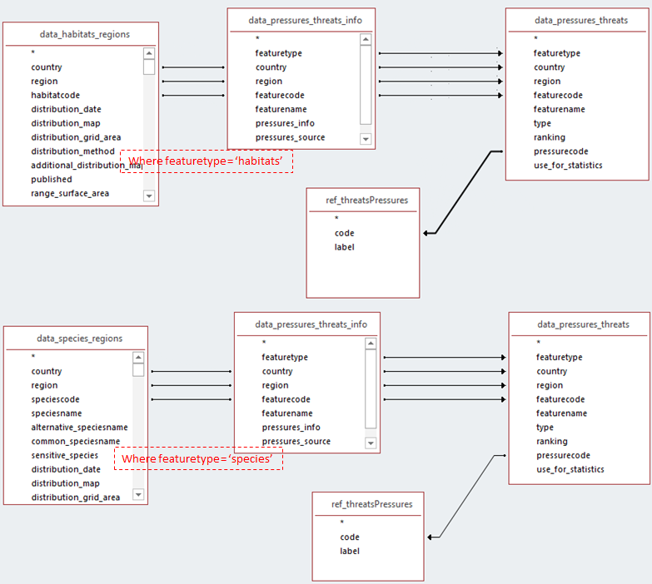
Note: for some features (habitat type or species), information or source for pressures/threats is reported, but no pressure code has been provided. If an analysis only on pressure code is requested, it can be done directly in the table data_pressures_threats by selecting the featuretype (habitats or species) then the pressure type (‘p’ or ‘t’), and eventually the field use_for_statistics.

- Relation between biogeographical reports and conservation measures
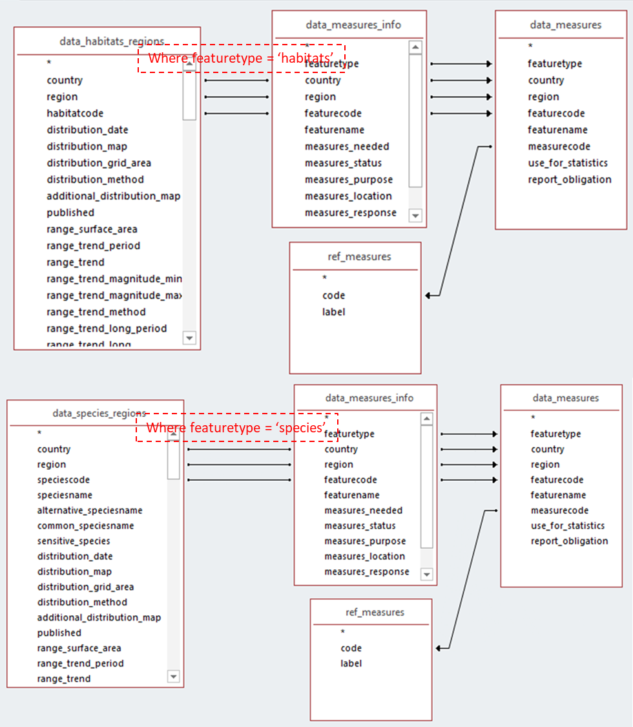

- Relation between biogeographical reports and main reason for change (as reported by Member States)
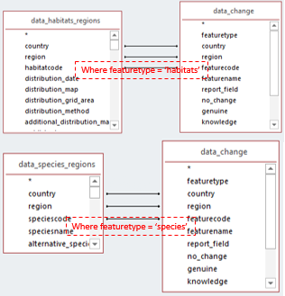
Note: reported information on the main reason for change in conservation status and trend in conservation status has been revised by the ETC/BD to harmonize the reported data between Member States. This information is available in the Species regions and Habitats regions MS level tables.

- Relation between biogeographical reports and annex V species (as reported by Member States)
Note: Annex V species information (e.g. hunting bags) is reported at the species level meaning it is not specific to the biogeographical region.

- Relation between biogeographical reports and EU assessments
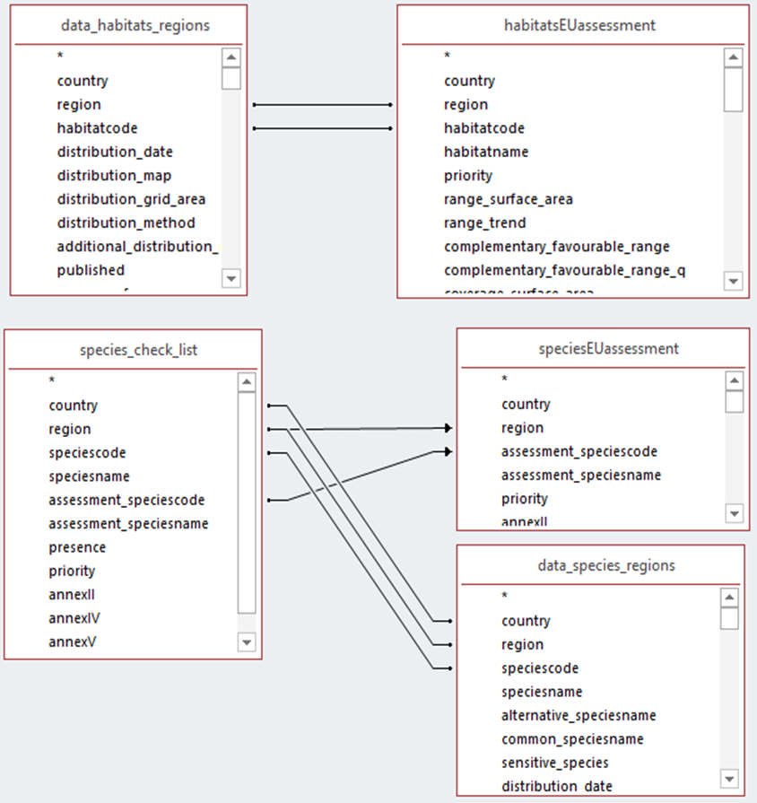

Selection of reports for statistics
Depending on the purpose of the statistics certain habitats and species reports need to be excluded from the analysis in order to generate useful information. In general, unless there was a specific need the EEA’s statistics are based on the reported information for habitats/species that:
- are present regularly (PRE)
- Species extinct after entry into force of the Habitats Directive (EXa)
- Species extinct prior to entry into force of the Habitats Directive (EXp) in case there is a restoration project or recent signs of recolonization for species of particular interest)
In the dataset tables these records are marked as use for statistics = ‘-1:true;’ in the field [use for statistics] . This field is present in the following tables (see below) to facilitate filtering, but the indication of use for statistics is identical across the tables with MS data.
data_habitats_regions
data_species_regions
data_pressures_threats_info
data_pressures_threats
data_measures_info
data_measures
data_changes
habitatsEUassessment_published
speciesEUassessment_published

At the EU level a record should be used for statistics (use for statistics = ‘-1:true;’ ) if it fulfils one of the three criteria above at least in one Member State within the biogeographical or marine region.
The reports for habitats and species for which the guidelines do not request the assessment of conservation status are excluded from the statistics. This includes:
- marginal habitats and species (MAR);
- occasional (OCC) and newly arriving (ARR) species
- reports for species regionally extinct before the Habitats Directive came into force (EXp) excluding the case of applied restoration projects and recent signs of recolonization – see above
- potential reports for habitats and species with uncertain occurrence (SCR, scientific reserve) that give only general information related to habitat/species without evaluation of the conservation status;
- any redundant reports e.g. provided for both marine and terrestrial regions for habitats and species for which only one, either terrestrial or marine report was expected.
- reports for individual species of Cladonia, Lycopodium, Sphagnum spp (or other optional reports) submitted in addition to mandatory genus level reports

In the dataset tables these records are marked as use for statistics = ‘0:false;’ in the field [use for statistics].

Additional queries
Additional queries to support user analyses and provide a better understanding of the dataset are the part of the current dataset. These are listed in the table Table 1-2 List of additional queries.
Table 1-2 List of additional queries
Query name | Description
query_habitats_pressures_threats | All level 2 pressures and threats (codes and description) reported by MS for habitats
query_species_pressures_threats | All level 2 pressures and threats (codes and description) reported by MS for species
query_conservation_measures_habitats | All conservation measures (codes and description) reported by MS for habitats
query_conservation_measures_species | All conservation measures (codes and description) reported by MS for annex II species and species from other annexes
query_reason_for_change_habitatstatus | Nature of change in the overall assessments for habitats between the previous and current reporting. This information is provided by MS (information provided by MS)
query_reason_for_change_speciestrend | Nature of change in the overall trend in conservation status for species between the previous and current reporting (information provided by MS)
query_species_MS_and_EU_overall_status | Link between the regional reports delivered by MS and European assessments from experts

Description of methods for fields where the value has been calculated by ETC from the information reported by Member States.
distribution_grid_area
Area from the EU distribution map. The method for compiling the reported distribution data into at EU level is provided in chapter 3.
conclusion_assessment_prev, conclusion_assessment_trend_prev
This fields contains the information on conservation status and trend reported by Member States for the period 2007-2012. For previous status and trend the following source has been used: https://www.eea.europa.eu/data-and-maps/data/article-17-database-habitats-directive-92-43-eec-1 For Greece the data from delayed delivery were used. The data are not included in the Eu dataset accessible via the ink above
For the species which were due to taxonomical reasons split into two or more new species since previous reporting, no previous status was attributed. This was also the case for habitats and species for which no report was submitted for 2007-2012 period.
use_for_statistics
The methods for generating this information are described in the chapter 2.1 Selection of reports for statistics of this document. Use for statistics field is used to facilitate filtering in these tables: data_habitats_regions, data_species_regions, data_pressures_threats_info, data_pressures_threats, data_measures_info, data_measures, data_changes, habitatsEUassessment, speciesEUassessment
coverage_etc, natura2000_area_etc, popsize_etc, natura2000_popsize_etc
Calculation is based on field best value, minimum and maximum reported for information type: coverage_surface_area, natura2000_area, population_size, natura2000_population.
The calculated figure in four ETC calculated fields equals the best value if this was reported, if not it equals an average of reported minimum and maximum. In special case when only minimum was reported, it is kept as such. If only maximum is reported, minimum is considered 0 (zero) and average is calculated on this basis.
(Note: For coverage_etc a substitute values were used in FR-CON for habitats 6510 where the value is 1000, and 3270 where the value is 8)
hab_condition_unknown, hab_condition_notgood, hab_condition_good
The calculated figure in ETC calculated fields equals an average of reported minimum and maximum. In special case when only minimum was reported, it is kept as such. If only maximum is reported, minimum is considered 0 (zero) and average is calculated on this basis.
natura2000_coverage_etc
The calculated figure in this ETC calculated is a percentage proportion between natura2000_area_etc and coverage_etc for habitats and between popsize_etc and natura2000_popsize_etc for species. For species population size, this calculation is meaningful and was thus applied only when the population unit of both population fields is the same is the same.
For some habitats and species the calculated coverage value is > 100%. The calculated values are still included in the EU dataset, but they considered ‘erroneous’ and are not used for analysis in State of Nature report
report_obligation
Indicates in the data_measures table whether the information for a habitat or species was mandatory or optional (mandatory for habitats and annex II species, optional for non-annex II species).

Overview on the spatial data
From the different habitats and species distribution data –produced by the member states- an EU distribution dataset –based on 10km² x 10km² grid cells - was produced. Cells with multiple habitats and species information were removed on the basis of a set of rules.
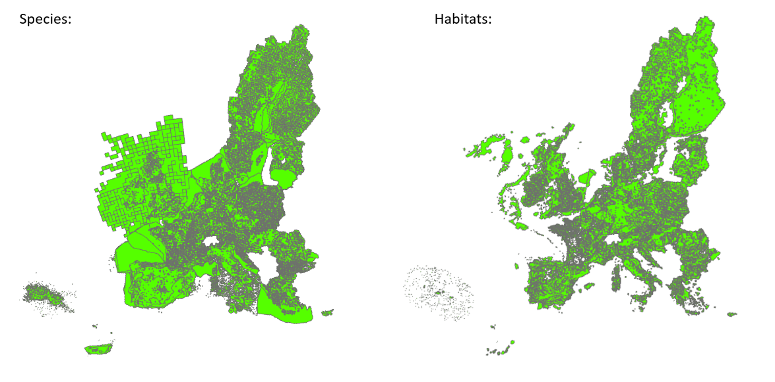

Six different spatial data sets were created:
- ART17 habitat distribution
  - ART17 habitat distribution MS (reporting unit: country-region-habitatcode)
  - ART17 habitat distribution EU (reporting unit: region-habitatcode)
- ART17 species distribution without sensitive species
  - ART17 species distribution MS (reporting unit: country-region-speciescode)
  - ART17 species distribution MS (reporting unit: region-speciescode)
- ART17 species distribution with sensitive species
  - ART17 species distribution MS (reporting unit: country-region-speciescode)
  - ART17 species distribution MS (reporting unit: region-speciescode)

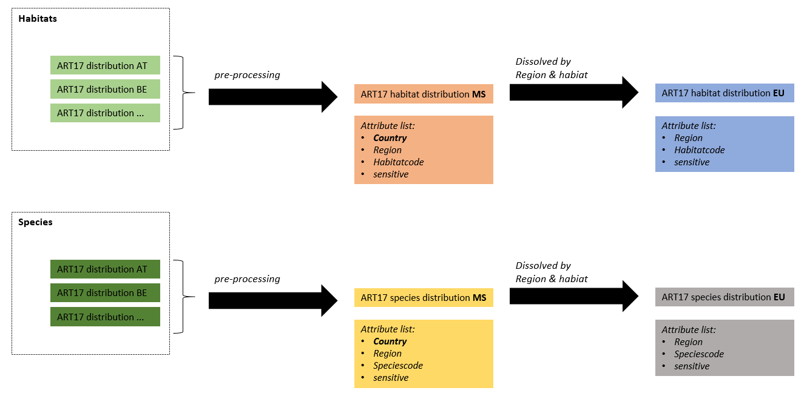
Additionally, the two important information: conservation status and conservation trend is attached as a separate table:
- For the MS distribution
  - habitatsMSassessment
  - speciesMSassessment
- For the EU distribution
  - habitatsEUassessment
  - speciesEUassessment

The four tables can be joined to the distribution data via the field [CO_MS_RE] or [CO_RE]:
