Article 12 dataset (description of the tabular and spatial dataset)

Jérôme Bailly-Maitre, Sabine Roscher, Želmíra Šípková-Gaudillat, Manuel Löhnertz, Michelle Watson, Pablo Bolanos

2020
Context:
The Topic Centre has prepared this Technical paper in collaboration with the European Environment Agency (EEA) under its 2020 work program as a contribution to the EEA’s work on Nature Directives reporting

Disclaimer:
This European Topic Centre on Biological Diversity (ETC/BD) Technical Paper has not been subject to a European Environment Agency (EEA) member country review. The content of this publication does not necessarily reflect the official opinions of the EEA. Neither the ETC/BD nor any person or company acting on behalf of the ETC/BD is responsible for the use that may be made of the information contained in this report.

`The withdrawal of the United Kingdom from the European Union did not affect the production of the report.
Data reported by the United Kingdom are included in all analyses and assessments contained herein, unless otherwise indicated.

Contents
1 Introduction 4
2 Overview on the tabular data 4
2.1 Content of the EU tabular dataset 5
2.2 Structure of the EU tabular dataset 5
2.3 Selection of reports for statistics 10
2.4 Additional queries 11
2.5 Description of methods for fields where the value has been calculated by ETC from the information reported by Member States. 11
3 Overview on the spatial data 13

Introduction
Article 12 of the Birds Directive requires Member States to report on their progress in implementing the Directive to the European Commission. The six-year reporting cycle was established in agreement with Member States in 2008-2012 before recently being legislatively established as well.
The current Article 12 reports cover the reporting period 2013-2018 and are elaborated according to the format established in 2011 and updated in 2016. Member States uploaded their reports between July and October 2019 on EIONET Central Data Repository CDR under the obligation “Birds Directive: Progress/implementation report (Article12, Birds Directive)”. The reports are required for all regularly occurring breeding species, and also for wintering and passage Annex I taxa and non-Annex I taxa triggering SPA designations (and in addition for Annex II species not occurring as breeders) (DG Environment, 2017).
The European Commission itself have to report on the overall implementation of the Birds (and the Habitats) Directives at the EU level. An important component in assessing the progress in implementation of the Directive is the EU population status of bird species. The latest EU population status assessment has been carried out by Stichting BirdLife Europe with BirdLife International and IUCN in 2020 under the contract from the European Commission.
The current EU Article 12 dataset includes the latest data submitted from Member States as their national Article 12 reports and latest results from the EU population status assessments. The purpose of this note is to document the structure of the EU Article 12 datasets covering both tabular and spatial data.
The following resources are useful to understand the EU population status assessments as well as the data reported from Member States:
- Article 12 EU population status assessments-Methodology This is a background document on the assessments EU population status.
- Article 12 web tool This web tool provides access to the data reported by Member States and EU population status assessments
- Reference portal for reporting under Article 12 of the Birds Directive provides links to all reference documents guiding Member States in preparation of their national reports.

Overview on the tabular data
The tabular data are located in ONAGER: NatureArt12
An extract of the tabular data had been created as MS Access database (S:\Common workspace\Bio\00_DATA_DELIVERABLES\ART12\f02_data\art12_tabular_database_2013_2018)

Content of the EU tabular dataset
The following data elements have been compiled for this EU Article 12 tabular dataset:
- Data on Member State level
- Data on population and distribution size and trends reported by Member States
- The nature of change in population size between the current and the previous reporting periods (as reported by MS in the current reporting period)
- Area calculations from the GIS data set on distribution
- Pressures and threats
- Information related to conservation measures, including the detailed list of measures
- Information related to Natura 2000 coverage
- Information related to Annex II species
- Birds checklists, and the cross linkage of species name used by Member States and the species name used for the European level as well as the information in which Annexes of the Birds Directive the birds are listed.

- Data on European level (EU28)
- EU population size and EU population trends
- EU population status and the Red List status
- EU population status and Red List status from the previous reporting period
- Contribution to Target 1 of the European Biodiversity Strategy as assessed by the experts

The detailed listing of all tables and their content is provided in the separate excel file. Where the data result directly from the reports delivered by the Member States this Annex provides the mapping for each table data field to the corresponding section in the report format.
A detailed overview of the methods used to produce assessments EU populationstatus can be found in the Article 12 EU population status assessments-Methodology .

Structure of the EU tabular dataset
The schema in Figure 1-1 shows a schematic overview of the available information “Bird season MS level” contains data reported by for a Member States or a subnational unit for a national population in a particular season such size of breeding or wintering population or its trends. The entity “Pressures & Threats” corresponds to a level with information on pressures and threats reported by Member States for a species within a season; similarly conservation measures contain information on conservation measures. For European level the table “Bird season EU level” contains information on EU status and trends. The “checklist” provides inter alia information on how the species names used in the national reports are cross-linked to the species name which is used for the European assessment. The entity diagram corresponding to this structure is provided in the Figure 1-2. Table 1-1 provides the descriptions of the data tables.
Figure 1-1 Schematic overview on data structure

Specific remarks in relation to the EU population status assessment
In general the EU population status was assessed for all regularly occurring species of EU. In addition, the EU population status was assessed for subspecies listed on the Annexes of the Birds Directive, subspecies with international plans and their subspecific counterparts. Some species have though the EU population status assessment at both the species and subspecies level. Both species and subspecies assessments are included in the data tables with assessments of EU population status.
For a majority of species, the EU population status assessments were based on data from the breeding season, but for a minority of species, winter data were (also) used. The EU population status of species that do not breed (regularly) within the EU were based solely on winter data.
If relevant for some species that occur in both seasons, the assessment process was carried out independently on data for both breeding and wintering populations and the EU population size and trends were calculated. The information on seasons for which the ‘assessment’ has been carried out for each species is provided in the field [season_reported] in the data tables with assessments of EU population status. The unique seasonal assessment (breeding or wintering) following the IUCN Red List methodologies was maintained representing the final EU population status of a species in the EU. These final EU population status assessments are compiled in the data table [birdsEUpopulation]. The complementary assessments for species with two seasonal assessment are included in the table [birdsEUpopulation_notassessed]; ror these species only EU population size and trends are provided and not the EU population or Red List status.

More information on EU assessment can be found in ‘ Article 12 EU population status assessments-Methodology ’.

List of tables
The description of the data tables is provided in the Table 1-1 below. The data tables in the database contain both the data reported by Member States, harmonised and compiled by EEA and also the outcomes from the EU population status assessment carried out under the contract from the European Commission (see above).
Table 1-1 List of tables
Table name | Description
data_bgreport | General report format (Article 12), main table
data_bgpublication | General report format (Article 12), list the most recent publications of EU-wide interest other than national atlas and national red list
data_bgnon_native_bird | General report format (Article 12), information on bird species that do not naturally occur in the wild in the European territory of the Member States and for which introduction has taken place during the reporting period
data_bgmonitoring | General report format (Article 12), information on national bird monitoring overview
data_gmeasures | General report format (Article 12), information on Measures taken in relation to approval of plans & projects
bird_check_list | Occurrence of the bird species for a given season in Member State
data_birds | Bird species’ status and trends report format
data_birds_annexII | Information related to Annex II species (Art. 7) (only relevant for species listed on the Annex II of the Directive)
data_change | Change and reason for change between reporting periods for population size.
data_bmeasures_info | Information related to main conservation measures (only mandatory for Annex I species and other species triggering SPA classification)
data_bmeasures | Conservation measures - list of measures taken for each bird species for a given season in Member State (only mandatory for Annex I species and other species triggering SPA classification)
data_bpressures_threats_info | Information related to main pressures and threats (only mandatory for Annex I species and other species triggering SPA classification)
data_bpressures_threats | Main pressures and threats - list of main pressures for each bird species for a given season in Member State (only mandatory for Annex I species and other species triggering SPA classification)
bird_crosslink_MS_EU | Crosslink between species codes used in member States reports and those used for EU assessment (at subspecies level if both species and subspecies level assessments were performed)
birdsEUpopulation | Final assessments of EU population status (see above Specific remarks in relation to the EU population status assessment)
birdsEUpopulation_notassessed | Complementary assessments for species with two seasonal assessment (see above Specific remarks in relation to the EU population status assessment)

Detail list of data fields is provided in the separate excel file the relation between the data tables is provided further below.
In addition to data tables the EU dataset contains the reference tables providing description of all values used for the standardised text information in the data tables. The reference tables for information from Member States is also available via EEA datacentre.
Two additional reference tables has been prepared to facilitate the use of data although the values they provide are not directly used in the data tables: ref_bird_grouping and ref_linkageSpeciesPlans. Detailed description of content of these reference tables is provided in the separate excel file.

Figure 1-2 Entity relationship diagram
- General report
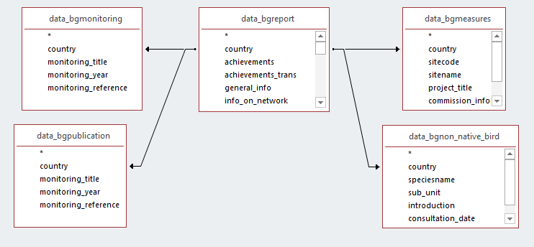

- Relation between checklist and seasonal reports
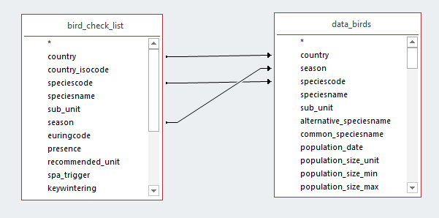

- Relation between seasonal reports and pressures/threats
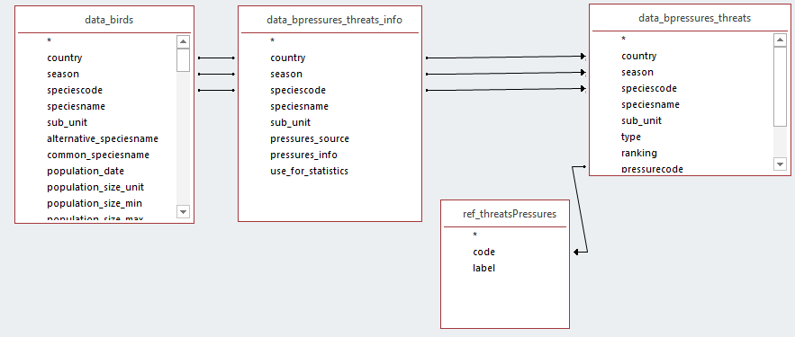
Note: for some bird reports, information or source for pressures/threats is reported, but no pressure code has been provided. If an analysis only on pressure code is requested, it can be done directly in the table data_pressures_threats by selecting the pressure type (‘p’ or ‘t’), and eventually the field use_for_statistics.

- Relation between seasonal reports and conservation measures
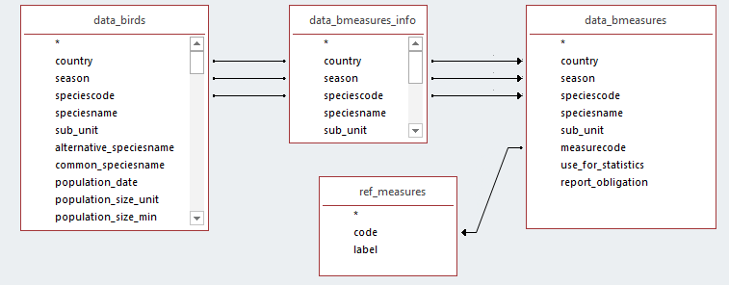

- Relation between seasonal reports and main reason for change
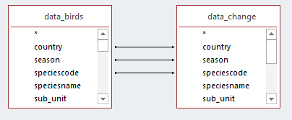

- Relation between seasonal reports and annex II species (as reported by Member States)
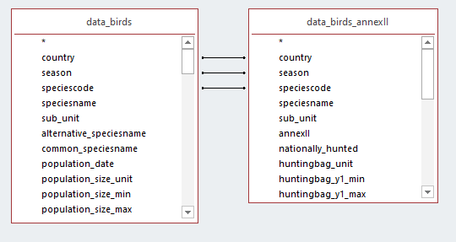
Note: Annex II species information (e.g. hunting bags) is relevant at the species level meaning it is not specific to the season. However some Member State provided the season specific figures.

- Relation between seasonal reports and EU population evaluations
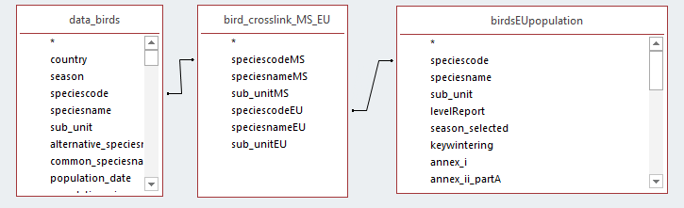

Selection of reports for statistics
The reports submitted by Member States on the optional basis need to be excluded from the analysis in order to generate useful information. In general, the EEA’s statistics are based on the reported information for species for which reporting was mandatory according to the reporting guidelines. These are:
- Species present regularly (PRE)
- Newly arriving species (ARR)
- Species extinct after entry into force of the Habitats Directive (EXa)
- Species extinct prior to entry into force of the Habitats Directive (EXp) in case there is a restoration project or recent signs of recolonization for species of particular interest)
In the dataset tables these records are marked as use for statistics = ‘-1:true;’ in the field [use for statistics] . This field is present in the following tables (see below) to facilitate filtering, but the indication of use for statistics is identical across all the tables.
data_birds
data_bpressures_threats_info
data_bpressures_threats
data_bmeasures_info
data_bmeasures
data_change

The reports for species for which the reporting is not requested but where Member States could have submittd the information on optional basis are:
- reports for occasional or vagrant species
- reports for non-native or feral bird species/populations (with an exception of four species included in Annex II of the Birds Directive)
- any other redundant reports e.g. provided for wintering bird species/populations for which the winter season report is not expected according to the guidelines.
- reports for bird species/populations regionally extinct before 1980 excluding those with reintroduction project for which the reporting is mandatory

In the dataset tables these records are marked as use for statistics = ‘0:false;’ in the field [use for statistics].
In the Article 12 dataset the selection of reports for statistics as described above only applies to data from Member States and is not applicable for EU assessments.

Additional queries
Additional queries to support user analyses and provide a better understanding of the dataset are the part of the current dataset. These are listed in the table Table 1-2 List of additional queries.
Table 1-2 List of additional queries
Query name | Description
query_conservation_measures | All conservation measures (codes and description) reported by MS for Annex I or bird species triggering SPA classification, and other bird species
query_pressures_threats | All level 2 pressures and threats (codes and description) reported by MS for Annex I or bird species triggering SPA classification, and other bird species
query_hunting_bags | The data provided for Annex II species linked with the information on national population size and trends
query_reason_for_change_population | Nature of change in the population size for bird species between the previous and current reporting.
query_wetland_birds_and_taxonomy | MS reports for bird species covered by AEWA convention and information on the taxonomical classification/groupings

Description of methods for fields where the value has been calculated by ETC from the information reported by Member States.
distribution_grid_area
Area from the EU distribution map. The method for compiling the reported distribution data into at EU level is provided in chapter 3.
use_for_statistics
The methods for generating this information are described in the chapter 2.1 Selection of reports for statistics of this document. Use for statistics field is used to facilitate filtering in these tables: data_birds, data_bpressures_threats_info, data_bpressures_threats, data_bmeasures_info, data_bmeasures, data_changes
In the Article 12 dataset the selection of reports for statistics as described above only applies to data from Member States and is not applicable for EU assessments.
popsize_etc, spa_popsize_etc
Calculation is based on field best value, minimum and maximum reported for information type: population_size and spa_population.
The calculated figure in two ETC calculated fields equals the best value if this was reported, if not it equals an average of reported minimum and maximum. In special case when only minimum was reported, it is kept as such. If only maximum is reported, minimum is considered 0 (zero) and average is calculated on this basis.
spa_coverage_etc
The calculated figure in this ETC calculated is a percentage proportion between spa_popsize_etc and popsize_etc. This calculation is meaningful and was thus applied only when the population unit of both population fields is the same.
For some bird species the calculated coverage value is > 100%. The calculated values are still included in the EU dataset, but they considered ‘erroneous’ and are not used for analysis in State of Nature report
report_obligation
Indicates in the data_measures and data_bpressures_threats tables whether the information for a bird species was mandatory or optional (mandatory for annex I bird species or triggering SPA classification, optional for other bird species).
taxOrder, taxFamily, taxGroup_en, tax, Family_en
The information on ‘Taxonomical order - scientific name’, ‘Family - scientific name’ and ‘Family - English name’ ‘Taxonomical group corresponding broadly to the level of taxonomical order’ was provided by the EC contractor as a part of the EU assessment data. In order to facilitate the use of this information together with data from Member States the information was copied across to the [bird_check_list] table providing the list bird species for a given season in Member State.

Overview on the spatial data
From the different ART12 distribution data –produced by the Member States- an EU distribution dataset –based on 10km² x 10km² grid cells - was produced. Cells with multiple species information were removed based on a set of rules.
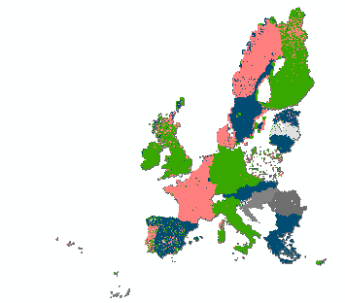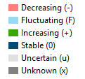
In addition to the species and the country code, the Member State breeding population trend, the EU speciescode and the EU speciedname were added to the dataset. All non breeding bird distribution were removed from the dataset.
Field name | Example | Field description
maptype | Distribution | Type of map: distribution map
sensitive | non-sensitive | Information on whether the species is sensitive.
season | breeding | Season of species: only breeding data is included
CO_MS | A001-FI | Combination of species code and Member State reporting unit
speciescode | A001 | Member State species code
country | FI | Member State reporting unit (two-digit code for MS or other for subnational units)
population_trend | S | Member State population trend
speciesname | Gavia stellata | Member State species name
speciescodeEU | A001 | EU species code
speciesnameEU | Gavia stellata | EU species name
AREA_ha | 5240000 | Area of distribution in ha
reporting_period | ART12 reporting period 2013-2018 | Reporting period
version | ART12_spatial_v2020-10-28 | Version of spatial file
SHAPE_Length | 30801763.73 | Geometry: length
SHAPE_Area | 2.68591E+11
 |  | Geometry: area –m²

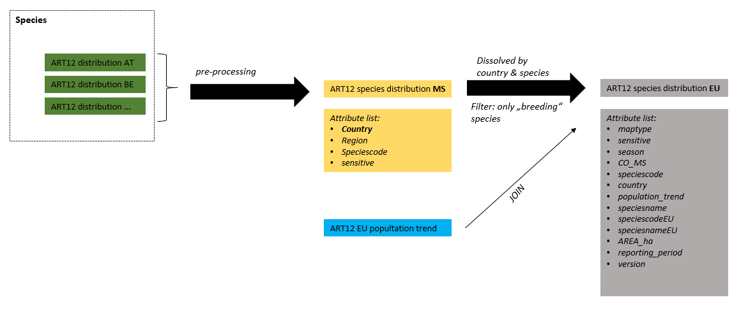

Additionally, the population trend was attached as a separate table:
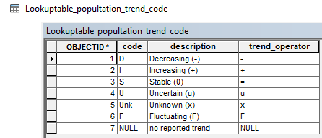

Including the lately delivered data from Romania.
The data from delayed delivery by Romania were not used for the EU population status assessment
According to IUCN red List methods the Red List status is assessed per species and not separately for a season (breeding or wintering) population

