EEALogo

**Final draft EMAS Environmental statement 2019**

Verified final 30/4/2020

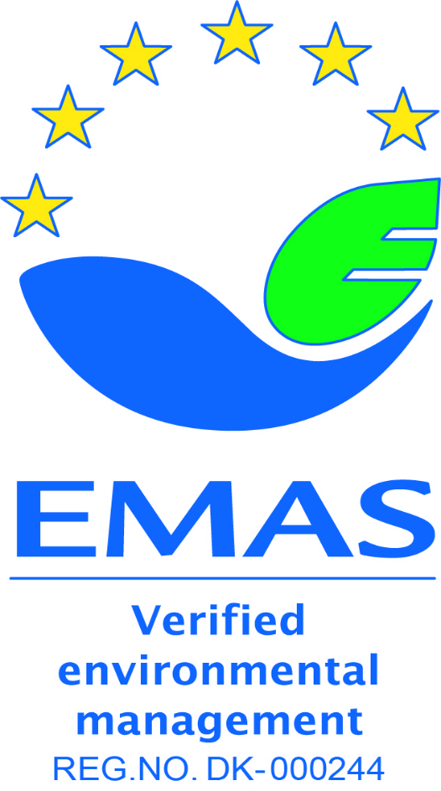

This environmental statement provides information to the general public and other interested

parties on the environmental performance and activities of the European Environment Agency (EEA)

in 2019. It can be found on the [EEA website](http://www.eea.europa.eu/about-us/emas). The EEA was first validated under the EMAS scheme in 2005 ([1]). This environmental statement is the seventh to be produced within the EMAS annual validation cycle. It contains updated data for 2019, which are compared with data from the previous 5 years.

Contents

Introduction 5

Brief description of the EEA’s mission and context 5

Environmental management system 5

Environmental management structure 5

Environmental impacts of EEA activities 6

Environmental performance at the EEA in 2019 6

Raising environmental awareness 6

Running the EEA offices 7

Electricity 8

Heating 9

Water 10

Paper 10

Waste 11

Carbon dioxide emissions related to travel 13

Environmental targets for 2019 with performance indicators 15

Annex A: Environmental Management Programme 2020 19

# Introduction

## Brief description of the EEA’s mission and context

The EEA is a Community body set up by Regulation (EC) No 401/2009 of the European Parliament and the Council of 23 April 2009 on the European Environment Agency and the European Environment Information and Observation Network. The legal framework is therefore based on EC law and, in the absence of relevant EC law provisions, on Danish law.

As such, the EEA is an Agency of the European Union and is mandated with the task of providing sound, independent information on the environment. The EEA is a major information source for those involved in developing, adopting, implementing and evaluating environmental policy, and for the general public.

The EEA is located centrally in Copenhagen and currently rents two buildings (the whole of Kongens Nytorv 6 (KN6) and three floors of KN8, which form one site. The premises date back to the 19th century and are labelled as a ‘D’ category building by the Danish Energy Agency. The number of staff is approximately 200, as well as 18 in-house consultants.

While the EEA is located in Denmark, its activities focus on supporting its stakeholders at European and international level, as well as the general public. This leads to a high volume of business travel and meetings across Europe, as well as the organisation of meetings and conferences at the EEA premises with participants from all over Europe

As an information and knowledge provider, the EEA develops various products, including environmental reports and assessments, data and maps, briefings and social media campaigns to communicate with its stakeholders. With a communication strategy in place that favours the reduction of paper consumption, more and more of these product types are designed and published online, while some reports are printed and disseminated on demand.

## Environmental management system

The European Environment Agency (EEA) uses an environmental management system, which was registered under the European Eco-Management and Audit Scheme (EMAS) in 2005. The first EMAS Regulation encompassing public and private sectors was adopted in 2001 ((EC) No 761/2001). It was subsequently updated by the revised Regulation (EC) No 2017/1505, which entered into force on 28 August 2017.

Since 2009, the EEA has published an annual environmental statement on its website.

EMAS is part of the EEA’s Quality Management System (QMS).

## Environmental management structure

The EEA’s environmental management system is an integral part of its management plan and is designed to make environmental responsibilities clear to employees. Staff members are encouraged to actively engage in projects that will lead to positive environmental impacts. New employees receive a 45-minute introduction to the EEA’s Environmental Management System (EMS) and several complementary activities exist to further inform staff about EMAS priorities.

The EMS is documented in a handbook on the EEA intranet, explaining its management and procedures.

## Environmental impacts of EEA activities

EEA activities have both direct and indirect impacts on the environment. The EEA routinely monitors its:

* use of electricity;
* energy for heating;
* water;
* paper;
* generation of waste; and
* CO2 emissions from business travel.

The EEA is not reporting on land use with regard to biodiversity as the premise has no urban green space, nor accessible roof top to be considered for significant improvement of its biodiversity (EMAS regulation[2]).

The EEA also regularly evaluates its activities in order to optimise and improve outputs, while limiting the use of resources and minimising negative impacts on the environment. One way to achieve this is through our procurement process, which follows the green public procurement guidelines: an ‘environmental impact statement’ is written in the initial proposal for procurement and specific, robust environmental criteria and ‘environmental considerations’ appear in the tender specifications. Tenderers have to comply by these criteria and considerations to qualify for a contract. It is standard EEA practice to build environmental considerations into procurement.

## Environmental performance at the EEA in 2019

The EEA has assessed the EMAS Sectoral Reference Document for public administration[3] for each of its core indicators against the Best Environmental Management Practices (BEMP) and concluded that relevant EEA practices are aligned.

## Raising environmental awareness

The EEA continues to assist other EU bodies to raise awareness of their environmental impacts. As such the Agency hosted in 2019 the 13th annual Greening Network of EU Agencies meeting with more than 20 participants from Agencies and EU institutions to learn and share best practices around the implementation of the environmental management system under EMAS. As host for a second time, the EEA was able to provide an overview of the challenges and improvements over a decade of implementing EMAS.

The inter-agency network was set up by the EEA in 2006 and was formally recognised by the heads of administration of EU agencies in May 2016. With more than 25 members from EU agencies, the network addresses common environmental topics, with particular focus on implementation and registration under the EMAS Regulation. The Greening Network is also involved in EU environmental governance through representation in the informal Inter-institutional Group on Environmental Management (GIME).

Internally, EMAS is part of the induction programme, during which all new employees get to know the EMAS quality standard and how the EEA applies EMAS on its own premises. In addition, as part of regular biannual internal audits, members of staff are interviewed at random about the aspects of their work that relate to EMAS. Also, the results of the annual statement are presented to staff as part of the programme meetings or management group meetings.

Finally, to encourage more sustainable consumption and efficient resource use by employees at home as well as at the workplace, regular information is provided in the weekly video loop in the canteen, which includes green tips. The yearly EEA swap party encourages the exchange of private items with colleagues. Those items that do not find a new owner during the evening are donated to a Danish Charity. The event is supported by the Social Committee.

## Running the EEA offices

The environmental impact of running the EEA offices is detailed below in several time series tables for the period from 2015 to 2019.

The tables cover electricity consumption, energy equivalent for district heating, water consumption, paper consumption and waste generation. The environmental performance in these areas is defined in relation to the number of people working at the EEA and the area of the office. Furthermore, the calculation of performance in terms of impacts per square metre is complicated by the fact that since 2005, some EEA staff members have been working in buildings other than the main building at KN6. Since 2010, the EEA has been renting an adjacent building (KN8). Initially two floors were rented, but since 2011, three floors have been rented. The size of the two buildings is approximately 10 000 m2 in total (7 200 m2 in KN6 and 2 800 m2 in KN8).

The number of people working at the EEA is expressed as full-time equivalents (FTEs) and is based on the same methodology as for other administrative reporting. The FTEs are correctly adjusted down for staff working on part-time contracts. Consultants are excluded, whereas extended leave and absences are counted as full whole FTEs. The change of working hours from 37.5 to 40 hours took place in 2014 and has been adjusted in the methodology. ([4]).

|  |  |  |  |  |  |
| --- | --- | --- | --- | --- | --- |
|  | **2015** | **2016** | **2017** | **2018** | **2019** |
| **FTE** | 196 | 196 | 201 | 211 | 212 |

## Electricity

**Consumption of electricity 2011-2019**

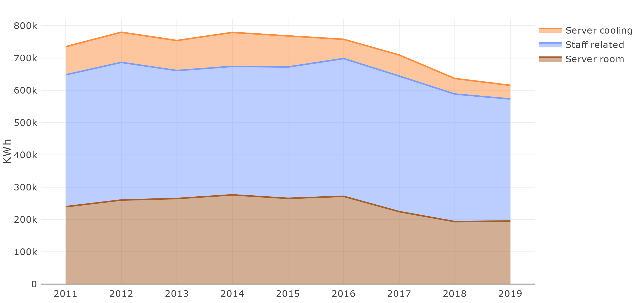

**Consumption of electricity 2015-2019**

|  |  |  |  |  |  |  |
| --- | --- | --- | --- | --- | --- | --- |
|  | **2015** | **2016** | **2017** | **2018** | **2019** | **Change 2018/2019** |
| Total kWh | 768 361 | 757 839 | 709 289 | 636 493 | 615346 | -3,3% |
| kWh/FTE | 3 920 | 3 867 | 3 529 | 3 017 | 2903 | -3,8% |

Note: 2015-2019 figures cover both rented buildings; Kongens Nytorv 6 and 8 (10 000 m2). kWh = kilowatt hours

The EEA is part of the Copenhagen Municipality, which is committed under its Climate Plan 2025 to be CO2 neutral by 2025. The municipality has achieved a reduction in CO2 emissions of 42 % since 2005, partly as a result of the transition to energy production from biomass and wind. The current energy provider delivers more than 70% of the power from renewables, mainly wind energy.

In addition, for the last 15 years the EEA bought electricity from renewable sources (wind energy) through the renewable energy certificate system (RECS). For 2019, the expected annual electricity consumption of 633 MWh was invoiced on the actual monthly consumption rather than an annual fixed invoice. As such the Agency is saving costs and 100 % of its energy comes from renewable sources.

The consumption of electricity can be broadly divided into two approximately equal parts: (1) the electricity needed for central computing (i.e. servers) and data storage (including the electricity used to cool the server room); and (2) the staff-related use of electricity in offices and meeting rooms. The main server room is located in KN6 on the third floor.

The continuous reduction in consumption also accounts for cost savings of around EUR 41.000 (2013 vs 2019). The installation of more energy efficient computing, multi- functional devices and new light sensors in corridors with energy efficient LED lights, as well as higher environmental awareness among staff, have led to positive results.

## Heating

**Consumption of heating energy 2015-2019**

|  |  |  |  |  |  |  |
| --- | --- | --- | --- | --- | --- | --- |
|  | **2015** |  |  |  |  |  |
| **2016** | **2017** | **2018** | **2019** | **Change 2018/2019** |
|  |  |  |  |  |
| **m3** | 989 |  |  |  |  |  |
| 1 035 | 991* |  |  |  |
|  |  |  |  |  |
| **MW** | - | - | 204 | 695 | 638 | -8% |
| **MW/FTE** |  |  |  |  |  |  |
| 3,3 | 3,0 |  |

Note: For all years, the figures cover KN6 (7 200 m2) only.

The local provider of heating, HOFOR, switched from steam to water-based heating in 2017. Thus, the reporting is now in megawatts (MW). The 2017 data therefore only accounts for the period from September to December. The consumption reflects both heating of building and warm water consumption. By 2021, all households in Copenhagen City will be supplied with water-based district heating, which is more energy efficient and will prevent loss of water in the district heating grid.

## Water

**Consumption of water 2015-2019**

|  |  |  |  |  |  |  |
| --- | --- | --- | --- | --- | --- | --- |
|  | **2015** | **2016** | **2017** | **2018** | **2019** | **Change 2018/2019** |
| m3 | 1 609 | 1 423 | 1 537 | 1 570 | 1 447 | -7,8% |
| m3/FTE | 8.4 | 7.4 | 7.7 | 7.4 | 6.8 | -8.1% |

Note: For all years, the figures cover KN6 (7 200 m2) only. The FTE includes all staff, but since 2010, an increasing number of staff have been located in KN8. No water consumption data for KN8 are available as they are included in the rent as an ‘aconto’.

The EEA’s consumption of water has decreased since 2013. This was achieved through a combination of measures, including the replacement of leaking toilets, a general lower consumption by staff and optimising canteen operations.

## Paper

**Consumption of paper 2015-2019**

|  |  |  |  |  |  |  |
| --- | --- | --- | --- | --- | --- | --- |
|  | **2015** | **2016** | **2017** | **2018** | **2019** | **Change from**  **2018/2019** |
| **No of sheets printed in-house** | 1 163 454 | 1 205 155 | 1 061 160 | 922 814 | 887 942 | -16% |
| **In-house sheets per FTE** | 5936 | 6148 | 5279 | 4323 | 3597 | -18% |
| **No of pages in printed reports (a)** | 15 493 000 (b) | 5 632 464 | 2 003 436 | 1 960 000 | 2 960 500(a) | 51% |

Notes:

(a) Sum of pdf pages for report printing (previous years word pages)

(b) The SOER alone was responsible for more than 11 000 000 printed pages

Compared with 2017, following the installation of new and fewer multi- functional devices (MFDs) and the implementation of the ‘follow-me’ or uniflow printing system, a steady drop in physical prints , and a stable reduction in the paper use in-house have been achieved, both in absolute figures and per FTE. Under this system, print jobs are triggered by swiping the access card through a reader on the closest MFD. This system not only ensures confidentiality but also avoids double printing and results in less printing in general. From 36 machines, the new fleet numbers was reduced to just 15 MFDs today. These are more energy efficient and boast low air and noise pollution ([5]) levels. They are both TEC3 and Blue Angel certified[6]￼).

## Waste

**Collection of waste (kg) 2015-2019**

|  |  |  |  |  |  |  |
| --- | --- | --- | --- | --- | --- | --- |
|  | **2015** |  |  | **2018** | **2019** | **Change 2018/2019** |
| **2016** | **2017** |
|  |  |
| **Household** | 18 050 |  |  | 14 445 |  | 71% |
| 17 865 | 15 475 | 24 755 |
|  |  |  |
| **Cardboard** | 2 215 |  |  | 1 958 |  | -10% |
| 3 620 | 1 535 | 1761 |
|  |  |  |
| **Paper** | 5 583 |  |  | 5 162 | 9000 | 74% |
| 6 390 | 6 370 |
|  |  |
| **Organic** | No data | No data | 1 870(b) | 7 197 | 6178 | -14% |
| **Electronic** | 1 290 |  |  | 860 |  | -52% |
| 1 273 | 2 620 | 410 |
|  |  |  |
| **Glass** | 600 |  |  | 856 |  | -30% |
| 400 | 680 | 600 |
|  |  |  |
| **Plastic** | - | - | - | 778(c) | 1081 | 39% |
| **Metal** | - | - | - | *216(d)* | 300 | - |
| **Total** | 27 738 | 29 548 | 28 550 | 31 256 | 44 085 | 41% |

Notes:

1. The weighing of organic waste was suspended because the contractor could not provide scales.
2. The weighing of organic waste was re-established in September 2017 because there was a new contractor.
3. The weighing of plastic waste was added to the reporting. Data are for the full year.
4. Newly added fraction for reporting. Not included in total as not a full year.

Compared with the previous 5-years of data, the figures for the reporting year are significantly higher in household and all other fractions. This can be partly attributed to the 90 office removals throughout 2019, as a consequence of the reorganisation. In quarter 4 of 2019, the refurbishment of the second floor in building KN6 began, involving the thorough sorting of 17 offices, including archives.

The EEA waste sorting improvement project was launched at the end of 2018 and provides a good reason for the increase in the different sorting fractions. The purpose of the project is to contribute more to the recycling of resources at community level.

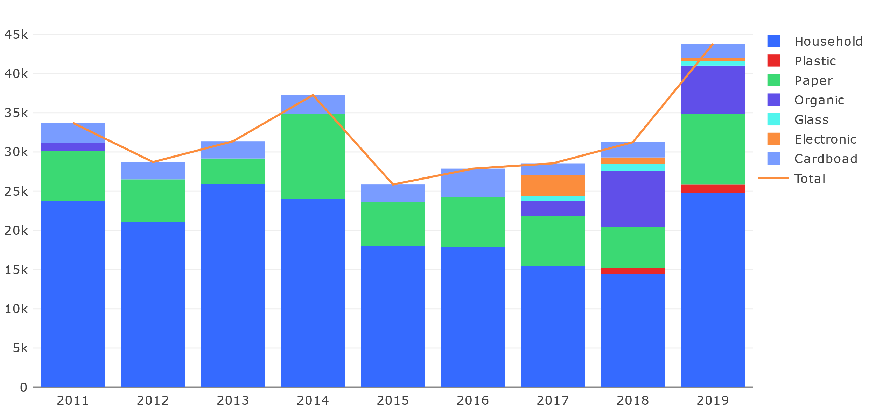

Source: EMAS dashboard

## Carbon dioxide emissions related to travel

Source: EEA travel service

**CO2 emissions (tonnes) 2015–2019**

|  |  |  |  |  |  |  |  |
| --- | --- | --- | --- | --- | --- | --- | --- |
|  | **2015** | **2016** | **2017** | **2018** | **2019** | **Change from 2018/ 2019** | **2019 Offset charge** |
| **Km travelled for missions and meeting** | 5 142 336 | 4 910 521 | 5 477 770 | 5 022 534 | 4 598 473 | -9% |  |
| **Emissions from meeting participants** | 552 | 560 | 569 | 550 | 515 | -6% |  |
| **Emissions from EEA missions** | 430 | 378 | 466 | 404 | 361 | -11% |  |
| **Total emissions for staff and meeting participants** | 982 | 938 | 1 035 | 954 | 876 | **-8%** | 13 269 EUR |

Emissions related to business travel have been reported since 2006. During this year, a carbon-offsetting scheme was introduced and the EEA became well known for limiting the carbon footprint of its business travel. The carbon-offsetting scheme is managed by the EEA’s travel agent Business Travel Specialist, and the offsets are used to support Gold Standard energy efficiency projects in Africa ([7]). Every quarter, diplomas are issued to confirm the offsetting of emissions. As a reference, a return flight CPH- BRU emits 257 kg CO2e (carbon dioxide equivalent).

A train ride between Copenhagen and Stockholm and back emits only 17 kg CO2e. The EEA encourages staff to use train transportation where convenient connections are available, such as to Stockholm.

| Environmental targets for 2019 with performance indicators | | |  |  |  |
| --- | --- | --- | --- | --- | --- |
| **Environmental issue** | **Source of impact** | **Action plan** | **Performance indicator** | **Performance in 2019** | **Change on target** |
| 1. Electricity consumption | 1. Central computing and data storage by servers | Introducing more energy efficient servers and related technology. | Zero growth for 2019 (based on the 5 year rolling average for 2014-2019) | 2014-19: 237 686 kWh  2019: 195 204 kWh | -18% |
|  |
| 2. Cooling in server room | Ensuring optimal temperature at all times. | Zero growth for 2019 (based on the 5 year rolling average for 2014-2019) | 2014-19: 69 440 kWh  2019: 42 275 kWh | -39% |
| 3. ‘Staff-related’ use of electricity in offices and meeting rooms (personal computers, printers, copy machines, lights, etc.) | Increasing awareness among staff. | Zero growth for 2019 (based on the 5 year rolling average for 2014-2019) per FTE | 2014-19: 403 971 kWh  2019: 377 867 kWh  2014-2019: 1990 kWh/FTE  2019: 1782 kWh/FTE | -6,5% |
| -10.5% |

|  |  |  |  |  |  |
| --- | --- | --- | --- | --- | --- |
|  |  |  |  |  |  |
| **Environmental issue** | **Source of impact** | **Action plan** | **Performance indicator** | **Performance in 2019** | **Change in** |
| **2. Paper consumption** | 4. Printing documents and emails | Raising awareness about printing habits. | 10 % reduction (based on the rolling 5 year average for 2014-2019) in absolute and per FTE figures | 2014-19: 1 026 033 (A4)  2019: 772725 (A4)  2014-19: 5008 (A4/FTE)  2019: 3597 (A4/FTE) | -25% |
| -28% |
| 5. Printing publications externally | Reducing the number of paper publications through more targeted dissemination and electronic publishing. | 5 % reduction (based on average for 2014-2019) | 2014-19: 5 491 800 (A4)  2019: 2 960 500 | -46% |
| **3. Sustainable resource use** | 6. Electricity, paper, heat and water consumption | Complete the installation of light sensors in all public areas.  Optimising existing LED system and electrical equipment (e.g. sleep mode) throughout the year aimed at achieving measurable reductions. | Reporting on results | No further investment due to start of open office space project for 2nd floor in KN6 |  |
| **4. Waste production** | 7. Elimination of unnecessary waste, such as the use of plastic bags in office bins | Follow-up on waste sorting project to ensure proper information and training for cleaning staff. | 5% reduction in total waste for 2019 (based on the rolling 5 year average for 2014-2019) per FTE | 2014-19: 32 479 (kg)  2019: 44 085 (kg)  2014-19: 159 (kg/FTE)  2019: 208 (kg/FTE) | +36%  +49% per FTE |
| **5. Greenhouse gas emissions** | 8. Business travel (staff and meetings participants) | Introduce selection criteria (tCO2e of flight) in the booking phase of missions to allow a conscious choice. | Zero growth of tCO2 e for 2019 (based on the 5 year rolling average for 2014-2019) | 2014-19: 940 tCO2e*  2019: 895 tCO2e*  2014-19: 4,6 tCO2e*/FTE  2019: 4,2 tCO2e*/FTE | -4,76  -8,75% |
| 9. External participants coming to EEA-organised meetings | Use videoconferencing and Skype conferencing if applicable. | Zero growth of tCO2 e for 2019 (based on the 5 year rolling average for 2014-2019) | 2015- 2019: 549 tCO2e*  2019: 515 tCO2e* | -6% |
| **6. Various negative environmental impacts of the EEA** | 10. All procurement | Calls for tender must include environmental criteria according to the type of goods purchased. All purchases are carried out against best-available environmental criteria. | Internal audit report 2019 on when and how green criteria are incorporated into core procurement process. | Well implemented through ‘environmental impact assessment’. Recommendation to make criteria clearer to evaluate; to involve EMAS coordinator in evaluation of tender procedures with EMAS relevance. |  |
| **7. Various positive environmental impacts of the EEA — awareness raising** | 11. Green communication/awareness-raising activities | Continue developing and implementing an integrated approach to awareness raising. | Reporting on results. | **Internal communication** activities carried out:   1. SMT EMAS management review carried out 29.4.2019 2. Another EEA swap party was successfully organised with colleagues in November 3. Contribution in the open office refurbishment project   **External communication:** activities: organisation of the Greening Network of EU Agencies (formalised under the Heads of Agencies Network) at the EEA on 27 June 2019  Participation in the informal inter-institutional Group on Environmental Management (GIME) in Brussels. |  |
| **8. Environmental, economic and social impacts** | 12. All EEA activities | Integration of EMAS and health and safety issues (reference EU standards, OHSAS 18001 standard) into a Total Quality and Environmental Management System (TQMS). | Reporting on the results. | With the combined function for EMAS and staff wellbeing, the tensions between staff needs and environmental sound behaviour become more evident (e.g. office climate and equipment, cleaning issues, space allocation). |  |
| **9. Internal environment** | 13. Environment in buildings | Improving insulation of window frames and doors. | Communication of the results of the projects. | No real progress as this would require the replacement of windows |  |

* tCO2e = tonnes of CO2 equivalent

# Annex A: Environmental Management Programme 2020

|  |  |  |  |
| --- | --- | --- | --- |
|  | | |  |
| **Environmental issue** | **Source of impact** | **Action plan** | **Performance indicator** |
| **1. Electricity consumption** | 1. Central computing and data storage by servers | Introducing more energy efficient technology. | Zero growth for 2020 (based on the 5 year rolling average for 2015-2020) |
| 2. Cooling in server room | Installing an amperometric clamp to monitor consumption (no meter since July 2015). | Zero growth for 2020 (based on the 5 year rolling average for 2015-2020) |
| 3. ‘Staff-related’ use of electricity in offices and meeting rooms (PCs, printers, copy machines, faxes, lights etc.) | Consider the IT- set-up per working station to have laptop and docking station, no extra PC.  Removal of fixed telephones. | Zero growth for 2020 (based on the 5 year rolling average for 2015-2020) per FTE |
| **2. Paper consumption** | 4. Printing documents and emails | Raising awareness to move more towards paperless office, e.g. further digitalisation of administrative workflows. | 10 % reduction (based on the rolling 5 year average for 2015-2020) in absolute and per FTE figures |
| 5. Printing publications externally | Continue to reduce the number of paper publications through close management of the publication plan as well as through more print on demand and web publishing. | 5 % reduction (based on average for 2015-2020) |
| **3. Sustainable resource use** | 6. Electricity, paper, heating and water consumption | Complete the installation of light sensors in all public areas.  Optimising existing LED system and electrical equipment (e.g. sleep mode) throughout the year aimed at achieving measurable reductions. | Reporting on the results |
| **4. Waste production** | 7. Waste sorting and reduction | Review implementation of waste sorting project to ensure proper information and training for cleaning staff. | 5% reduction in total waste for 2020 (based on the rolling 5 year average for 2015-2020) per FTE |
| **5. Greenhouse gas emissions** | 8. Business travel of staff | Considering the impact of the COVID-19 pandemic an even higher reduction can be expected:  Continuation of virtual meetings over missions.  Introduce selection criteria (tCO2e of flight) in the booking phase of missions to allow a conscious choice.  Create a list of destinations reachable by train. | 3% reduction in tCO2 e for 2020 (based on the 5 year rolling average for 2015-2020) |
| 9. External participants coming to EEA-organised meetings by plane | Continuation of virtual conferencing when applicable. | 3% reduction in tCO2 e for 2020 (based on the 5 year rolling average for 2015-2020) |
| **6. Various negative environmental impacts of the EEA** | 11. All procurement | Calls for tender of relevant services must include environmental criteria according to the type of goods purchased. All purchases are carried out against best available environmental criteria. | All procurement aligned to EU directives. |
| **7. Various positive environmental impacts of EEA awareness raising** | 12. Green communication/awareness-raising activities | Continuing development and implementation of an integrated approach to awareness raising. | Reporting on results. |
| **8. Environmental economic and social impacts** | 13. All EEA activities | Using synergies between EMAS and staff health and well-being aspects (e.g. reduce meat consumption, exercise) | Reporting on the results. |
| **9. Internal environment** | 14. Environment in buildings/health and safety aspects | Involve the EMAS and staff well-being coordinator in the office space optimisation projects in case of further roll-out to other floors. | Reporting on the results. |

1. Bureau Veritas is the verifier of this statement, dated 23/04/2020 and registered under DANAK DK- 6002
2. Commission Regulation (EU) 2018/2026 amending Annex IV to Regulation (EC) No 1221/2009 on EMAS
3. Commission Decision (EU) 2019/61
4. Methodology was aligned for 2018 with the reporting in the Programming Document.
5. *The machines consume approximately 408WH in printing mode (2WH in sleep mode). The building parts are from low-pollutant materials thus reducing possible harm to the environment and health risks. Noise level of sound pressure 4,7dB and sound power level in active mode is approx. 64dB.*
6. *TEC= Typical Energy Consumption standard, 1.3 kWh/week. The models meets the energy requirements of the program Energy Start version 2.0, 1; Blue Angel is the ecolabel for special environmental friendliness in terms of energy efficiency, low on emissions*.
7. http://www.co2balance.com