EEALogo

**EMAS Environmental statement 2018**

Verified final 15.5.2019

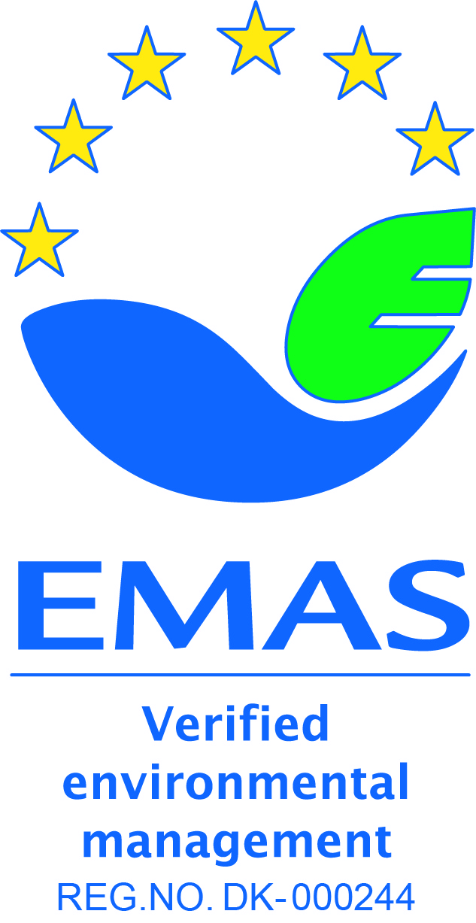

This environmental statement provides information to the general public and other interested

parties on the environmental performance and activities of the European Environment Agency (EEA)

in 2018. It can be found on the [EEA website](http://www.eea.europa.eu/about-us/emas). The EEA was first validated under the EMAS scheme in 2005[1]. This environmental statement is the seventh to be produced within the EMAS annual validation cycle. It contains updated data for 2018, which are compared with data from the previous 5 years.

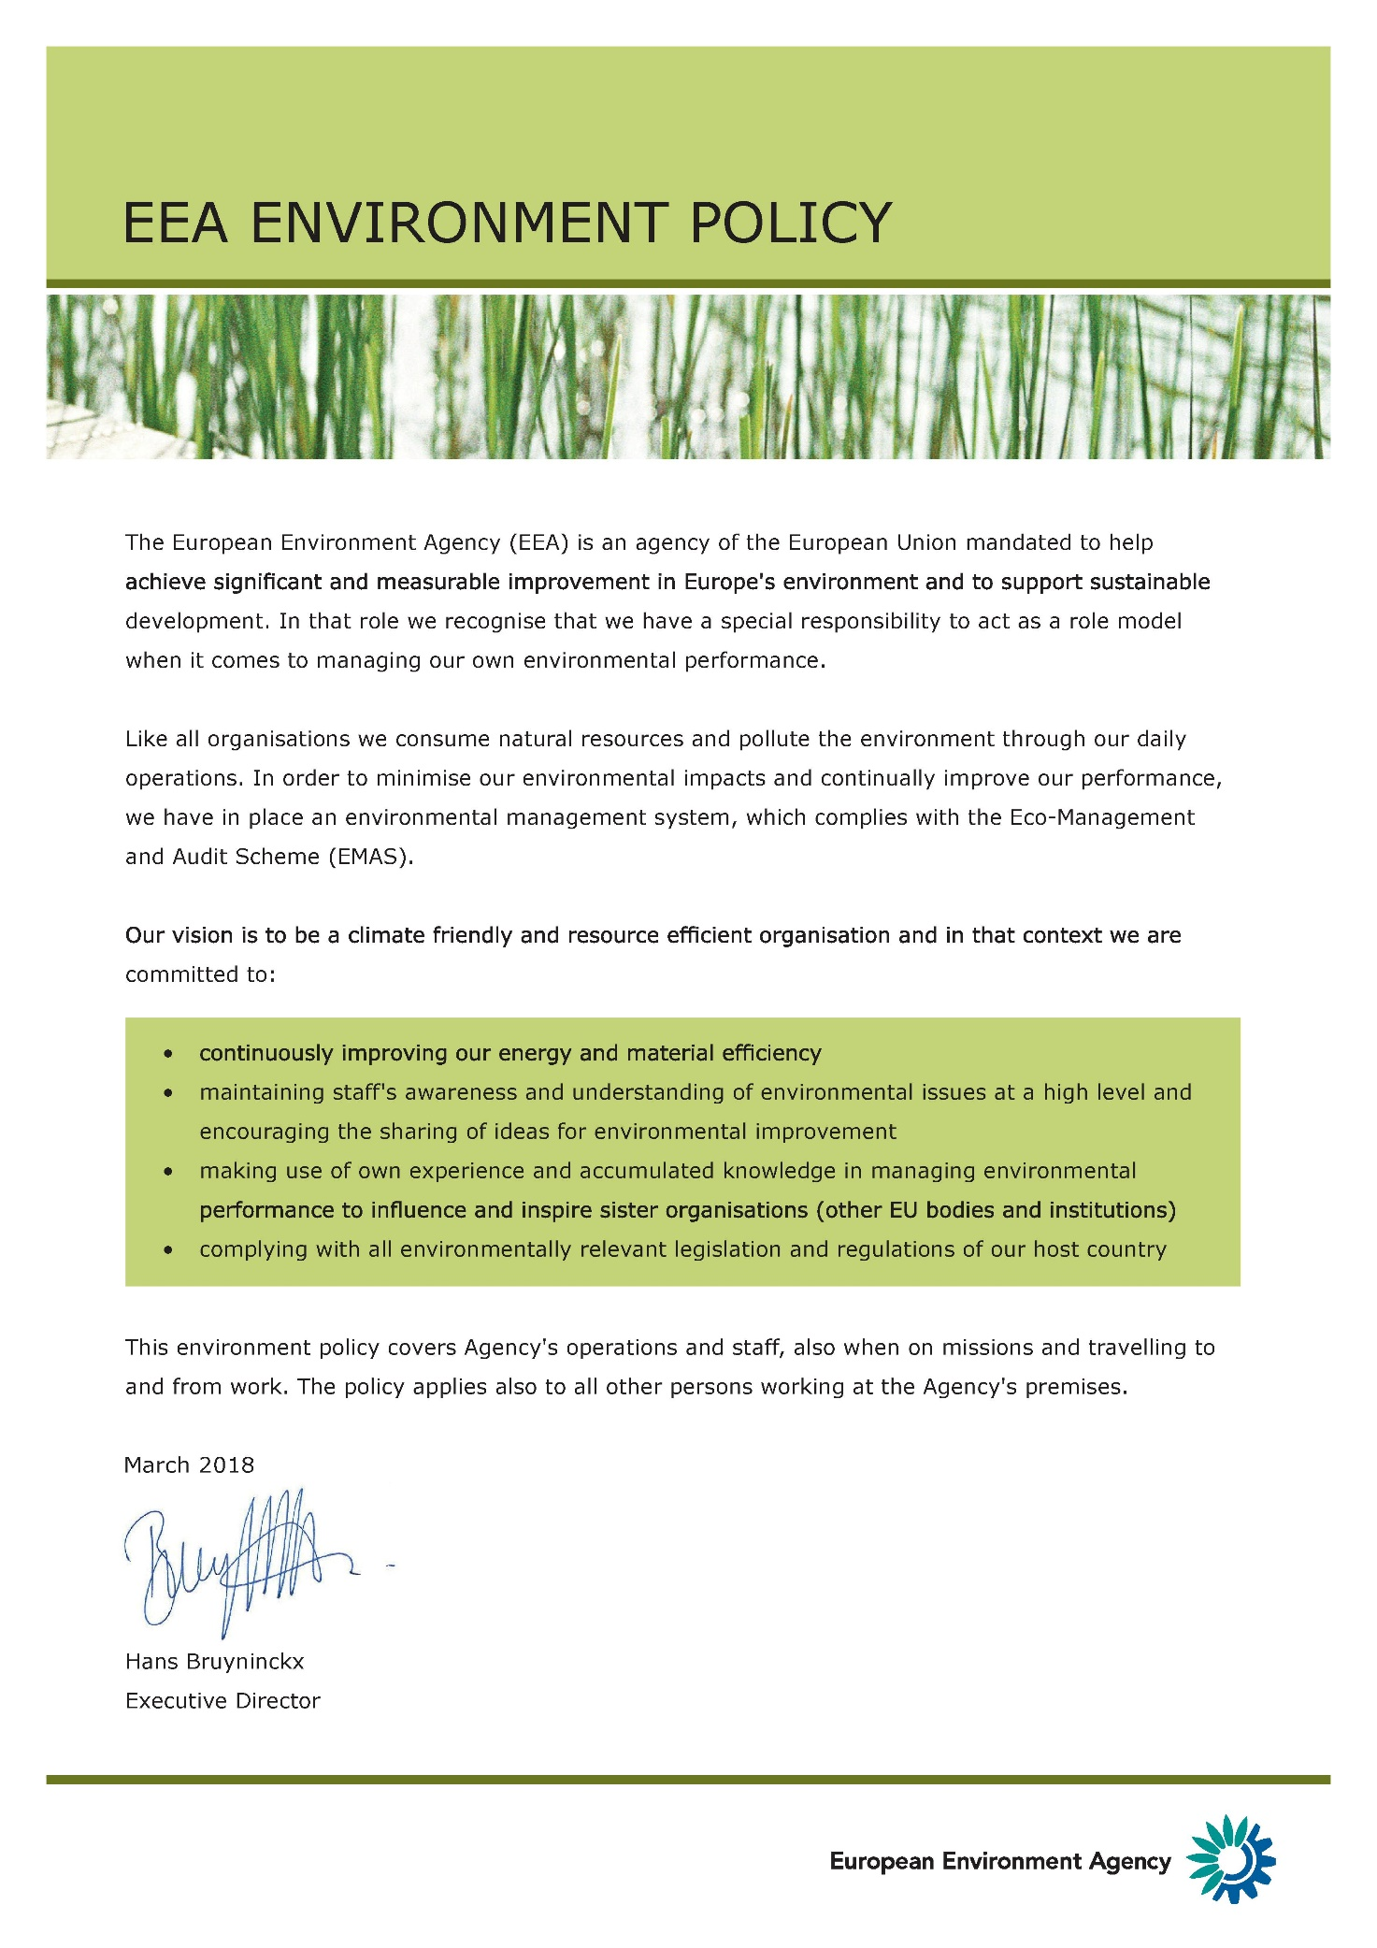

Contents

Introduction 5

Environmental management system 5

Environmental management structure 5

Environmental impacts of EEA activities 5

Environmental performance at the EEA in 2018 6

Raising environmental awareness 6

Running the EEA offices 6

Electricity 7

Heating 8

Water 8

Paper 9

Waste 10

Carbon dioxide emissions related to travel 11

Environmental targets for 2018 with performance indicators 13

Annex A: Environmental Management Programme 2019 17

# Introduction

## Environmental management system

The European Environment Agency (EEA) uses an environmental management system, which was registered under the European Eco-Management and Audit Scheme (EMAS) in 2005. The first EMAS Regulation encompassing public and private sectors was adopted in 2001 ((EC) No 761/2001). It was subsequently updated by the revised Regulation (EC) No 2017/1505, which entered into force on 28 August 2017.

Since 2009, the EEA has published an annual environmental statement on its website.

EMAS is part of the EEA’s Quality Management System (QMS).

## Environmental management structure

The EEA’s environmental management system is an integral part of its management plan and is designed to make environmental responsibilities clear to employees. Staff members are encouraged to actively engage in projects that will lead to positive environmental impacts. New employees receive a 45-minute introduction to the EEA’s Environmental Management System (EMS) and several complementary activities exist to further inform staff about EMAS priorities.

The EMS is documented in a handbook on the EEA intranet, explaining its management and procedures.

## Environmental impacts of EEA activities

EEA activities have both direct and indirect impacts on the environment. The EEA routinely monitors its:

* use of electricity;
* energy for heating;
* water;
* paper;
* generation of waste; and
* CO2 emissions from business travel.

The EEA also regularly evaluates its activities in order to optimise and improve outputs, while limiting the use of resources and minimising negative impacts on the environment. One way to achieve this is through our procurement process which follows the green public procurement guidelines: An ‘environmental impact statement’ is written in the initial proposal for procurement and specific, robust environmental criteria and ‘environmental considerations’ appear in the tender specifications. Tenderers have to comply by these criteria and considerations to be considered for a contract. It is standard EEA practice to build environmental considerations into procurement.

## Environmental performance at the EEA in 2018

## Raising environmental awareness

The EEA also continues to assist other EU bodies raise awareness of their environmental impacts. The Inter-agency Greening Network, set up by the EEA in 2006, was formally recognised by heads of administration of EU agencies in May 2016. With more than 25 members from EU agencies, the network addresses common environmental topics, with particular focus on implementation and registration under the EMAS Regulation. The Greening Network also is involved in EU environmental governance through representation in the informal Inter-institutional Group on Environmental Management (GIME).

Internally, EMAS is part of the induction programme, during which all new employees get to know the EMAS quality standard and how the EEA applies EMAS in its own premises. In addition, as part of regular biannual internal audits, members of staff are interviewed at random about the aspects of their work that relate to EMAS. Also, the results of the annual statement are presented to staff as part of the programme meetings or management group meetings.

Finally, to encourage more sustainable consumption and efficient resource use by employees at home as well as at the workplace, regular information is provided in the weekly video loop in the canteen, which includes green tips. In 2018, the EEA swap party was organised for the third time, to encourage the exchange of private items with colleagues. Those items that did not find a new owner during the evening were donated to a Danish Charity. The event brought together about 20 colleagues and was supported by the Social Committee.

## Running the EEA offices

The environmental impact of running the EEA offices is detailed below in several time series tables for the period from 2013 to 2018.

The tables cover electricity consumption, energy equivalent for district heating, water consumption, paper consumption and waste generation. The environmental performance in these areas are defined in relation to the number of people working at the EEA and the area of the office. Furthermore the calculation of performance in terms of impacts per square metre is complicated by the fact that since 2005 some EEA staff members have been working in buildings other than the main building at KN6. Since 2010, the EEA has been renting an adjacent building (KN8). Initially two floors were rented, but since 2011, three floors have been rented. The size of the two buildings is approximately 10 000 m2 in total (7 200 m2 in KN6 and 2 800 m in KN8).

The number of people working at the EEA is expressed as full time equivalents (FTEs) and is based on the same methodology as for other administrative reporting. The FTEs are correctly adjusted down for staff working on part-time contracts. Consultants are excluded, whereas extended leave and absences are counted as full FTEs. The change of working hours from 37.5 to 40 hours took place in 2014 and has been adjusted in the methodology.[2]

|  |  |  |  |  |  |  |
| --- | --- | --- | --- | --- | --- | --- |
|  | **2013** | **2014** | **2015** | **2016** | **2017** | **2018** |
| **FTE** | 212 | 204 | 196 | 196 | 201 | 211 |

## Electricity

**Consumption of electricity 2012-2018**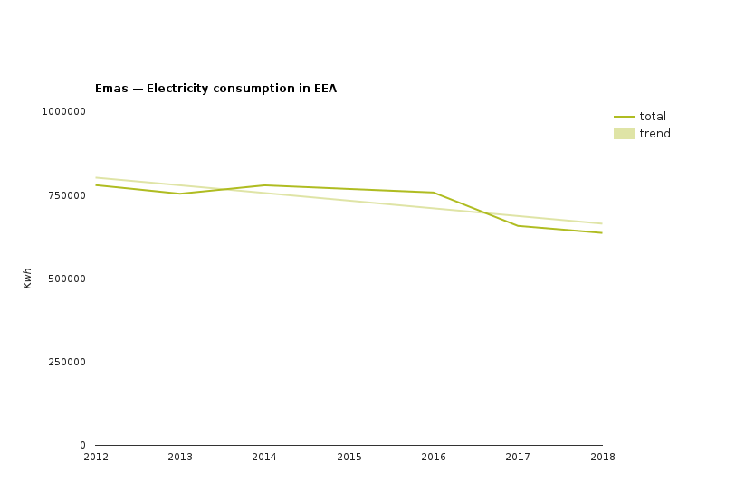

**Consumption of electricity 2013-2018**

|  |  |  |  |  |  |  |  |
| --- | --- | --- | --- | --- | --- | --- | --- |
|  | **2013** | **2014** | **2015** | **2016** | **2017** | **2018** | **Change 2013/2018** |
| Total kWh | 762 206 | 779 251 | 768 361 | 757 839 | 709 289 | 636 493 | -16% |
| kWh/FTE | 3 557 | 3 820 | 3 920 | 3 867 | 3 529 | 3 017 | -15% |

Note: 2013-2018 figures cover both buildings; Kongens Nytorv 6 and 8 (10 000 m2). kWh = kilowatt hours

The EEA is part of the Copenhagen Municipality, which is committed under its Climate Plan 2025 to be CO2 neutral by 2025. There has been a reduction of CO2 emissions by 42% since 2005 partly as a result of the transition to energy production from biomass and wind. The current energy provider delivers more than 70% of the power from renewables, mainly wind energy.

In addition, for the last 15 years the EEA bought electricity from renewable sources (wind energy) through the renewable energy certificate system (RECS). Since 2018, the expected annual electricity consumption of 734 MWh was invoiced on the actual monthly consumption rather than an annual fixed invoice. As such the Agency is saving costs.

for 2018, which corresponds to the EEA’s expected annual electricity consumption, was purchased in the form of a RECS certificate. Thus our energy is 100% sourced from renewables.

The consumption of electricity can be broadly divided into two approximately equal parts: (1) the electricity needed for central computing (i.e. servers) and data storage (including the electricity used to cool the server room); and (2) the staff-related use of electricity in offices and meeting rooms. The main server room is located in KN6 on the third floor.

The continuous reduction in consumption also accounts for cost savings of around 34.000 EUR per year (2013 vs 2018). The installation of more energy efficient computing, multi- functional devices and new light sensors in corridors with energy efficient LED lights, as well as higher environmental awareness among staff, have led to positive results.

## Heating

**Consumption of heating energy 2013-2018**

|  |  |  |  |  |  |  |
| --- | --- | --- | --- | --- | --- | --- |
|  | **2013** |  | **2015** |  |  |  |
| **2014** | **2016** | **2017** | **2018** |
|  |  |  |  |
| **m3** | 937 |  | 989 |  |  |  |
| 845 | 1 035 | 991* |  |
|  |  |  |  |
| **MW** | - | - | - | - | 204 | 695 |
| **m³/FTE** | 4.15 | 4.00 | 5.12 | 5.28 | 5.08 |  |
| 3.29 |

Note: For all years, the figures cover KN6 (7 200 m2) only.

The local provider of heating HOFOR switched from steam to water-based heating in 2017. Thus the reporting is now in megawatts (MW). The 2017 data therefore only accounts for period September through December. The consumption reflects both heating of building and warm water consumption. By 2021, all households in Copenhagen City will be supplied with water-based district heating, which is more energy efficient and will prevent loss of water in the district heating grid.

## Water

**Consumption of water 2013-2018**

|  |  |  |  |  |  |  |  |
| --- | --- | --- | --- | --- | --- | --- | --- |
|  | **2013** | **2014** | **2015** | **2016** | **2017** | **2018** | **Change 2013/2018** |
| m3 | 2 326 | 1 787 | 1 609 | 1 423 | 1 537 | 1 570 | -33% |
| m3/FTE | 11.2 | 8.9 | 8.4 | 7.4 | 7.7 | 7.4 | -34% |
| l/m2 | 237 | 182 | 165 | 145 | 154 | 157 |  |

Note: For all years, the figures cover KN6 (7 200 m2) only. The FTE includes all staff, but since 2010, an increasing number of staff have been located in KN8. No water consumption data for KN8 is available as included in the rent as an aconto.

The EEA’s consumption of water has decreased since 2013. This was achieved through a combination of measures, including the replacement of leaking WCs, a general lower consumption by staff and optimising canteen operations.

## Paper

**Consumption of paper 2013-2018**

|  |  |  |  |  |  |  |  |
| --- | --- | --- | --- | --- | --- | --- | --- |
|  | **2013** | **2014** | **2015** | **2016** | **2017** | **2018** | **Change from**  **2013 to 2018** |
| **No of sheets printed in-house** | 1 327 381 | 1 188 345 | 1 163 454 | 1 205 155 | 1 061 160 | 1 034132 | - 22% |
| **In-house sheets per FTE** | 6261 | 5825 | 5936 | 6148 | 5279 | 4901 | -22% |
| **No of pages in published reports (a)** | 12 651 000 | 4 901 400 | 15 493 000 (b) | 5 632 464 | 2 003 436 | 1 960 000 | - 15% to 2017 |

**Notes:**

(a) Sum of word pages for report printing.

(b) The SOER alone was responsible for more than 11 000 000 printed pages

Compared to 2013, a stable reduction in the paper use in-house has been achieved both in absolute figures and per FTE. One of the contributing factors is the ongoing improvement from the installation of new multi- functional devices (MFDs) in November 2017 and the implementation of the ‘follow-me’ or uniflow printing system; print jobs are triggered by swiping the access card through a reader on the closest MFD. This system not only ensures confidentiality but also avoids double printing and results in less printing in general. From 36 machines, the new fleet numbers was reduced to just 15 MFDs today. These are more energy efficient and boast low air and noise pollution[3] levels. They are both TEC3 and Blue Angel certified[4].

## Waste

**Collection of waste (kg) 2013-2018**

|  |  |  |  |  |  |  |  |
| --- | --- | --- | --- | --- | --- | --- | --- |
|  | **2013** |  | **2015** |  |  | **2018** | **Change 2013/2018** |
| **2014** | **2016** | **2017** |
|  |  |  |
| **Household** | 25 910 |  | 18 050 |  |  | 14 445 | -44% |
| 23 995 | 17 865 | 15 475 |
|  |  |  |
| **Cardboard** | 2 055 |  | 2 215 |  |  | 1 958 | -5% |
| 2 400 | 3 620 | 1 535 |
|  |  |  |
| **Paper** | 3 255 |  | 5 583 |  |  | 5 162 | 59% |
| 10 865 | 6 390 | 6 370 |
|  |  |  |
| **Organic** | No data(a) | No data | No data | No data | 1 870(b) | 7 197 | - |
| **Electronic** | 1 306 |  | 1 290 |  |  | 860 | -34% |
| 2 046 | 1 273 | 2 620 |
|  |  |  |
| **Glass** | 600 |  | 600 |  |  | 856 | 43% |
| 200 | 400 | 680 |
|  |  |  |
| **Plastic** | - | - | - | - | - | 778(c) |  |
| **Metal** | - | - | - | - | - | *216(d)* |  |
| **Total** | 33 126 | 39 506 | 27 738 | 29 548 | 28 550 | 31 256 | -6% |

**Notes:**

1. The weighing of organic waste suspended due to no available scale by the contract provider.
2. The weighing of organic waste was re-established since September 2017 due to a new contractor.
3. The weighing of plastic waste was added to the reporting. Data is for the full year.
4. Newly added fraction for reporting. Not included in total as not a full year.

Compared with 2013 data, a significant reduction in household and cardboard waste was achieved in 2018.

Furthermore the paper consumption was reduced by 19% from 2017 when in November the new multi-functional devices were introduced with follow-me printing.

In addition, the overall waste production fell by 6% compared with 2013. Even though we added plastic waste and organic waste in the reporting, we still achieved an overall reduction of waste.

## Carbon dioxide emissions related to travel

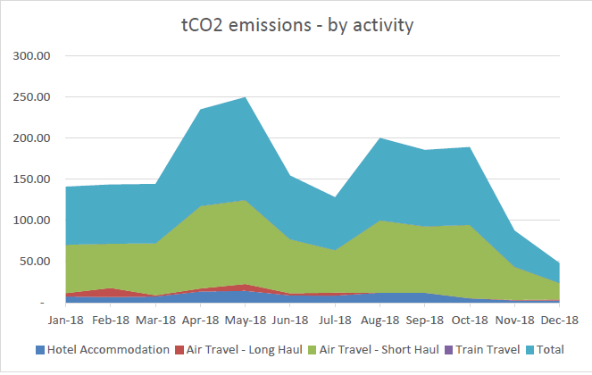

Source: co2balance.com, EEA report 2018

**CO2 emissions (tonnes) 2014–2018**

|  |  |  |  |  |  |  |  |
| --- | --- | --- | --- | --- | --- | --- | --- |
|  | **2014 with RFI**(a) | **2015** | **2016** | **2017** |  |  |  |
| **2018** | **Change from 2014 to 2018** | **2018 Offset charge** |
|  |  |  |
| **Km travelled for missions and meeting** | 4 792 419 | 5 142 336 | 4 910 521 | 5 477 770 | 5 022 534 | 5 % |  |
| **Emissions from meeting participants** | n/a | 552 | 560 | 569 | 550 | n/a |  |
| **Total emissions for staff and meeting participants** | 923 | 982 | 938 | 1 035 | 954 | 3 % | 14 451 EUR |

**Notes:**

1. In 2014 the calculation method was changed to include the radiative forcing index. This method uses a multiplier of 1.9, which accounts for other greenhouse gases, such as nitrogen oxides (NOx) and water vapour, and is added to the emissions factor to take into account the effects of greenhouse gas emissions at high altitude caused by aviation. The EEA chose to begin applying this index in 2014.

Emissions related to business travel have been reported since 2006. During this year, a carbon-offsetting scheme was introduced and the EEA became well known for limiting the carbon footprint of its business travel. The carbon-offsetting scheme is managed by the EEA’s travel agent Business Travel Specialist, and the offsets are used to support Gold Standard energy efficiency projects in Africa[5]. Every quarter, diplomas are issued to confirm the offsetting of emissions. As a reference a return flight CPH- BRU emits 257 kg CO2e.

A train ride between Copenhagen and Stockholm and return emits only 17 kg CO2e. The EEA encourages staff to use train transportation where convenient connections are available, such as Stockholm.

| Environmental targets for 2018 with performance indicators | | |  |  |  |
| --- | --- | --- | --- | --- | --- |
| **Environmental issue** | **Source of impact** | **Action plan** | **Performance indicator** | **Performance in 2017/2018** | **Change on target** |
| **1. Electricity consumption** | 1. Central computing and data storage by servers | Introducing more energy efficient servers and related technology. | Zero growth for 2016-2018 (based on the average for 2011-2013). | 2011-13: 254 904 kWh  2016-18: 229 788 kWh | Yes, -10% |
|  |
| 2. Cooling in server room | Ensuring optimal temperature at all times. | Zero growth for 2016–2018 (based on the average for 2011-2013). | 2011-13: 91 232 kWh  2016-18: 57 643 kWh | Yes, -37,8% |
| 3. ‘Staff-related’ use of electricity in offices and meeting rooms (personal computers, printers, copy machines, lights, etc.) | Increasing awareness among staff. | Zero growth for 2016-2018 (based on the average for 2011-2013) per FTE. | 2011-13: 414 613 kWh  2016-18: 433 602 kWh  2011-2013: 2025 kWh/FTE  2016- 18: 2136 kWh/FTE | + 4,6% |
| + 5% |

|  |  |  |  |  |  |
| --- | --- | --- | --- | --- | --- |
|  |  |  |  |  |  |
| **Environmental issue** | **Source of impact** | **Action plan** | **Performance indicator** | **Performance in 2018** | **Change in** |
| **2. Paper consumption** | 4. Printing documents and emails | Raising awareness about printing habits. | 3 % reduction (base year 2013) in absolute and per FTE figures. | 2013: 1 327 381 (A4)  2013: 5 876 (A4)/FTE  2018: 1 034 132 (A4)  2018: 4 901 (A4)/FTE | - 22% YES |
| -17% YES |
| 5. Printing publications externally | Reducing the number of paper publications through more targeted dissemination and electronic publishing. | Zero growth for 2016-2018 (base year 2013).  Note: report production, including a streamlined workflow, was included in the management plan system. The workflow foresees SMT approval if a report is to be printed or published electronically. | 2013: 12 651 000 (A4)  2016-18: 3 198 633 (A4) | YES |
| **3. Sustainable resource use** | 6. Electricity, paper, heat and water consumption | Devise suitable campaigns throughout the year aimed at achieving measurable reductions. | Reporting on the results. | See ´Raising environmental awareness’ |  |
| **4. Waste production** | 7. Elimination of unnecessary waste, such as the use of plastic bags in office bins | Devise a suitable campaign and identify actions to reduce waste. | Reporting on the results (Base year 2013 with 212 FTE). | 2013: 33 126kg  2013: 156 per FTE  2018: 31 256 kg total waste  2018: 148 kg per FTE | -6% (kg)  -6% (FTE) |
| **5. Greenhouse gas emissions** | 8. Business travel (staff and meetings participants) | Use videoconferencing and Skype conferencing if possible, including for meetings with ETCs, except for one meeting annually. | tCO2e: 3 % reduction (base year 2014)  Radiative forcing index (RFI) included since 2014. | 2014: 923 tCO2e*  2014: 5t/FTE  2018: 954 tCO2e  2018: 5 t/FTE | +3% |
| 9. External participants coming to EEA-organised meetings | Use videoconferencing and Skype conferencing if applicable. | Zero growth in tCO2e (base year 2015) since introduction of RFI. | 2015: 552 tCO2e  2017: 569 tCO2e  2018: 550 tCO2e | +0,4% |
| **6. Various negative environmental impacts of the EEA** | 10. All procurement | Calls for tender must include environmental criteria according to the type of goods purchased. All purchases are carried out against best-available environmental criteria. | New EU directives requiring new certifications are taken into account. | Fully implemented |  |
| **7. Various positive environmental impacts of the EEA — awareness raising** | 11. Green communication/awareness-raising activities | Continue developing and implementing an integrated approach to awareness raising. | Reporting on results. | Internal communication activities carried out   1. SMT EMAS management review carried out in March 2018 2. Another EEA swap party was successfully organised with colleagues in November 3. Communication campaign for new waste sorting project was successfully carried out   External relations include membership of the Greening Network of EU Agencies (formalised under the Heads of Agencies Network) and the informal inter-institutional Group on Environmental Management (GIME) in Brussels. |  |
| **8. Environmental, economic and social impacts** | 12. All EEA activities | Integration of EMAS and health and safety issues (reference EU standards, OHSAS 18001 standard) into a Total Quality and Environmental Management System (TQMS). | Reporting on the results. | With the combined function for EMAS and staff wellbeing, the tensions between staff needs and environmental sound behaviour become more evident (e.g. office climate and equipment, cleaning issues, space allocation). |  |
| **9. Internal environment** | 13. Environment in buildings | Improving insulation of window frames and doors. | Communication of the results of the projects. | No real progress as this would require the replacement of windows |  |

* tCO2e = tonnes of CO2 equivalent

# Annex A: Environmental Management Programme 2019

|  |  |  |  |
| --- | --- | --- | --- |
|  | | |  |
| **Environmental issue** | **Source of impact** | **Action plan** | **Performance indicator** |
| **1. Electricity consumption** | 1. Central computing and data storage by servers | Introducing more energy efficient technology. | Zero growth for 2019 (based on the 5 year rolling average for 2014-2019) |
| 2. Cooling in server room | Installing an amperometric clamp to monitor consumption (no meter since July 2015). | Zero growth for 2019 (based on the 5 year rolling average for 2014-2019) |
| 3. ‘Staff-related’ use of electricity in offices and meeting rooms (PCs, printers, copy machines, faxes, lights etc.) | Consider the IT- set-up per working station to have laptop and docking station, no extra PC.  Removal of fixed telephones. | Zero growth for 2019 (based on the 5 year rolling average for 2014-2019) per FTE |
| **2. Paper consumption** | 4. Printing documents and emails | Raising awareness to move more towards paperless office, e.g. further digitalisation of administrative workflows. | 10 % reduction (based on the rolling 5 year average for 2014-2019) in absolute and per FTE figures |
| 5. Printing publications externally | Continue to reduce the number of paper publications through close management of publication plan as well as through more print on demand and web publishing. | 5 % reduction (based on average for 2014-2019) |
| **3. Sustainable resource use** | 6. Electricity, paper, heat and water consumption | Complete the installation of light sensors in all public areas.  Optimising existing LED system and electrical equipment (e.g. sleep mode) throughout the year aimed at achieving measurable reductions. | Reporting on the results |
| **4. Waste production** | 7. Waste sorting and reduction | Follow-up on waste sorting project to ensure proper information and training for cleaning staff. | 5% reduction of total waste for 2019 (based on the rolling 5 year average for 2014-2019) per FTE |
| **5. Greenhouse gas emissions** | 8. Business travel of staff | Introduce selection criteria (tCO2e of flight) in the booking phase of missions to allow a conscious choice.  Replacing missions with virtual meetings whenever possible. | Zero growth of tCO2 e for 2019 (based on the 5 year rolling average for 2014-2019) |
| 9. External participants coming to EEA-organised meetings by plane | Using videoconferencing/Skype conferencing when applicable. | Zero growth of tCO2 e for 2019 (based on the 5 year rolling average for 2014-2019) |
| **6. Various negative environmental impacts of the EEA** | 11. All procurement | Calls for tender of relevant services must include environmental criteria according to the type of goods purchased. All purchases are carried out against best available environmental criteria. | All procurement aligned to EU directives. |
| **7. Various positive environmental impacts of EEA awareness raising** | 12. Green communication/awareness-raising activities | Continuing development and implementation of an integrated approach to awareness raising. | Reporting on results. |
| **8. Environmental economic and social impacts** | 13. All EEA activities | Using synergies between EMAS and staff health and well-being aspects (e.g. reduce meat consumption, exercise) | Reporting on the results. |
| **9. Internal environment** | 14. Environment in buildings/health and safety aspects | Involve the EMAS and staff well-being coordinator in the office space optimisation projects. | Reporting on the results. |

1. Bureau Veritas is the verifier of this statement, dated 16/05/2019 and registered under DANAK DK- 6002
2. Methodology was aligned for 2018 with the reporting in the Programming Document.
3. *The machines consume approximately 408WH in printing mode (2WH in sleep mode). The building parts are from low-pollutant materials thus reducing possible harm to the environment and health risks. Noise level of sound pressure 4,7dB and sound power level in active mode is approx. 64dB.*
4. *TEC= Typical Energy Consumption standard, 1.3 kWh/week. The models meets the energy requirements of the program Energy Start version 2.0, 1; Blue Angel is the ecolabel for special environmental friendliness in terms of energy efficiency, low on emissions*.
5. http://www.co2balance.com