EEALogo

**EMAS Environmental statement 2017**

Final

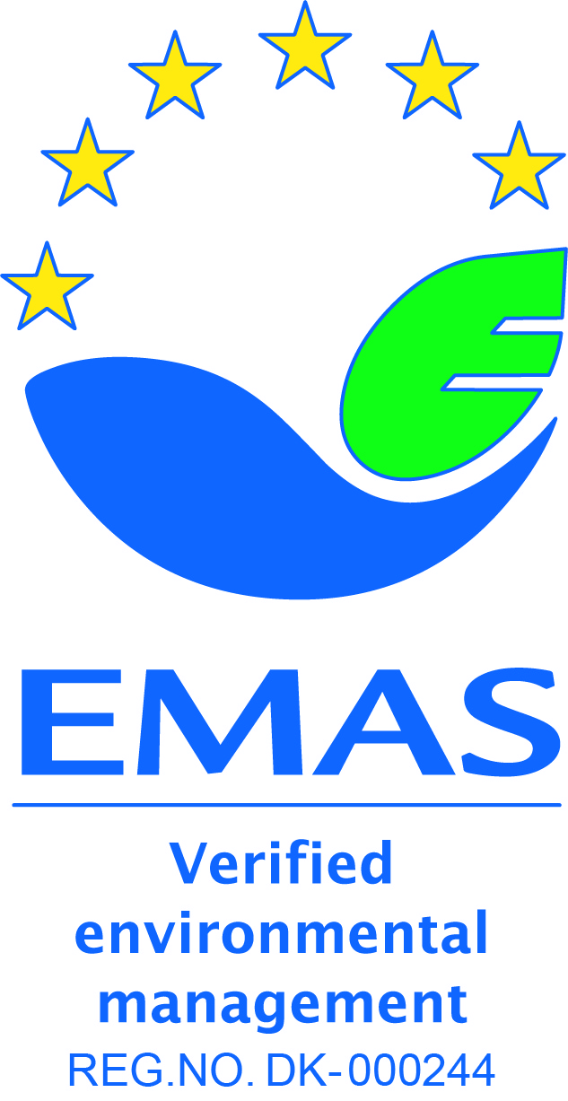

This environmental statement provides information to the general public and other interested

parties on the environmental performance and activities of the European Environment Agency (EEA)

in 2017. It can be found on the [EEA website](http://www.eea.europa.eu/about-us/emas). The EEA was first validated under the EMAS scheme in 2005[1]. This environmental statement is the seventh to be produced within the EMAS annual validation cycle. It contains updated data for 2017, which are compared with data from the previous 5 years.

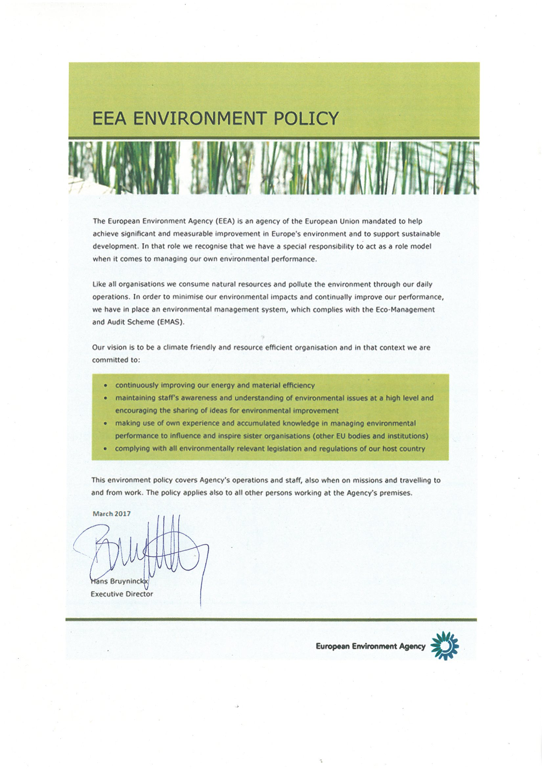

Contents

Introduction 5

Environmental management system 5

Environmental management structure 5

Environmental impacts of EEA activities 5

Environmental performance at the EEA in 2017 6

Raising environmental awareness 6

Running the EEA offices 6

Electricity 7

Heating 8

Water 8

Paper 9

Waste 10

Carbon dioxide emissions related to travel 11

Environmental targets for 2017 with performance indicators 12

Annex A: Environmental Management Programme 2018 16

# Introduction

## Environmental management system

The European Environment Agency (EEA) uses an environmental management system, which was registered under the European Eco-Management and Audit Scheme (EMAS) in 2005. The first EMAS Regulation encompassing public and private sectors was adopted in 2001 ((EC) No 761/2001). It was subsequently updated by the revised Regulation (EC) No 2017/1505, which entered into force on 28 August 2017.

Since 2009, the EEA has published an annual environmental statement on its website. Since 2016, this statement has also been included in the Consolidated Annual Activity Report (CAAR).

EMAS is part of the EEA’s Quality Management System (QMS).

## Environmental management structure

The EEA’s environmental management system is an integral part of its management plan and is designed to make environmental responsibilities clear to employees. Staff members are encouraged to actively engage in projects that will lead to positive environmental impacts. New employees receive a 45-minute introduction to the EEA’s Environmental Management System (EMS) and several complementary activities exist to further inform staff about EMAS priorities.

The EMS is documented in a handbook on the EEA intranet, explaining its management and procedures.

## Environmental impacts of EEA activities

EEA activities have both direct and indirect impacts on the environment. The EEA routinely monitors its:

* use of electricity;
* energy for heating;
* water;
* paper;
* generation of waste; and
* CO2 emissions from business travel.

The EEA also regularly evaluates its activities in order to optimise and improve outputs, while limiting the use of resources and minimising negative impacts on the environment. One way to achieve this is through our procurement process which follows the green public procurement guidelines: An ‘environmental impact statement’ in written in the initial proposal for procurement and specific, robust environmental criteria and ‘environmental considerations’ appear in the tender specifications. Tenderers have to comply by these criteria and considerations to be considered for a contract. It is standard EEA practice to build environmental considerations into procurement.

## Environmental performance at the EEA in 2017

## Raising environmental awareness

In 2017, the EEA Executive Director chaired the EMAS award jury and participated in the award ceremony at the Sustainable Tourism conference in Malta, addressing the audience on the topic of sustainable tourism in Europe.

The EEA also continues to assist other EU bodies raise awareness of their environmental impacts. The Inter-agency Greening Network, set up by the EEA in 2006, was formally recognised by heads of administration of EU agencies in May 2016. With more than 25 members from EU agencies, the network addresses common environmental topics, with particular focus on implementation and registration under the EMAS Regulation. The Greening Network also is involved in EU environmental governance through representation in the informal Inter-institutional Group on Environmental Management (GIME).

Internally, EMAS is part of the induction programme, during which all new employees get to know the EMAS quality standard and how the EEA applies EMAS in its own environmental. In addition, as part of regular biannual internal audits, members of staff are interviewed at random about the aspects of their work that relate to EMAS. Also, the results of the annual statement are presented to staff as part of the programme meetings or management group meetings.

Finally, to encourage more sustainable consumption and efficient resource use by employees at home as well as at the workplace, regular information is provided in the weekly video loop in the canteen, which includes green tips. In 2017, the EEA swap party was organised for the third time, to encourage the exchange of private items with colleagues. Those items that did not find a new owner during the evening were donated to a Danish Charity. The event brought together about 20 colleagues and was supported by the Social Committee.

## Running the EEA offices

The environmental impact of running the EEA offices is detailed below in several time series tables for the period from 2012 to 2017.

The tables cover electricity consumption, energy equivalent for district heating, water consumption, paper consumption and waste generation. The environmental performance in these areas is defined in relation to the number of people working at the EEA and the area of the office.

The number of people working at the EEA is expressed as full time equivalents (FTEs) and is derived from the time recording system that both staff and in-house consultants use. It is based on a 40-hour working week. The change of working hours from 37.5 to 40 hours took place in 2014.[2]

|  |  |  |  |  |  |  |
| --- | --- | --- | --- | --- | --- | --- |
|  | **2012** | **2013** | **2014** | **2015** | **2016** | **2017** |
| **FTE** | 235 | 226 | 211 | 193 | 196 | 195 |

## Electricity

**Consumption of electricity 2012-2017**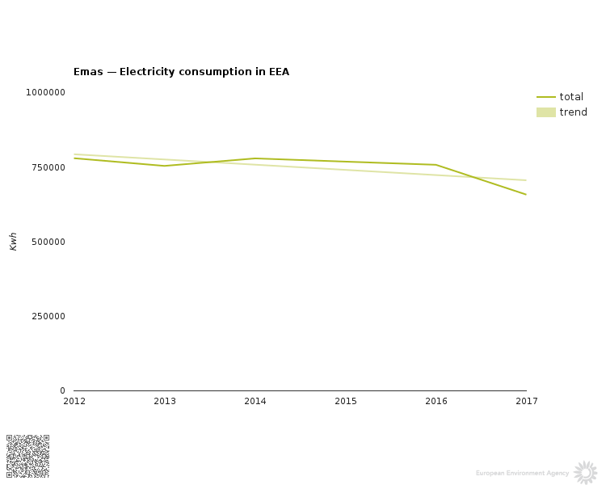

**Consumption of electricity 2012-2017**

|  |  |  |  |  |  |  |  |
| --- | --- | --- | --- | --- | --- | --- | --- |
|  | **2012** | **2013** | **2014** | **2015** | **2016** | **2017** | **Change 2012/2017** |
| **Total kWh** | 779 851 | 762 206 | 779 251 | 768 361 | 757 839 | 709 289 | -9% |
| **kWh/FTE** | 3 321 | 3 374 | 3 693 | 3 981 | 3 867 | 3 637 | 10% |
| **kWh /m2** | 78 | 76 | 78 | 77 | 76 | 71 | -9% |

Note: 2012-2017 figures cover both buildings; Kongens Nytorv 6 and 8 (10 000 m2).

kWh = kilowatt hours

The consumption of electricity can be broadly divided into two approximately equal parts: (1) the electricity needed for central computing (i.e. servers) and data storage (including the electricity used to cool the server room); and (2) the staff-related use of electricity in offices and meeting rooms. The main server room is located in KN6 on the third floor.

As gathering, managing and disseminating environmental data is one of the main objectives of the EEA, the reduction of the overall use of electricity is not a goal per se. This has led to an increase in overall electricity use and use per FTE. However, the installation of more energy efficient computing, new light sensors in corridors and a switch to energy efficient LED lights, as well as higher environmental awareness among staff, have kept the results within range.

A specific improvement was achieved by replacing the server cooling system in July 2015 (third floor, KN6). The new system uses the outside temperature to regulate the cooling system and optimises the energy consumption. Furthermore, in 2017, the EEA bought electricity from renewable sources (wind energy) through the renewable energy certificate system (RECS). The agreed quantity of 770 MWh, which corresponds to the EEA’s expected annual electricity consumption, was purchased in the form of a RECS certificate.

## Heating

**Consumption of heating energy 2013-2017**

|  |  |  |  |  |  |
| --- | --- | --- | --- | --- | --- |
|  | **2013** |  | **2015** |  |  |
| **2014** | **2016** | **2017** |
|  |  |  |
| **m3** | 937 |  | 989 |  |  |
| 845 | 1 035 | 991* |
|  |  |  |
| **m³/FTE** | 4.15 | 4.00 | 5.12 | 5.28 | 5.08 |
|

*Note: The local provider of heating HOFOR switched from steam to water-based heating in 2017. As of 2018, the reporting of heating will be in megawatts (MW). By 2021, all households in Copenhagen City will be supplied with water-based district heating, which is more energy efficient and will prevent loss of water in the district heating grid.

## Water

**Consumption of water 2012-2017**

|  |  |  |  |  |  |  |  |
| --- | --- | --- | --- | --- | --- | --- | --- |
|  | **2012** | **2013** | **2014** | **2015** | **2016** | **2017** | **Change**  **2012/2017** |
| **m3** | 1 827 | 2 326 | 1 787 | 1 609 | 1 423 | 1 537 | -16% |
| **m3/FTE** | 8 | 10 | 8,5 | 8 | 7,3 | 7,9 | - |
| **l/m2** | 254 | 323 | 248 | 223 | 198 | 213.5 | - |

Note: For all years, the figures cover KN6 (7 200 m2) only. The FTE includes all staff, but since 2010, an increasing number of staff have been located in KN8. Currently 53 people are in Kongens Nytorv 8 (March, 2017).

The EEA’s consumption of water has decreased significantly over recent years, due to the replacement of leaking WCs, optimising canteen operations and a general lower consumption by staff.

## Paper

**Consumption of paper 2013-2017**

|  |  |  |  |  |  |  |
| --- | --- | --- | --- | --- | --- | --- |
|  | **2013** | **2014** | **2015** | **2016** | **2017** | **Change from**  **2013 to 2017** |
| **No of sheets printed in-house** | 1 327 381 | 1 188 345 | 1 163 454 | 1 205 155 | 1 061 160 | -20% |
| **In-house sheets per FTE** | 5 876 | 5 632 | 6028 | 6149 | 5442 | -7% |
| **No of pages in published reports (a)** | 12 651 000 | 4 901 400 | 15 493 000 (b) | 5 632 464 | 2 003 436 | -84,16% |

**Notes:**

(a) Sum of pages per report print run.

(b) The SOER alone was responsible for more than 11 000 000 printed pages

In 2017, a significant improvement in the reduction in the paper used to print EEA publications externally can be noted. In line with its Communication Strategy to move from paper to web, the EEA is moving towards greater electronic dissemination of publications. Since 2014, this objective has considerably improved environmental performance by reducing paper consumption.

Another improvement project was successfully implemented to optimise and reduce paper and energy consumption through purchase of new multi- functional devices (MFDs) in November 2017., Such devices use the ‘follow-me’ or uniflow printing system; print jobs are triggered by swiping the access card through a reader on the closest MFD. This system not only ensures confidentiality but also avoids double printing and results in less printing in general. From 36 machines, the new fleet numbers just 15 MFDs today. These are more energy efficient and boast low air and noise pollution[3] levels. They are both TEC3 and Blue Angel certified[4].

## Waste

**Generation of waste (kg) 2012-2017**

|  |  |  |  |  |  |  |  |
| --- | --- | --- | --- | --- | --- | --- | --- |
|  | **2012** | **2013** |  | **2015** |  |  | **Change 2012/2017** |
| **2014** | **2016** | **2017** |
|  |  |  |
| **Household** | 21 095 | 25 910 |  | 18 050 |  |  | -27% |
| 23 995 | 17 865 | 15 475 |
|  |  |  |
| **Cardboard** | 2 210 | 2 055 |  | 2 215 |  |  | -31% |
| 2 400 | 3 620 | 1 535 |
|  |  |  |
| **Paper** | 5 410 | 3 255 |  | 5 583 |  |  | +18% |
| 10 865 | 6 390 | 6 370 |
|  |  |  |
|  | No data (b) | No data | No data | No data | No data | 1 870( c) | - |
| **Organic** |
| **Electronic** | 1 237 | 1 306 |  | 1 290 |  |  | +112% |
| 2 046 | 1 273 | 2 620 |
|  |  |  |
| **Glass** | No data (a) | 600 |  | 600 |  |  | +13% |
| 200 | 400 | 680 |
|  |  |  |
| **Total** | 29 573 | 33 126 |  | 27 738 |  |  | -3% |
| 39 506 | 29 548 | 28 550 |
|  |  |  |
| **Total/FTE** | 126 | 147 |  | 144 |  |  | +16% |
| 187 | 151 | 146 |
|  |  |  |

***Notes:***

1. The weighing of glass was suspended in 2012 because of collector-related logistics.
2. The weighing of organic waste suspended due to no available scale by the contract provider.
3. The weighing of organic waste was re-established since September 2017 due to a new contractor.

Compared with 2012 data, a significant reduction in household and cardboard waste was achieved in 2017.

The increase in e-waste is due to the replacement of copy machines and servers in 2017.

In addition, the overall waste production fell by 8 % compared with 2012, which is quite a positive result to report.

## Carbon dioxide emissions related to travel

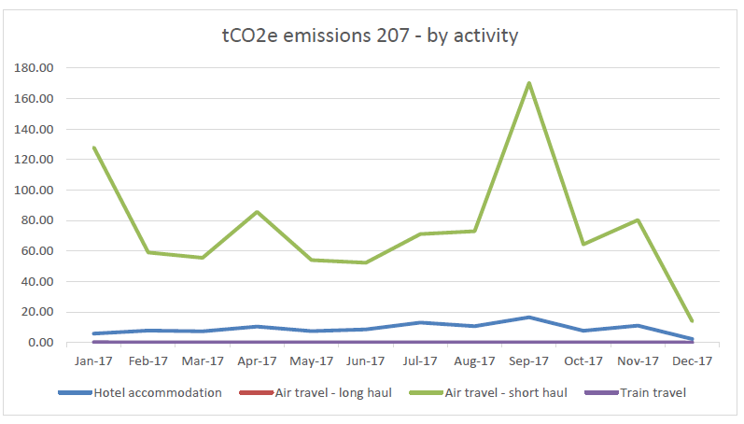

**CO2 emissions (tonnes) 2013–2017**

|  |  |  |  |  |  |  |  |  |
| --- | --- | --- | --- | --- | --- | --- | --- | --- |
|  | **2013** |  | **2014 with RFI** | **2015** | **2016** | **2017** |  |  |
| **2014 w/o RFI** | **Change from 2014 to 2017** | **2017 Offset charge** |
|  |  |  |
| **Km travelled for missions and meeting** | 5 565 610 | 4 792 419 | 4 792 419 | 5 142 336 | 4 910 521 | 5 477 770 | 14 % |  |
| **CO2 emissions related to staff missions** | 287 | 238 | n/a | 430 | 378 | 466 | n/a | 7054 EUR |
|  |
| **CO2 emissions for meeting participants** | 330 | 247 | n/a | 552 | 560 | 569 | n/a | 8623 EUR |
|  |
| **Total** | 617 | 485 | 923 | 982 | 938 | 1 035 | 12 % | 15 676 EUR |
|

**Notes:**

1. The large increase in CO2 emissions between 2014 and 2015 is due to a change in the calculation method to one based on the radiative forcing index. This method uses a multiplier of 1.9, which accounts for other greenhouse gases, such as nitrogen oxides (NOx) and water vapour, and is added to the emissions factor to take into account the effects of greenhouse gas emissions at high altitude caused by aviation. The EEA chose to begin applying this index in 2014.
2. These figures are without the radiative forcing index (RFI).

Emissions related to staff’s business travel have been reported since 2006. During this year, a carbon-offsetting scheme was introduced and the EEA became well known for limiting the carbon footprint of its business travel. The carbon-offsetting scheme is managed by the EEA’s travel agent Business Travel Specialist, and the offsets are used to support Gold Standard energy efficiency projects in Africa[5]. Every quarter, diplomas are issued to confirm the offsetting of CO2. The total km travelled for missions and meetings in 2017 was 5 477 770 km, which is 14 % more than in 2014.

| Environmental targets for 2017 with performance indicators | | |  |  |  |
| --- | --- | --- | --- | --- | --- |
| **Environmental issue** | **Source of impact** | **Action plan** | **Performance indicator** | **Performance in 2017** | **Change on target** |
| **1. Electricity consumption** | 1. Central computing and data storage by servers | Introducing more energy efficient servers and related technology. | Zero growth for 2016-2018 (based on the average for 2011-2013). | 2011-13: 254 904 kWh  2016: 271 749 kWh  2017: 224 283 kWh  2018: | -3% |
|  |
| 2. Cooling in server room | Ensuring optimal temperature at all times. | Zero growth for 2016–2018 (based on the average for 2011-2013)  NB: the 2016 figure is based on an estimated calculation using 2014 data, assuming the same staff related consumption as on the 3rd floor for 2017. | 2011-13: 91 232 kWh  2016: 59 478 kWh  2017: 65 304 kWh  2018: | -32% |
| 3. ‘Staff-related’ use of electricity in offices and meeting rooms (personal computers, printers, copy machines, lights, etc.) | Increasing awareness among staff. | Zero growth for 2016-2018 (based on the average for 2011-2013) per FTE. | 2011-13: 414 613 kWh  2016: 486 090 kWh  2017: 419 702 kWh  2018:  2011-2013: 2025 kWh/FTE  2016: 2519 kWh/FTE  2017: 2152 kWh/FTE  2018: | + 10% |
| + 24% |
|  |  |  |  |  |  |
|  |  |  |  |  |  |
| **Environmental issue** | **Source of impact** | **Action plan** | **Performance indicator** | **Performance in 2017** | **Change in** |
| **2. Paper consumption** | 4. Printing documents and emails | Raising awareness about printing habits. | 3 % reduction (base year 2013) in absolute and per FTE figures. | 2013: 1 327 381 (A4)  2013: 5 876 (A4)/FTE  2017: 1 061 160 (A4)  2017: 5442 (A4)/FTE | -20% |
| -7% |
| 5. Printing publications externally | Reducing the number of paper publications through more targeted dissemination and electronic publishing. | Zero growth for 2016-2018 (base year 2013).  Note: report production, including a streamlined workflow, was included in the management plan system. The workflow foresees SMT approval if a report is to be printed or published electronically. | 2013: 12 651 000 (A4)  2017: 2 003 436 (A4)  2018: | -84% |
| **3. Sustainable resource use** | 6. Electricity, paper, heat and water consumption | Devise suitable campaigns throughout the year aimed at achieving measurable reductions. | Reporting on the results. | See ´Raising environmental awareness’ |  |
| **4. Waste production** | 7. Elimination of unnecessary waste, such as the use of plastic bags in office bins | Devise a suitable campaign and identify actions to reduce waste. | Reporting on the results (Base year 2012 with 235 FTE). | 2012: 29 573kg  2012: 126 per FTE  2017: 27 210 kg total waste  2017: 140 kg per FTE | -8% (kg)  +11% (FTE) |
| **5. Greenhouse gas emissions** | 8. Business travel (staff and meetings participants) | Use videoconferencing and Skype conferencing if possible, including for meetings with ETCs, except for one meeting annually. | tCO2e: 3 % reduction (base year 2014)  Radiative forcing index (RFI) included since 2014. | 2014: 923 tCO2e*  2014: 4t/FTE  2017: 1035 tCO2e  2017: 5 t/FTE | +12% |
| 9. External participants coming to EEA-organised meetings | Use videoconferencing and Skype conferencing if applicable. | Zero growth in tCO2e (base year 2015) since introduction of RFI. | 2015: 552 tCO2e  2017: 569 tCO2e | +3% |
| **6. Various negative environmental impacts of the EEA** | 10. All procurement | Calls for tender must include environmental criteria according to the type of goods purchased. All purchases are carried out against best-available environmental criteria. | New EU directives requiring new certifications are taken into account. | Fully implemented |  |
| **7. Various positive environmental impacts of the EEA — awareness raising** | 11. Green communication/awareness-raising activities | Continue developing and implementing an integrated approach to awareness raising. | Reporting on results. | Internal communication activities carried out   1. SMT EMAS management review carried out in March 2017 2. A second EEA swap party was successfully organised with colleagues in November 3. Announcements regarding EMAS included posters for a call for new environmental auditors in September, a video loop in the canteen and the regular introduction of EMAS to new staff   External relations include membership of the Greening Network of EU Agencies (formalised under the Heads of Agencies Network) and the informal inter-institutional Group on Environmental Management (GIME) in Brussels. |  |
| **8. Environmental, economic and social impacts** | 12. All EEA activities | Integration of EMAS and health and safety issues (reference EU standards, OHSAS 18001 standard) into a Total Quality and Environmental Management System (TQMS). | Reporting on the results. | With the combined function for EMAS and staff wellbeing, the tension between staff needs and environmental sound behaviour becomes more evident (e.g. office climate and equipment, cleaning issues, space allocation). |  |
| **9. Internal environment** | 13. Environment in buildings | Improving insulation of window frames and doors. | Communication of the results of the projects. | No real progress as this would require the replacement of windows |  |

* tCO2e = tonnes of CO2 equivalent

# Annex A: Environmental Management Programme 2018

|  |  |  |  |
| --- | --- | --- | --- |
|  | | |  |
| **Environmental issue** | **Source of impact** | **Action plan** | **Performance indicator** |
| **1. Electricity consumption** | 1. Central computing and data storage by servers | Introducing more energy efficient technology. | Zero growth for 2016-2018 (based on the average for 2011-2013) |
| 2. Cooling in server room | Installing a separate meter to monitor consumption (no meter since July 2015). | Zero growth for 2016-2018 (based on the average for 2011-2013) |
| 3. ‘Staff-related’ use of electricity in offices and meeting rooms (PCs, printers, copy machines, faxes, lights etc.) | Increasing awareness among staff about these aspects. Bending the trend of staff related electricity consumption. | Zero growth for 2016-2018 (based on the average for 2011-2013) per FTE |
| **2. Paper consumption** | 4. Printing documents and emails | Introduction of ‘follow-me’ printing to reduce paper consumption (Ongoing project). | 3 % reduction (base year 2013) in absolute and per FTE figures |
| 5. Printing publications externally | Reducing the number of paper publications through more print on demand and web publishing as well as targeted dissemination and electronic publishing. | Zero growth for 2016-2018 (base year 2013) |
| **3. Sustainable resource use** | 6. Electricity, paper, heat and water consumption | Optimising existing LED system and electrical equipment (e.g. sleep mode) throughout the year aimed at achieving measurable reductions. | Reporting on the results, see electricity consumption ‘staff related’. |
| **4. Waste production** | 7. Elimination of unnecessary waste such as the use of plastic bags in office bins | Introducing waste separation bins for plastic, organic and paper waste in corridors or in kitchens of each floor of KN7 and KN8. | Reporting on progress |
| **5. Greenhouse gas emissions** | 8. Business travel of staff | Register the number of videoconferences and Skype conferences; where possible replace missions including meetings with ETCs, except for one meeting per year. | tCO2e: 3 % reduction (base year 2014) |
| 9. External participants coming to EEA-organised meetings by plane | Using videoconferencing/Skype conferencing when applicable. | tCO2 e zero growth (base year 2014) |
| **6. Various negative environmental impacts of the EEA** | 11. All procurement | Calls for tender of relevant services must include environmental criteria according to the type of goods purchased. All purchases are carried out against best available environmental criteria. | All procurement aligned to EU directives. |
| **7. Various positive environmental impacts of EEA awareness raising** | 12. Green communication/awareness-raising activities | Continuing development and implementation of an integrated approach to awareness raising. | Reporting on results. |
| **8. Environmental economic and social impacts** | 13. All EEA activities | Using synergies between EMAS and staff health and well-being aspects (e.g. reduce meat consumption, exercise) | Reporting on the results. |
| **9. Internal environment** | 14. Environment in buildings | Improving insulation of window frames in both buildings in cooperation with landlord. | Reporting on the results. |

1. Bureau Veritas is the verifier of this statement, dated 28/03/2018 and registered under DANAK DK- 6002
2. The calculation of performance in terms of impacts per square metre is complicated by the fact that since 2005 some EEA staff members have been working in buildings other than the main building at KN6. Since 2010, the EEA has been renting an adjacent building (KN8). Initially two floors were rented, but since 2011, three floors have been rented. The size of the two buildings is approximately 10 000 m2 in total (7 200 m2 in KN6 and 2 800 m in KN8).
3. *The machines consume approximately 408WH in printing mode (2WH in sleep mode). The building parts are from low-pollutant materials thus reducing possible harm to the environment and health risks. Noise level of sound pressure 4,7dB and sound power level in active mode is approx. 64dB.*
4. *TEC= Typical Energy Consumption standard, 1.3 kWh/week. The models meets the energy requirements of the program Energy Start version 2.0, 1; Blue Angel is the ecolabel for special environmental friendliness in terms of energy efficiency, low on emissions*.
5. http://www.co2balance.com