Installing and using Zotero at the EEA

Contents
1 Introduction and summary 3
2 Installing Zotero and accessing the EEA group library 4
3 Adding references to the EEA shared library 11
3.1 Creating a project collection 11
3.2 Checking for existing references 11
3.3 Adding a new reference 12
Manually inputting references 12
Extracting references from scientific journals online using Zotero Connector 16
Extracting references from scientific journals online using Zotero Bookmarklet 18
Extracting references using document identifier numbers 18
3.4 Editing and deleting references 19
3.5 Adding files to references 19
By drag and drop 20
Using the Zotero Connector plugin 20
4 Using Zotero in Word 22
4.1 Setting Zotero preferences in Word 22
4.2 Citations in the text 24
Adding a citation 24
Adding multiple citations within the same set of parentheses 24
Adding prefixes, suffixes and page ranges 25
Incorporating the author’s name into a sentence 26
Changing citations 26
4.3 Bibliographies 27
Adding a bibliography 27
Adding non-cited sources to a bibliography 27
Editing references in a bibliography 27
Updating citations and references after edits or deletions 27
4.4 Removing Zotero field codes 27

Introduction and summary
This is a guide to using Zotero to manage references for EEA reports. The screenshots have been created in a mixture of Mac and Windows, and the instructions are identical in either case, except where indicated.
Main points to note:
- All references for every report should be managed through Zotero and stored in the EEA shared library in the EEA group at https://www.zotero.org/groups/122386/eea.
- Do not use other citation management systems (e.g. EndNote or Mendeley).
- Do not use your own libraries or create your own groups.
- All references for each report should be grouped in a ‘collection’ for that report. This makes it easier for us to check that they are all present and correct. A ‘collection’ is a grouping of references in the library, like a playlist in iTunes. A reference can exist in more than one collection.
- Do not add a reference to the library without first checking that it is not already there. Otherwise, we end up with multiple copies of the same reference, which makes it hard to manage and maintain consistency.
- When adding a reference to Zotero, ensure that you are adding it to the EEA library and to your project collection.
- You can add reference citations to your report in Word using the Zotero plugin for Word, which is automatically installed with Zotero.
- Before starting to add citations in Word, make sure that you have selected the ‘EEA’ style in Zotero Document Preferences.
- Do not attempt to edit citations from within Word. Instead, make any changes you need (e.g. correcting the title or an author name, or adding a page range after the date) from within the Zotero app, and then use the ‘refresh’ button in Word to update the document to reflect the changes you have made. This is to ensure that the references remain linked to the library, where our editors can make changes to ensure that the references correctly reflect EEA style.

Installing Zotero and accessing the EEA group library
- Install Zotero: Open your browser and go to Zotero.org. Click on the red ‘download now’ button (on the right in the image below).
- 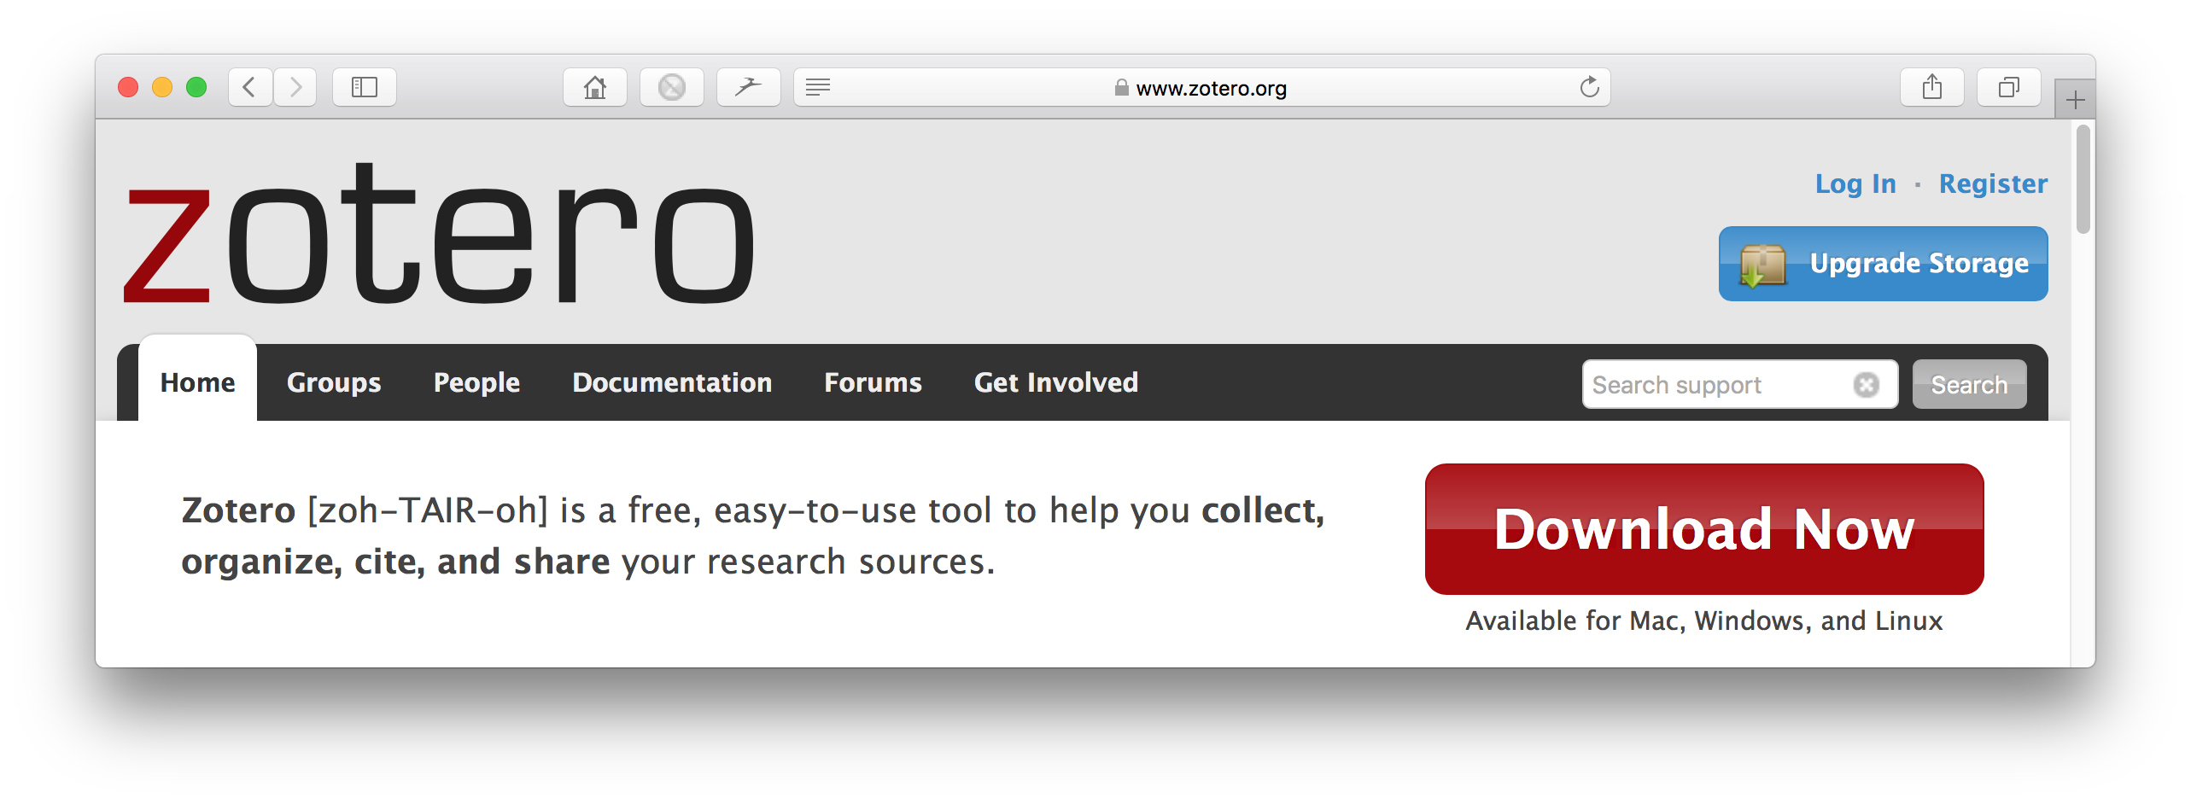
- This will take you to a screen with two options. Click on the left-hand option: ‘Zotero 5.0’ (you should be automatically provided with the correct version for your computer; if not, choose the correct platform from the links below the button). Then click on ‘Allow’ and ‘Install now’, when prompted. When Zotero is installed, the Word plugin is installed automatically.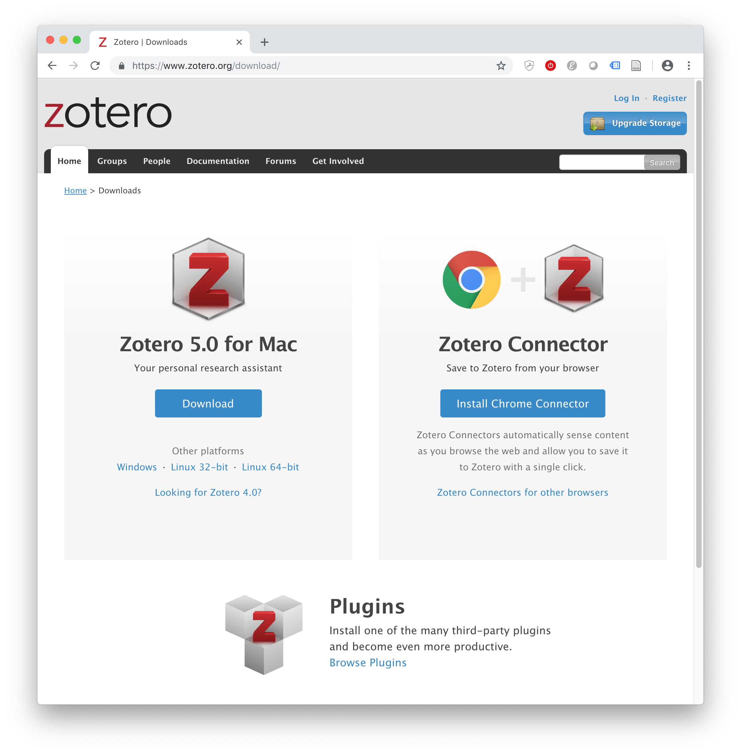
- If you are using Chrome, Firefox, or older versions of Safari, you can also install the Zotero Connector browser plugin, from the button on the right (again, it should automatically offer the correct one for your browser, but there are links to other versions). The browser plugin adds a button to your browser toolbar that makes it easy to add references from websites and online archives. See Extracting references from scientific journals online for more details.
- If you are using Edge, Internet Explorer, Opera, or the latest version of Safari, you cannot use the Zotero connector plugin. However, you can add the Zotero bookmarklet to your bookmarks bar to easily add references to your own personal Zotero account (see Step 2 for details on setting up your Zotero account). The Zotero bookmarklet can be found at https://www.zotero.org/downloadbookmarklet. Add it to your browser by dragging the button into your bookmarks bar (you may need to enable your bookmarks bar in your browser settings).
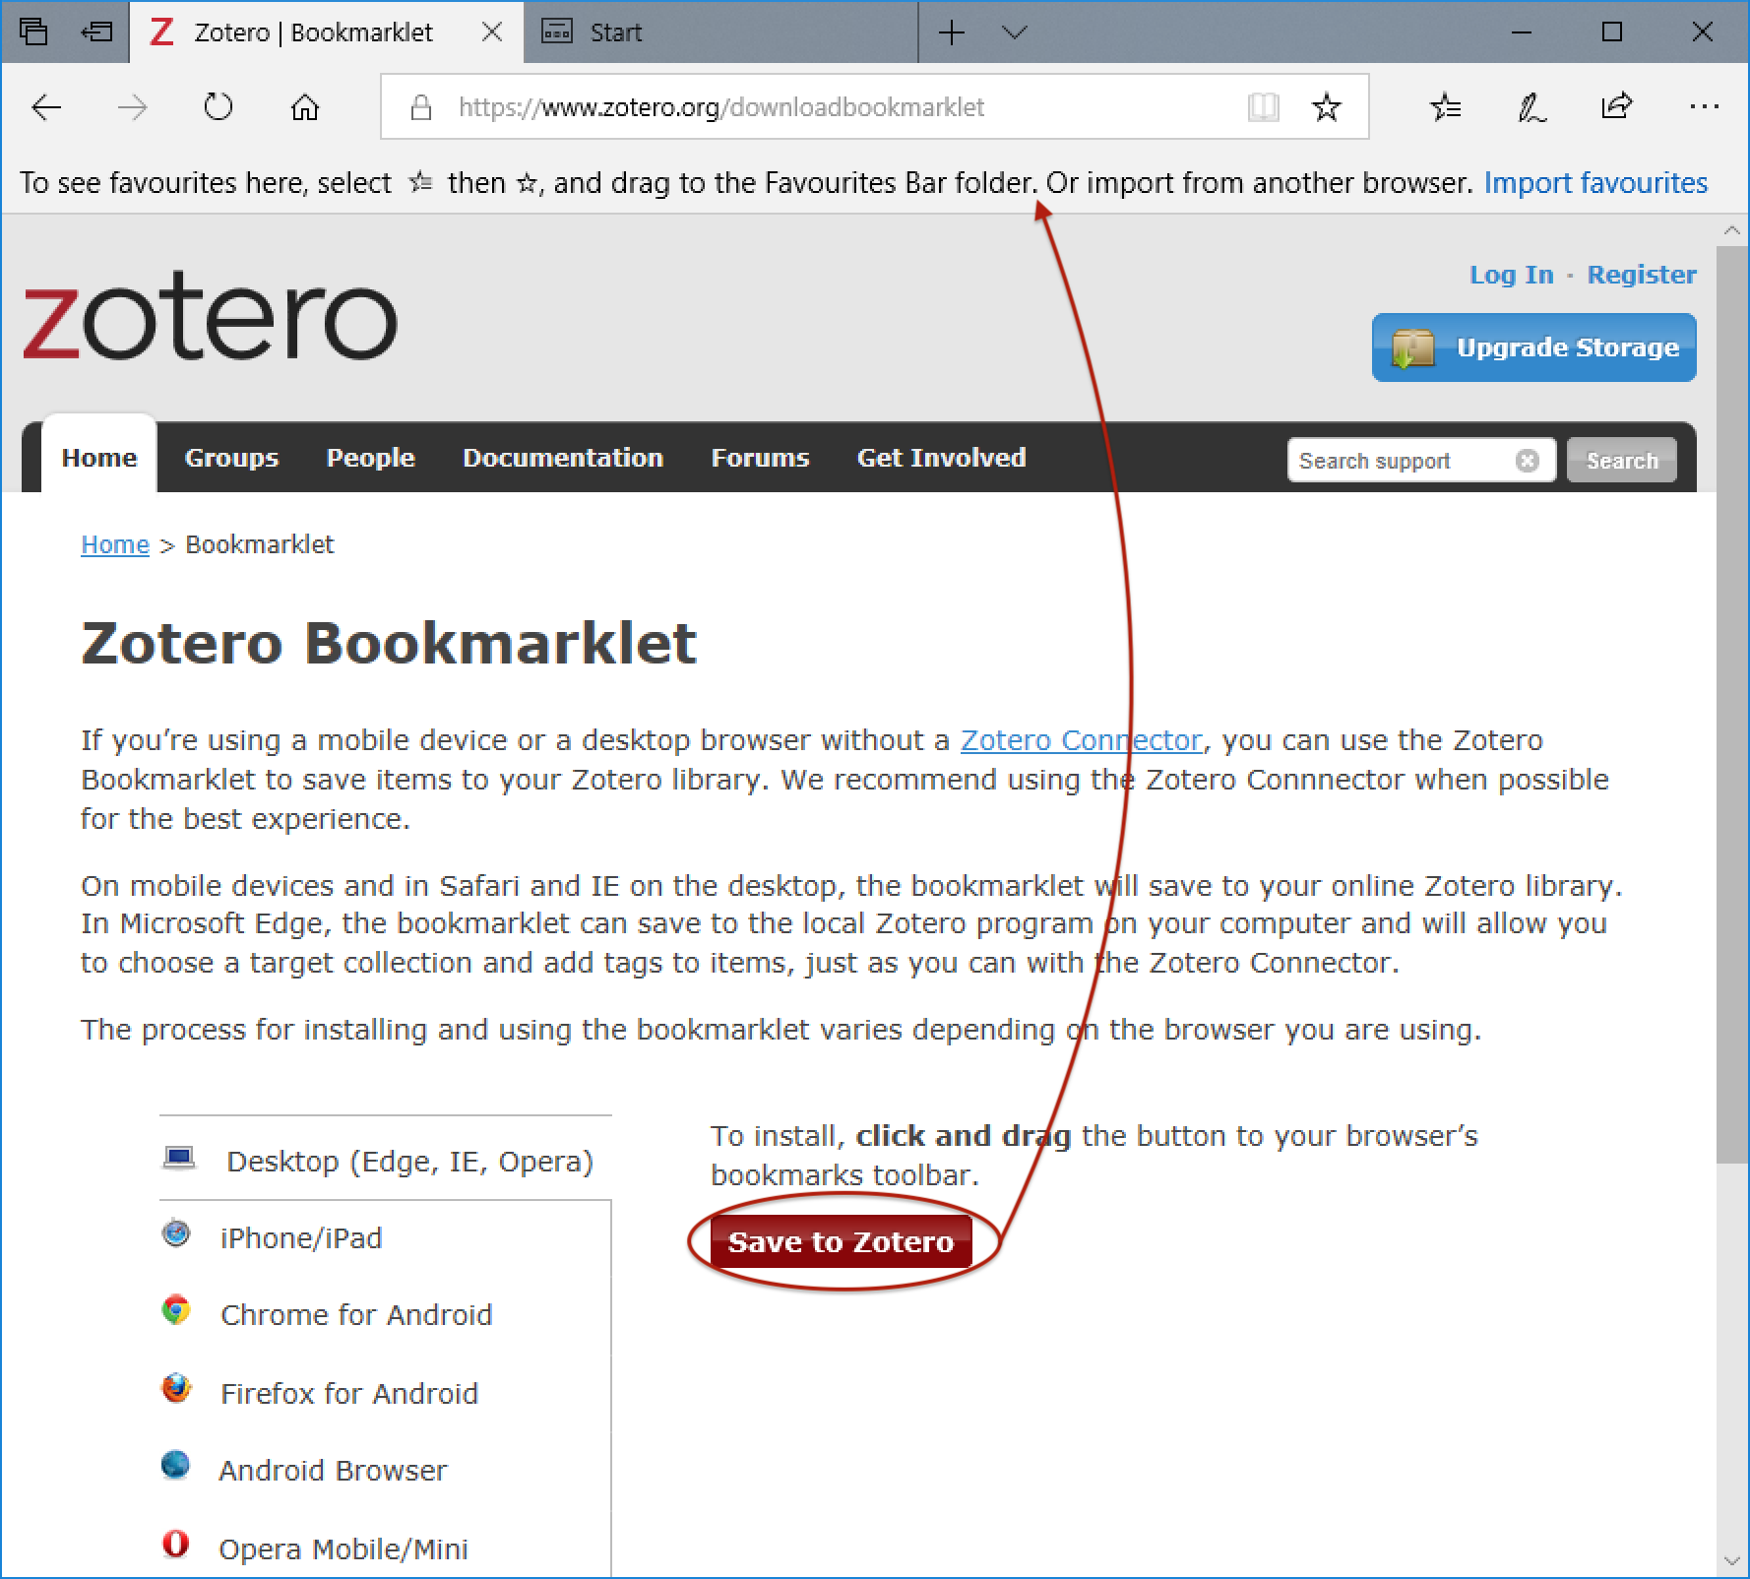
- See Extracting references from scientific journals online using Zotero Bookmarklet for details of how to use the bookmarklet.
- Get a Zotero account: Go to Zotero.org and click on ‘Register’ in the top right corner. Enter a username and password and email address. Go to your email inbox and click on the link that Zotero has sent you.
If you already have a Zotero account, click ‘Login’ instead of ‘Register’. If you aren’t sure whether you have one or not, click ‘Login’ and type your email address, and click ‘Forgot password’. If you have an account, then you will be sent a new login link. If you don’t receive a login link, you don’t have an account already, and you should create one.
Your Zotero account gives you a personal library where you can store references. However, references for EEA projects should be stored in the shared EEA library accessed through the EEA group.
- Apply for membership of the EEA group: When you are logged in to Zotero in your browser, go to https://www.zotero.org/groups/122386/eea. Click ‘Join’ (circled in red below). This will send a request to the EEA administrator, who will approve you to join the EEA group. Note that it may take a few hours for the EEA administrator to approve your membership.
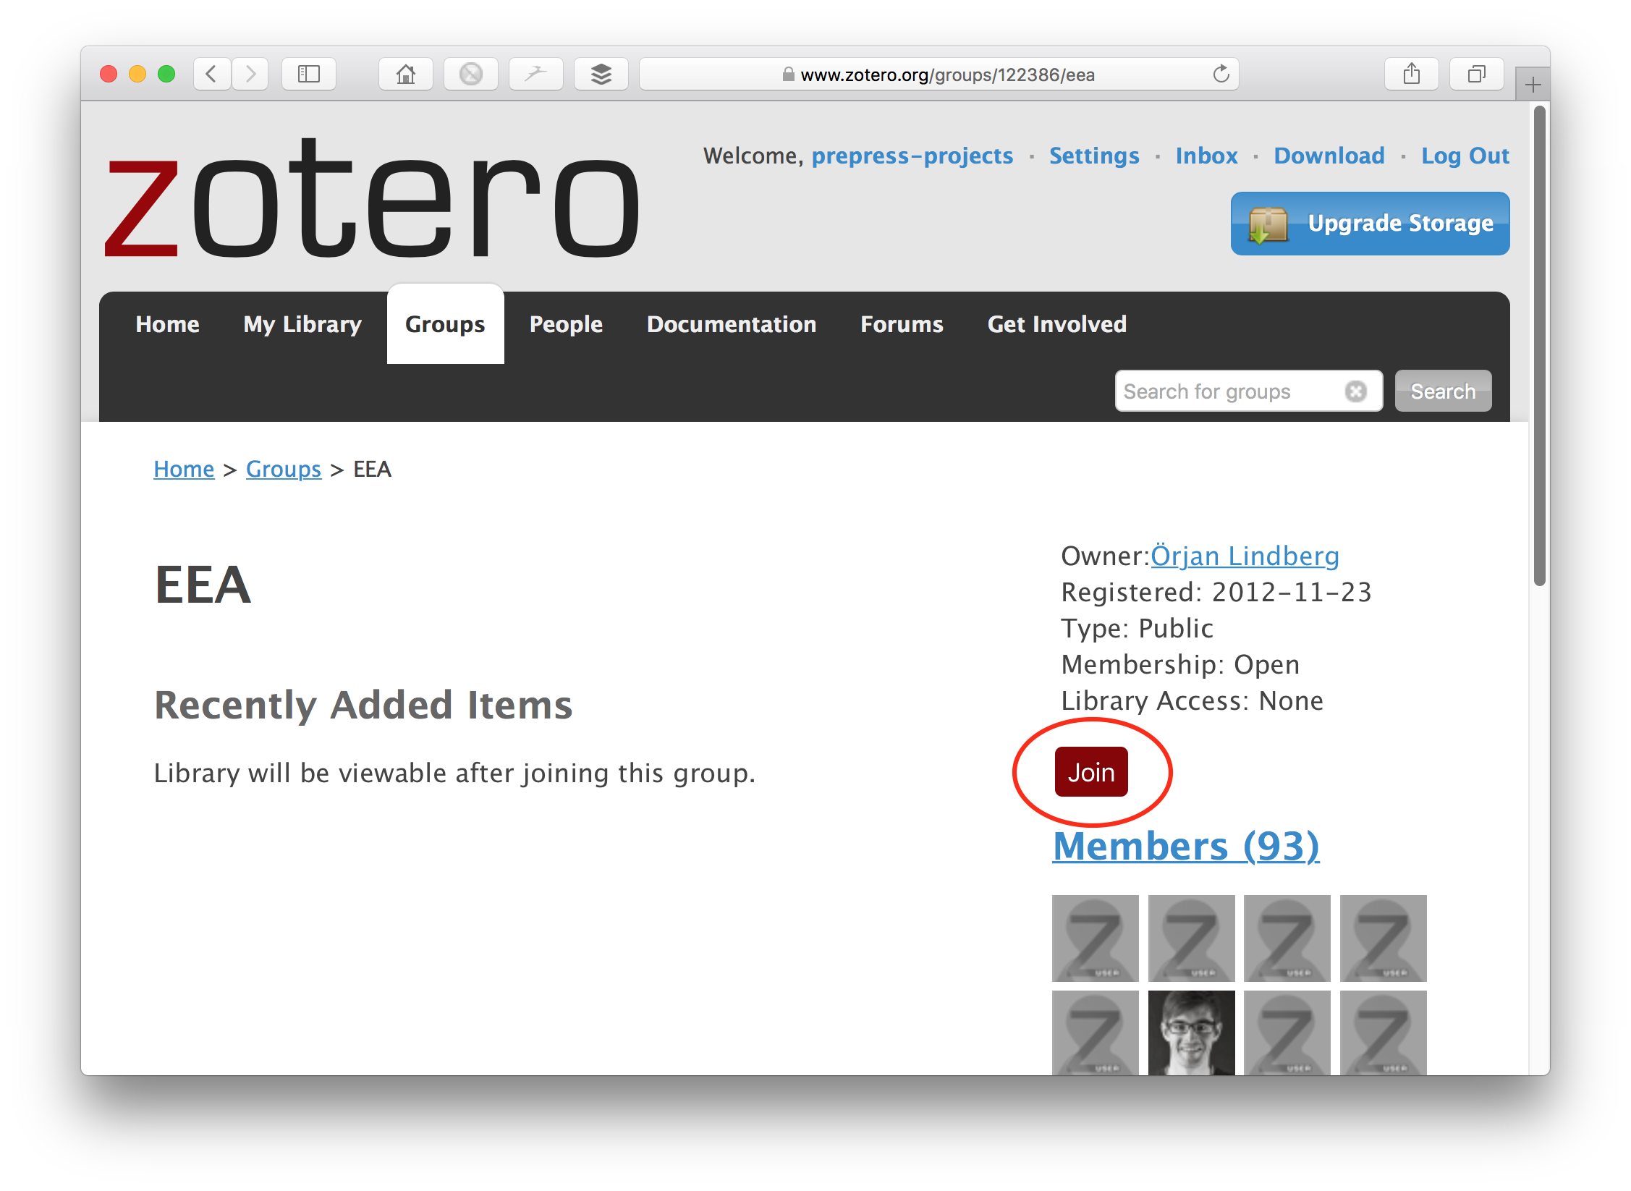
- Access the EEA library from your computer: Open the Zotero app.
- From the menu bar, choose Zotero > Preferences (Mac) or Edit > Preferences (Windows). This opens the preference pane.
- Click on the ‘Sync’ option. Then enter your Zotero username and password and click ‘Set Up Syncing’.
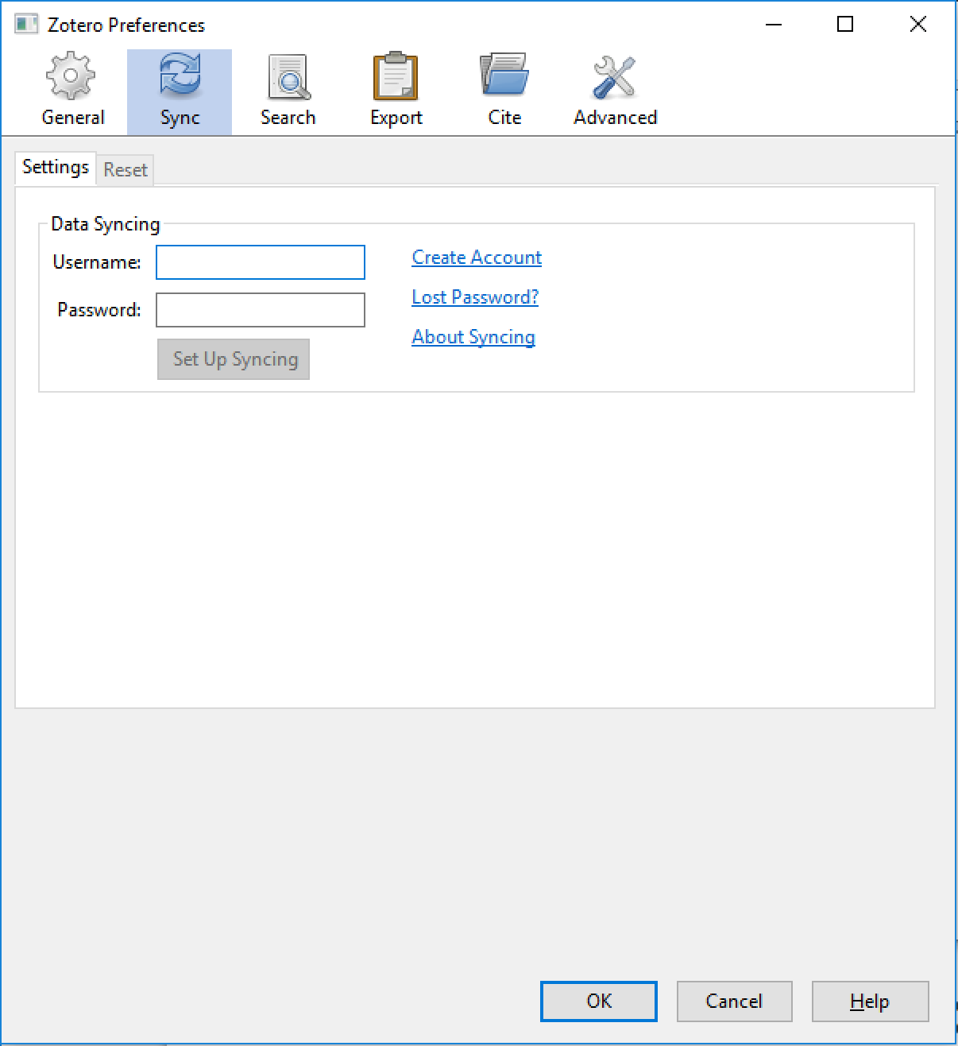
- Once you have done this, you will see some additional syncing options. Click ‘Choose Libraries…’ to choose which libraries (of the ones your account has access to) you want to sync with this computer. Make sure that the EEA library is included.
- If you plan to use the Zotero Bookmarklet, ensure that ‘My Library and Feeds’ is also included in the Libraries to Sync.
- Ensure that ‘Sync automatically’ is ticked. This will keep your computer continually updated with any changes or additions made by other users of the library, and it will keep the library updated with any changes or additions you make.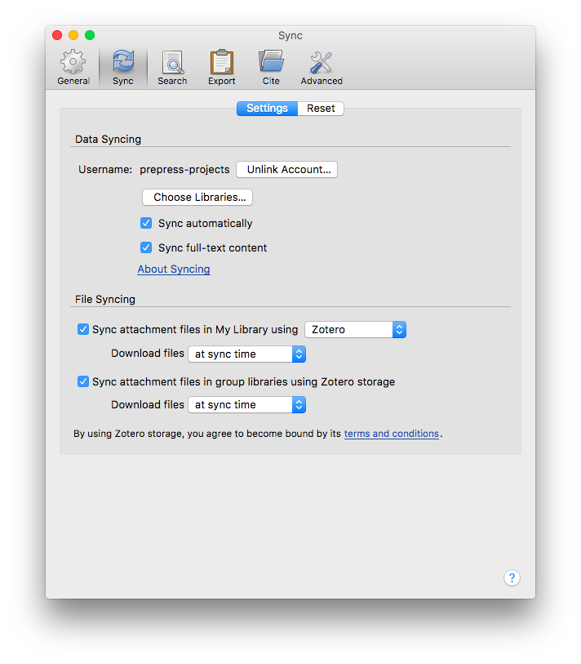Press the ‘Sync libraries’ button near the top right of the Zotero pane.
- The EEA library will take a few minutes to sync with your computer. It will appear below ‘My Library’ on the left hand panel of the Zotero pane (see below).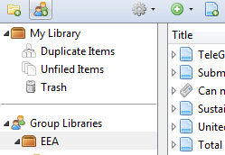
- Install the EEA referencing style: Download the file ‘EEA referencing style.csl’ from the intranet (Intranet > Communication > Writing and Editing Tools) to your desktop. Open Zotero Preferences and choose the ‘Cite’ tab. Click the ‘+’ button at the bottom of the list of styles and choose the EEA referencing style.csl file from the file browser.
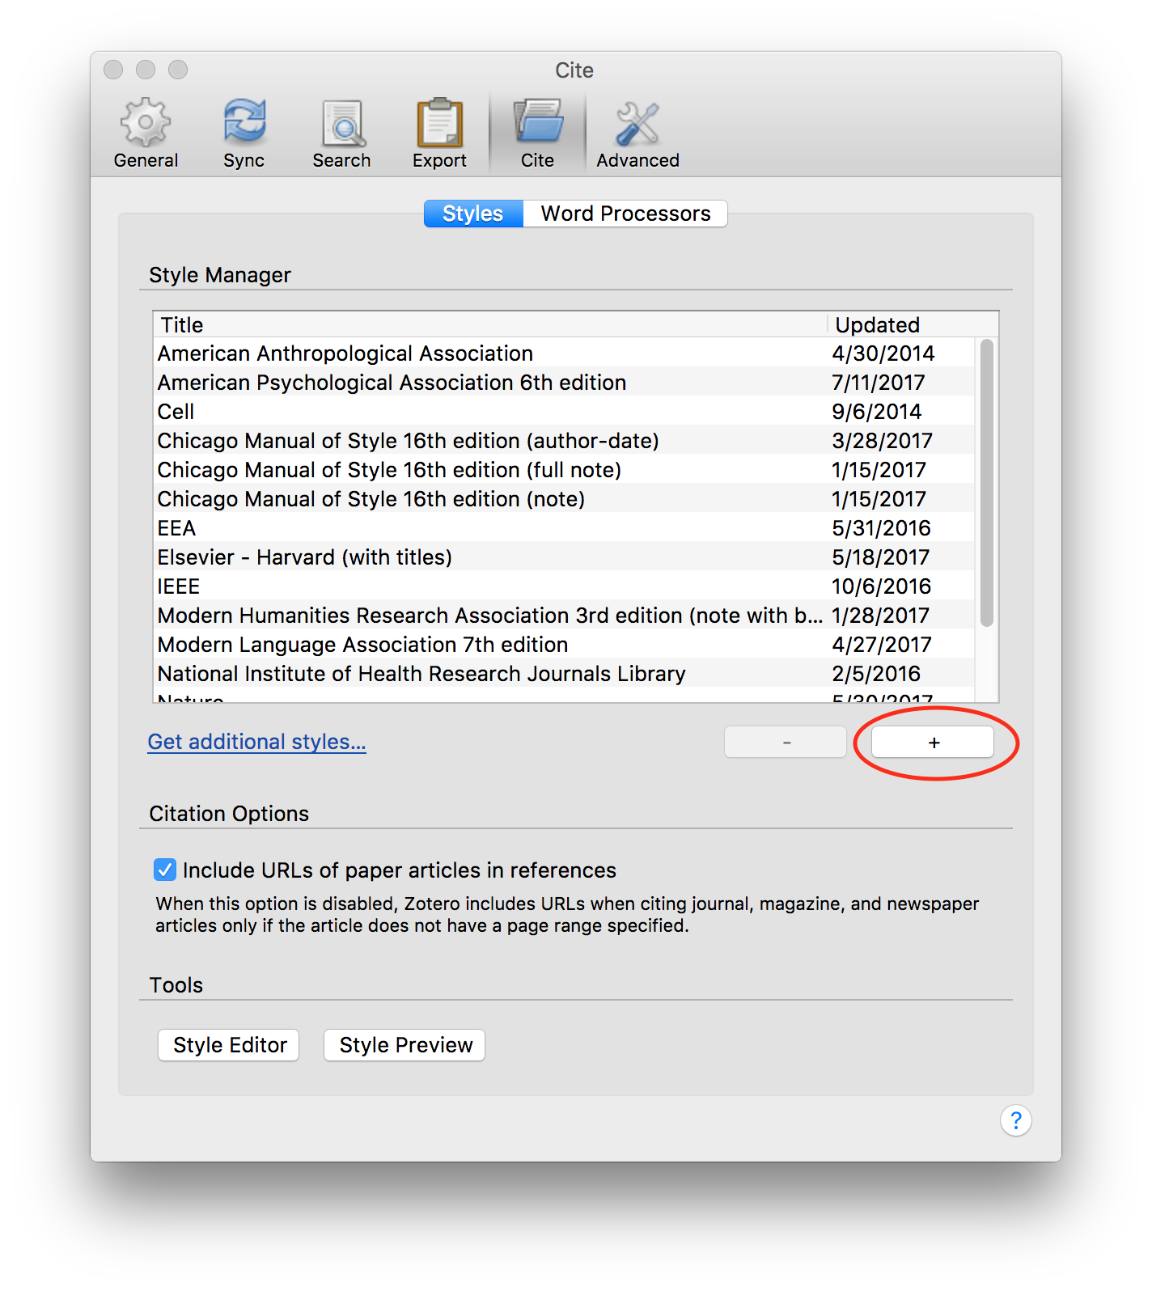
- Changing the citation dialogue box to ‘classic view’: When adding citations in Word documents, the classic view seems to be a bit more user friendly than the default setting. To change the default to ‘classic view’, open Firefox and click on the Zotero icon. Click on the ‘gear’ button and click on ‘Preferences’ and then on ‘Cite’. Then click on the ‘Word Processors’ tab and tick the box next to ‘Use classic Add Citation dialog’. 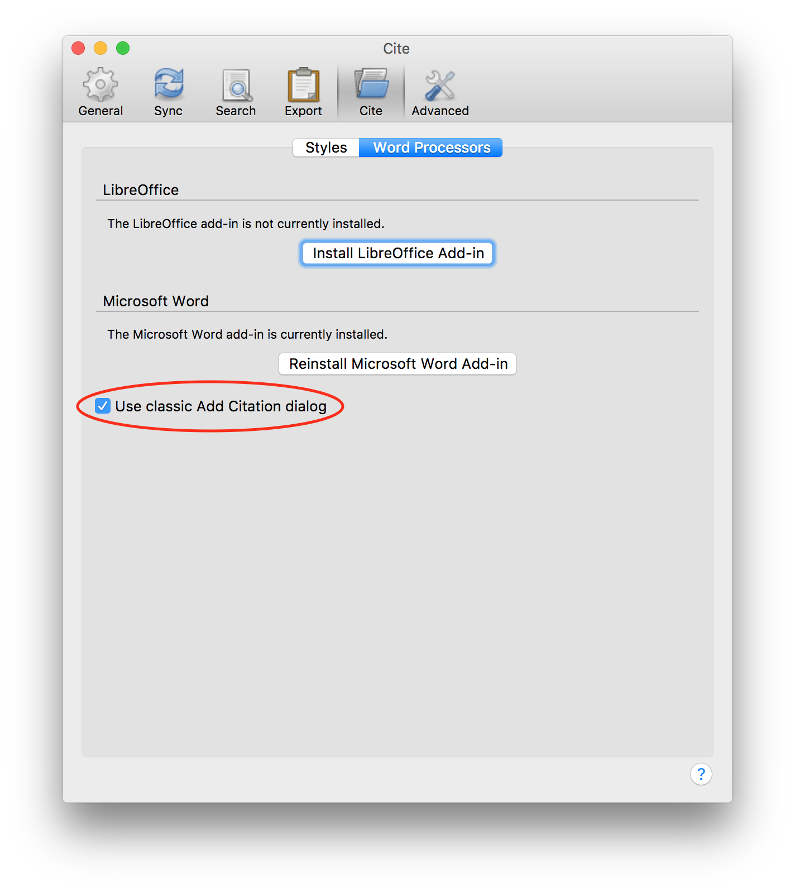

Adding references to the EEA shared library

Creating a project collection
- The first step in starting a new project in Zotero is creating a collection within the EEA library. This allows you to get an overview of the references used in your report. For big reports, it’s often helpful to create sub-collections for individual parts or chapters (as shown below).
- 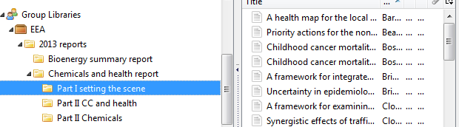
- Any references added to the project collection also become part of the EEA group library. The collections are groupings of references in the group library (like playlists in iTunes). The same reference can be present in multiple collections, and editing it will update it in all the collections.
- Create your new collection by selecting the appropriate collection in the EEA group library where you want your collection to go. For example, for reports to be published in 2018, choose the ‘2018 reports’ collection and create a new collection for your report in that folder.

Checking for existing references
- Always check to see if the reference is already in the EEA group library before you add a new reference. If you add a new reference when a reference to that paper already exists in another collection in the library, then you end up with two copies of the same reference. This makes it hard to manage the reference. For example, if you cite one copy of the reference in one place and another copy of the reference in another, you could end up with two identical, or nearly identical, references in your reference list.
- Click on the EEA folder: 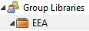
- You can search by title, author or year using the search box at the top of the Zotero window: If the reference is already in the EEA library, then drag it into the project collection or sub-collection. This does not remove it from whatever collection it’s already in, so you don’t need to worry about disrupting anyone else’s work.

Adding a new reference
- Once you have confirmed that your reference is not already present, you can add it in several ways. Normally three are used: manually inputting information; extracting references from web material (including scientific journals); and extracting references using document identifier numbers.
- It is also possible to extract information from PDF files, but this is complicated and in any case works by simply looking up the PDF in Google Scholar.
- When you add a reference it will appear in the currently selected collection. It’s therefore a good idea to ensure that your report collection is selected at all times while you work on your report.
- If you haven’t selected a collection, but do have the EEA library selected, then your reference will appear in the ‘Unfiled items’ collection at the bottom of the library items in the sidebar. You can drag it from there into your report collection.
- If you have accidentally saved your reference into your local library, ‘My library’, you can drag it from there into your report collection in the EEA library.

Manually inputting references
- This is the most commonly used method for adding references such as reports, books, EU opinions and legislation.
- To add a reference manually, click on ‘New item’ . Then choose the appropriate reference type from the dropdown list. Choosing the right option is important because the rules for referencing different types of source vary. The most commonly used ones are:
  - ‘Report’
  - ‘Statute’ (used for national and EU regulations, directives, etc.)
  - ‘Bill’ (used for Commission green papers, communications, etc.)
  - ‘Book’
  - ‘Book Section’ (used for a chapter in a book containing contributions from more than one author)
  - ‘Newspaper Article’
  - ‘Journal Article’
  - ‘Web Page’ (this isn’t created using the dropdown list — see below for more details)
- For all types of reference, please provide author, title and year of publication.
- Page ranges should be separated with hyphens, as specified in the EEA Writing Manual, e.g. 75-84.
- You can toggle between a name as a single word (abbreviation) or phrase (e.g. ‘EC’ or ‘United Nations’) and a name formatted as Surname, Firstname (e.g. ‘Schmidt, Vera’) by clicking on the box icon to the right of the name.
- Examples of the fields to be filled in for each of these reference types are shown below. Only the fields noted and shown in the screenshots are needed for the reference list to be formatted correctly, but there is no need to remove other fields if they have been filled in.
  - Reports must include the following parameters: Title, Author, Institution and Date. Where appropriate, they should also include Report Type, Report Number and Place of publication.
EEA reports should have ‘EEA Report’ as their Report Type, and the Report Number should be included. They should not include the place of publication (Place), but all other reports should include this information.
  - Statute should be used for legislation including Decisions, Directives and Regulations. They must include Name of Act, Author, Code, Date Enacted. 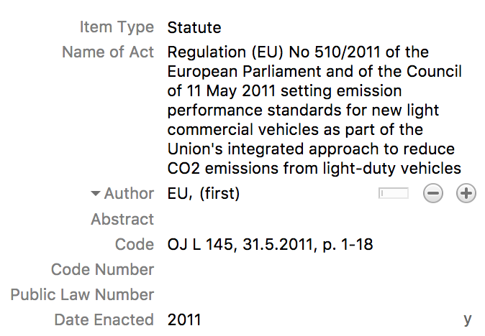
For subsequent searches of the database, it can be useful to add a short title (e.g. Water Framework Directive).
For all EU legislation, the author should be ‘EU', regardless of whether or not it predates the formation of the EU.
  - Web Pages must include the following parameters: Title, Author, Date, URL, Accessed (the date when the web page was last accessed). If the website has an overall title, this should be included as Website Title.
You can also use the Blog Post item type for items that are clearly blog posts. Include the Blog Title (the title of the website) and use Title for the post title. Also include Author, URL and Accessed date. If you are in any doubt over whether or not something is a blog post, choose Web Page. Both types will display similarly in the reference list.
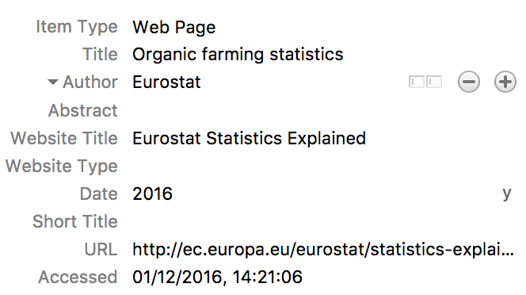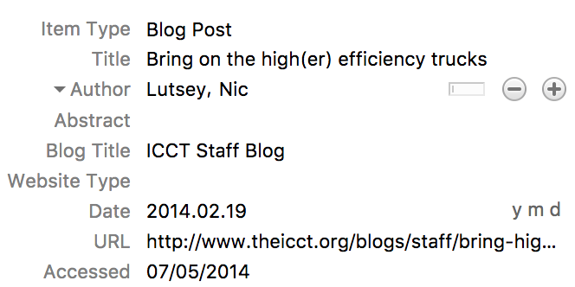
  - Bills include European Commission green papers, communications, etc. The author should be ‘EC’. Include the code number as Code and the date of publication. (Note that European Commission reports should be entered as Reports.)
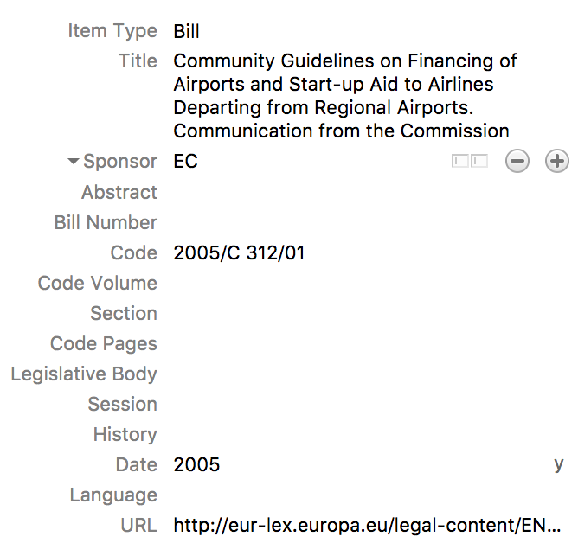
  - Journal articles should include the Publication (name of the journal), Volume, Issue, Pages and Date of publication.
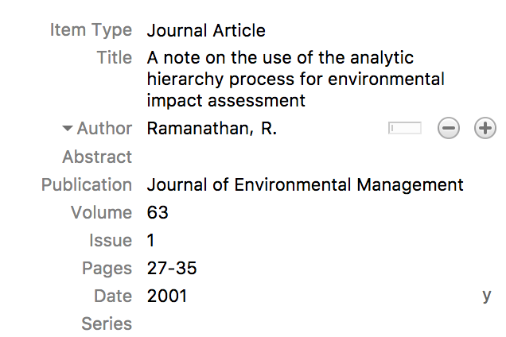
  - Books and book sections should include a Publisher and Place of publication. Book sections should include a page range in Pages.
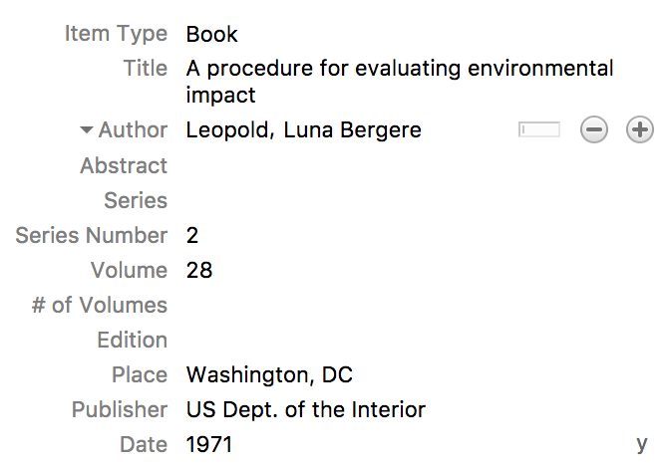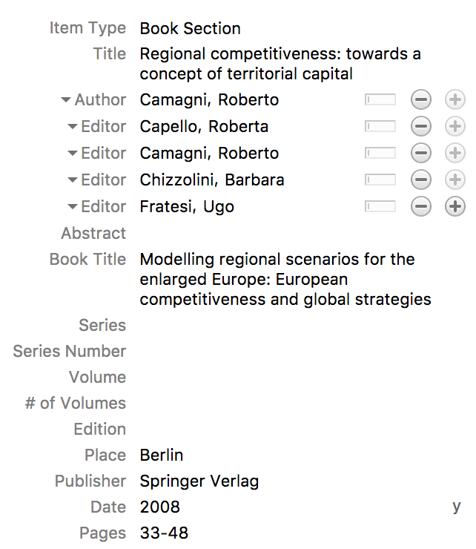
  - Newspaper articles and Magazine articles should include the Publication (name of the newspaper and the Date. Include the Author if you know it. Provide a URL and Accessed date if you accessed the article online, or the Section and Pages if you are referring to a print copy. Both Newspaper Articles and Magazine Articles will appear similarly in the reference list.
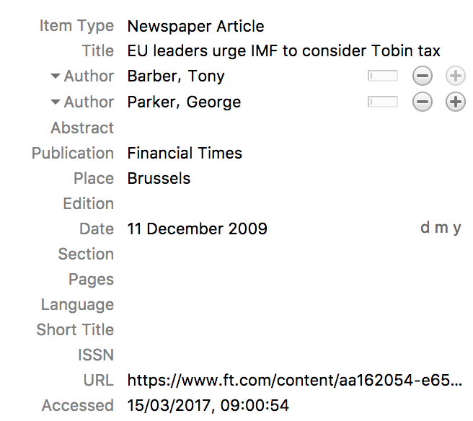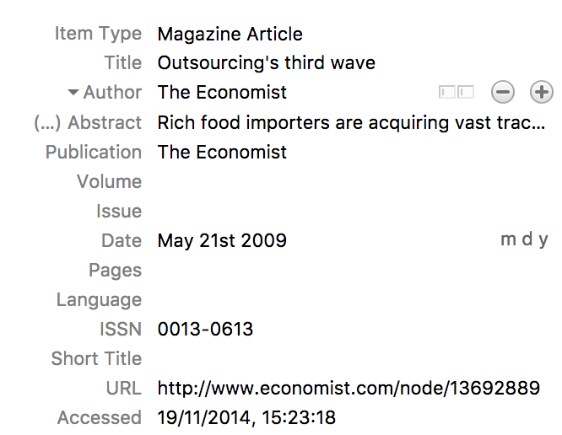
  - Conference papers should include the Conference Name, Place and Date of the conference. If the conference spanned multiple days, choose the starting date, or the date the paper was actually presented if you know it.
  - If none of the other item types seem to fit, categorise the reference as a Document and fill in as much information as you have.
  - Personal communications do not appear in the reference list and therefore should not be managed in Zotero. Instead, type the information manually in Word.

Extracting references from scientific journals online using Zotero Connector
- Scientific references are often complex and can take a long time to add manually. Luckily it is very easy to extract the relevant data from scientific journals online if you have installed the Zotero Connector plugin for your browser (see Step 1 in Installing Zotero and accessing the EEA group library for details of how to install the Connector).
- The Zotero Connector adds a button to your browser toolbar. If you are on the web page of a scientific article, Zotero should recognise this and its button icon should change to the ‘sheet of paper’. 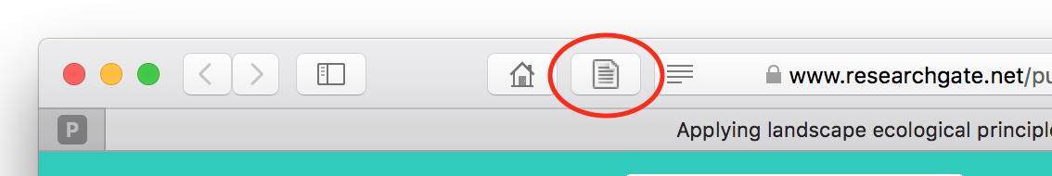
- When you click on the button, you will see a dialog where you can choose which library and collection you want to save the reference to. Using the drop-down menu, choose the EEA library and select the collection for the document or chapter you are currently working on.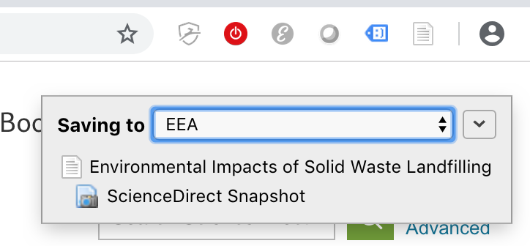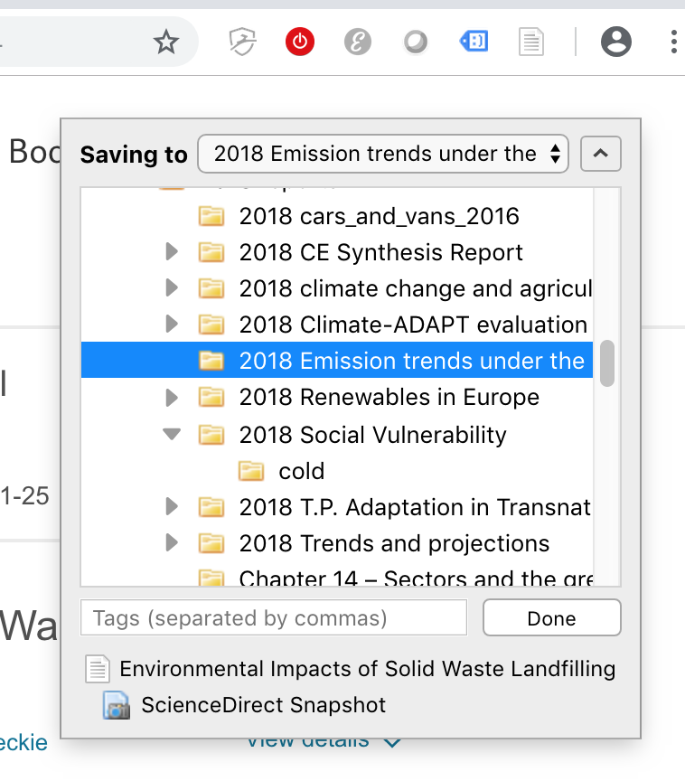
- If there are many references on the page (e.g. if you have searched in Google Scholar) then the icon will be a folder (see below). Clicking on it will enable you to choose which references to extract. 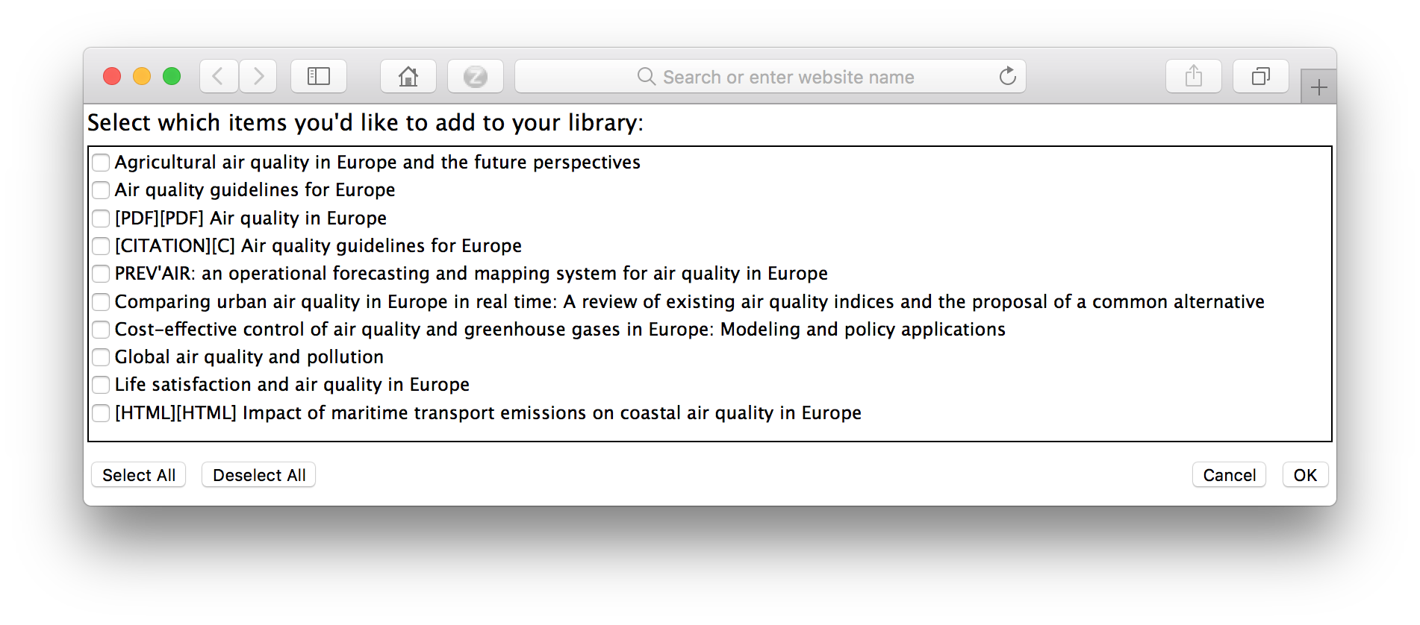
- If the web page you are on is not a journal article or a collection of journal articles, Zotero will try to extract what information it can from the web page metadata. In this way you can extract information for news articles, blog posts, books (e.g. from Amazon) or reports hosted on websites.
The Zotero button icon will change to the ‘any document’ image. Clicking on it will have mixed results depending on how good the website authors were at providing the information in the metadata. You may need to edit the title or add authors or a date. 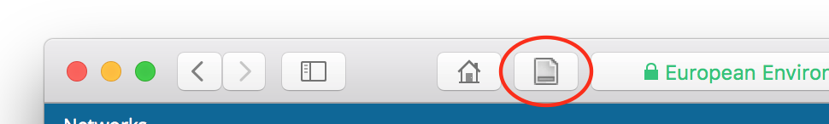

Extracting references from scientific journals online using Zotero Bookmarklet
- If the Zotero Connector plugin is not available for your browser, you can still add references using the Zotero Bookmarklet (see Step 1 in Installing Zotero and accessing the EEA group library for details of how to install the Bookmarklet). Click on the Bookmarklet in your bookmarks bar to save data from the page you are on.
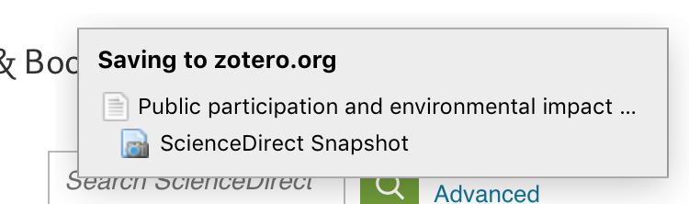
- The Bookmarklet will only work properly if you are logged in to your account on the Zotero website. If you are not logged in when you click it, it will bring up a pop-up window where you can log in so that it can save the reference.
- In Edge, the Bookmarklet will work with the Zotero app. If the Zotero app is running, the reference will be saved into the collection currently selected in the Zotero app. Otherwise, the reference will be added to your personal library in your online Zotero account.
- In Internet Explorer, Opera, Safari, and browsers on mobile devices, the Bookmarklet can only add references to your personal library in your online Zotero account.
- You must use the Zotero app to copy the references from your personal library into the appropriate collection in the EEA library before you cite them in your document.
- If you have saved a reference with the Bookmarklet but can’t find it in the Zotero app, check that your Zotero app is syncing correctly with your ‘My Library & Feeds’ collection in your online Zotero account. See Step 4 of Installing Zotero and accessing the EEA group library for more information on setting up syncing.
- As with the Connector, you may need to correct or supplement the data gathered from the web page, as the Bookmarklet may not have been able to find all the relevant information in the page metadata.

Extracting references using document identifier numbers
- This is another really helpful method for generating references if you have a document identifier such as an ISBN, DOI or PubMed ID. Just press the ‘wand’ icon and add the relevant information. Zotero will look up the document and create a new reference.
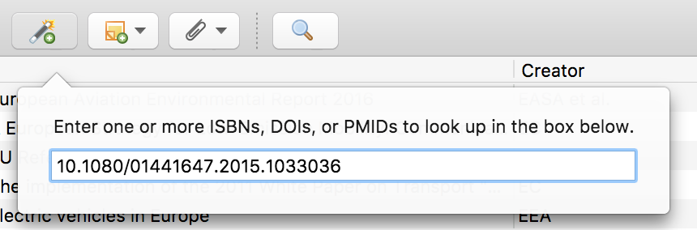

Editing and deleting references
- If you come across a reference that contains errors then feel free to correct it in Zotero. This includes corrections to bring the reference into line with the EEA Writing Manual, for example regarding capitalisation of titles.
- If you find an item that is duplicated, do not delete one of the copies. There is a function for identifying and merging duplications, but this will be handled by the library administrator.
- In general, do not delete project collections or individual references (you can, of course, remove a reference from your project collection without deleting it). The library is backed up periodically but this only saves the references, not the project collection structure. So it would be very inconvenient if someone deleted everything.

Adding files to references
- You can now add PDF documents and web snapshots to the Zotero EEA library. This is a good way of keeping track of the content of your references so you can easily return to them at a later date.
- This is a recent improvement to the EEA library, and so older references in the EEA library will not have attached PDFs or website snapshots.
- Double-click on a file in Zotero to open it. Web snapshots will open in your default browser and PDFs in your default PDF viewer.

By drag and drop
- Simply drag the file from your computer into Zotero. Drag it on top of the reference you want it to be associated with, and it will become a ‘child’ of that reference.
- If you miss, and the file becomes associated with the wrong reference, just drag it onto the correct reference.
- It is also possible to drag a file into Zotero without associating it with a reference. In that case, it will appear in the list alongside the other references. It will have an Item Type of ‘Attachment’. It will not have the metadata associated with the document and therefore will be cited wrongly if you try to cite it using Zotero’s Word plugin.
Again, you can associate the file with the appropriate reference by dragging it on top of the reference in the list. If there is no appropriate reference, you will need to create one.

Using the Zotero Connector plugin
- By default, Zotero saves PDFs (if they are available) and web snapshots automatically when you save a reference using the Zotero Connector button or Save to Zotero bookmarklet in your browser. The pop-up shows you what will be saved.
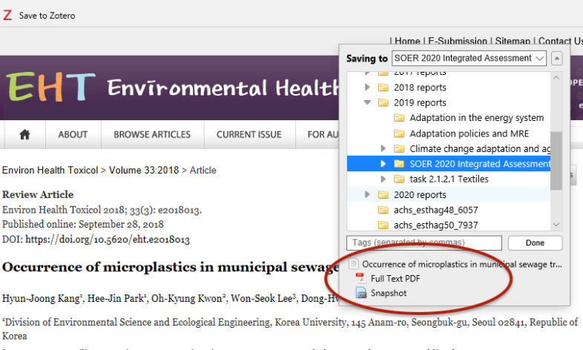
- You can set Zotero’s behaviour when creating references in the General section of Zotero Preferences. If you want to save PDFs when saving items from your browser, ensure that ‘Automatically attach associated PDFs and other files when saving items’ is ticked.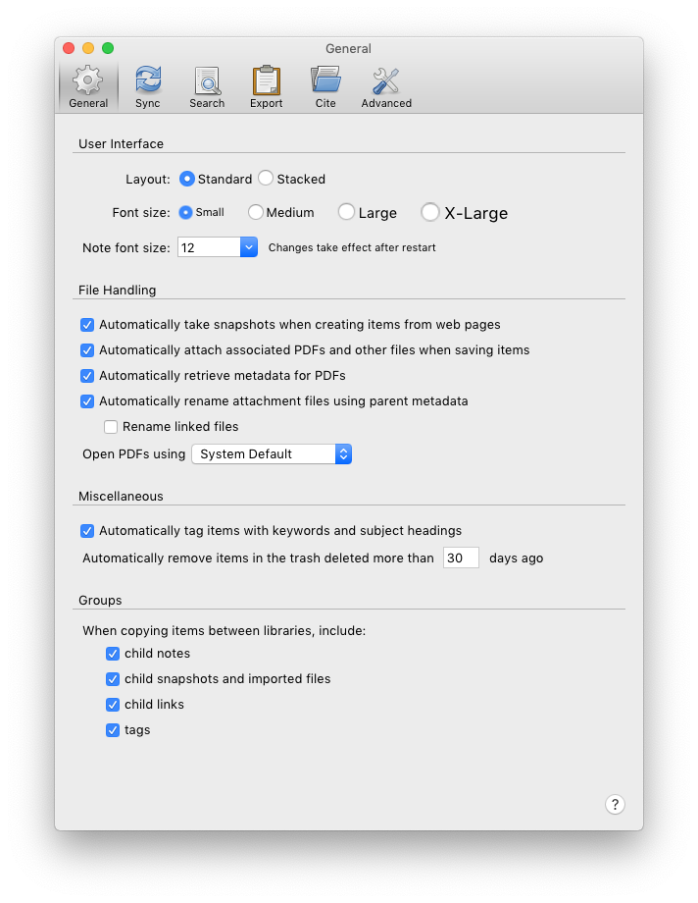 It is also helpful to ensure that all the items under ‘When copying items between libraries, include:’ are ticked as well. This means that if you save a Zotero reference in your own library and want to copy it into the EEA library, all the associated items will come with it.

Using Zotero in Word

Setting Zotero preferences in Word
- In Word, the Zotero functions are accessed via the ‘Zotero’ tab at the top of the window. Note that you will need to have the Zotero application active whenever you are using Zotero in Word.
- 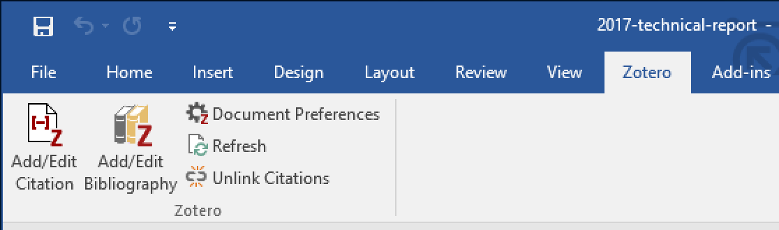
- The first time you use Zotero in a Word document you will be asked to choose a style. Select the EEA style from the list (see below). If there is no EEA style in the list, then refer back to step 5 in the instructions for installing Zotero.
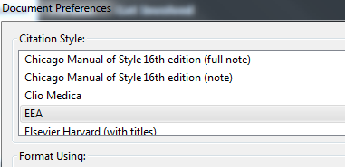
- If you use Zotero frequently and use different styles, please ensure that you have selected ‘EEA’ style when you are writing for the EEA. Click on ‘Document Preferences’ in the Zotero ribbon, and choose EEA from the list.
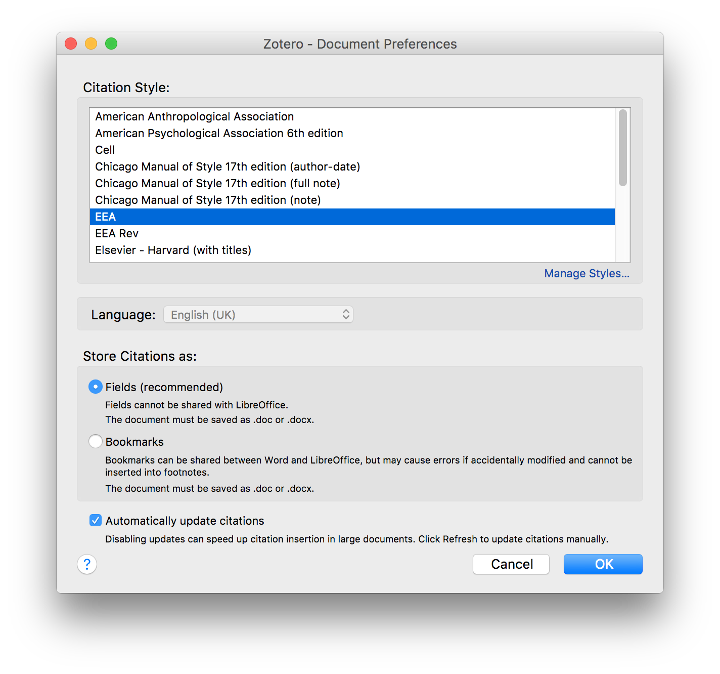
- Ensure that the preferences are set to store citations as Fields.
- In most cases, you should leave Automatically update citations ticked. However, in very large documents with many references, frequent updating of citations can slow Word down. If you are experiencing this, then untick Automatically update citations. You will need to click Refresh in the Zotero ribbon periodically to keep your citations in the document up to date. Ensure that you refresh before saving the final version of the document.

Citations in the text

Adding a citation
- To add citations in a document, use the ‘Add/Edit citation’ button.
- Next, navigate to the correct project collection and select the appropriate reference. Click on ‘OK’.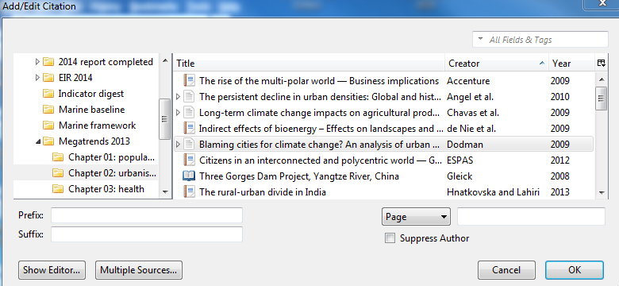

Adding multiple citations within the same set of parentheses
- It is often useful to add several citations together, e.g. (Morris, 2007; Smith et al., 2011).
- To do this, click on the ‘Insert citation’ button and then click on ‘Multiple sources’ (towards the bottom left in the image above).
- Select the first reference to be added and click on the green arrow to shift it into the right-hand pane (see image below). Repeat this until all the required references are in place, then click ‘OK’.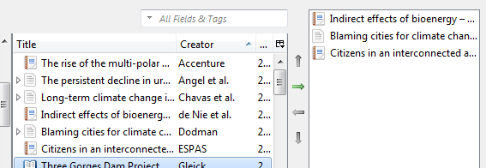

Adding prefixes, suffixes and page ranges
- In some cases, you may want to include introductory text in a reference citation, such as ‘(see, for example, Broadmann, 2014)’. This text can be added in the Prefix text field in the Add/Edit Citation dialog box. Text to follow a citation can be added in the ‘Suffix’ field.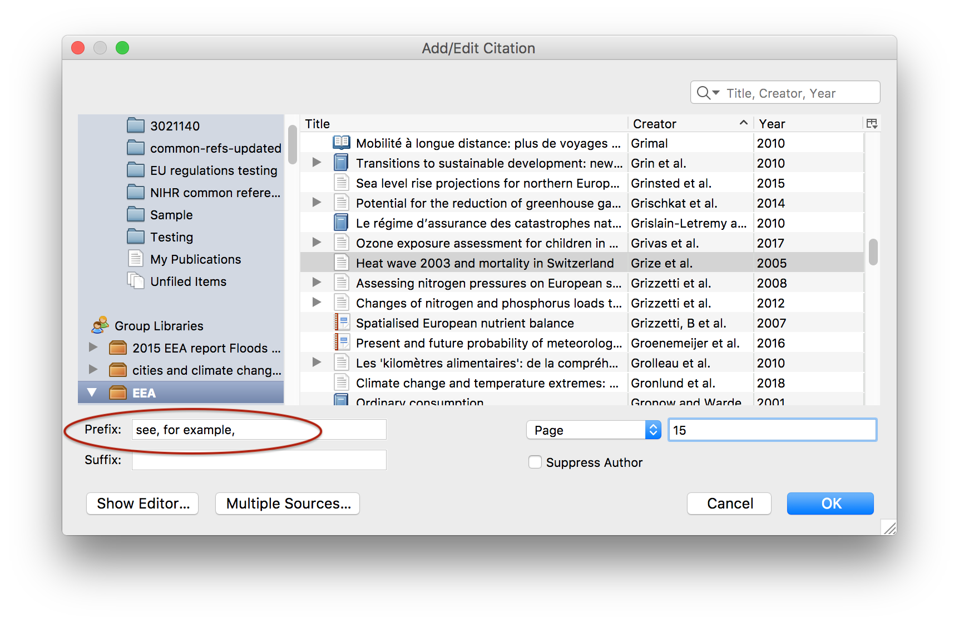
- You can cite a specific page, paragraph or figure using the ‘Page’ drop-down menu and adding the number in the text field next to it. 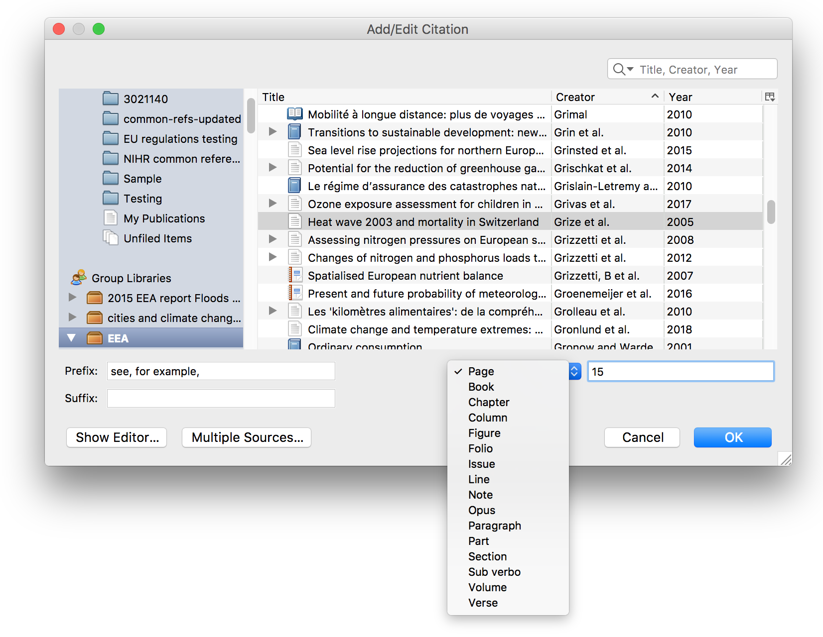
- These additions affect only the current citation, so you can refer to the whole work or cite the same work without the prefix in another part of your document.
- You can add these when editing an existing citation by clicking on ‘Add/Edit Citation’ in the Zotero ribbon when your cursor is in the citation (see Changing citations, below).

Incorporating the author’s name into a sentence
- In some instances, it is useful to incorporate an author into a sentence and merely bracket the year, for example: ‘According to Smith et al. (2011), …’.
- This construction is also used in lists of sources for figures, maps, etc. For example:
Sources: Morris (2007); Smith et al. (2011).
- To do this, simply type the author’s name in the document and then click on the ‘Insert citation’ button. Select the appropriate reference and the tick the box next to ‘Suppress Author’ (near the bottom right of the ‘Add Citation’ pane.
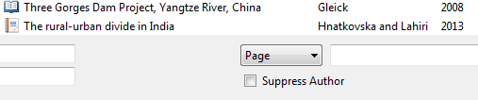
The citation will be limited to the year but the full reference will be included in the bibliography.

Changing citations
- If the wrong reference is selected, an additional reference should be added in a citation, or you want to add, for example, a page number, then you can click the ‘Add/Edit citation’ button while your cursor is in the citation. (It’s normally just as quick to delete the original citation and add a new one.) Edit the citation as above.
- Do not edit the citation by deleting or overtyping a part of it within Word. When Zotero next refreshes the references, it will either keep the changes and prevent the reference from being updated with any changes made in the library, or discard the changes . Neither option is desirable; instead, make changes within Zotero using Add/Edit citation.
- Do not edit the citation using the ‘Show Editor…’ button at the bottom of the Add/Edit citation. This breaks the link to the Zotero item and it will no longer be updated with any changes made in the library. Our editors check and correct references in the library to ensure that they reflect EEA style. If the link is broken, then these corrections will not be reflected in your document.

Bibliographies

Adding a bibliography
- To add a bibliography, click on the ‘Add bibliography’ button.

Adding non-cited sources to a bibliography
- It may be necessary to add references to a bibliography that have not been cited in the text of a document but have nevertheless informed the analysis. To do this, click on the ‘Edit bibliography’ button. Select an additional reference and click on the green arrow to add it to the right hand panel, then repeat this until all needed references are included. Press OK.
- 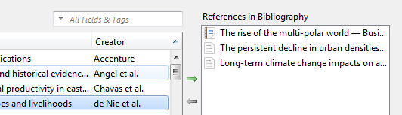

Editing references in a bibliography
- If you spot an error in a reference in your bibliography, do not attempt to correct it by editing the text in the Word document. This will be undone when you next use ‘Zotero refresh’.
- Instead, find the corresponding item in the Zotero app, by browsing or searching within the report collection, and edit the fields there. You will then need to refresh the citations in the document (see below) for the changes to show there.

Updating citations and references after edits or deletions
- In some instances, it may be necessary to ‘refresh’ the citations and references in a document. This could occur if a citation is deleted, necessitating some renumbering of other citations (e.g. if ‘EEA, 2010a’ is deleted, then ‘EEA, 2010b’ will need to change). It could also occur if references are corrected in Zotero after being included in a Word document.
- To refresh all citations and references in a document, click on the ‘Zotero refresh’ button.

Removing Zotero field codes
- Do not remove Zotero field codes once the document is complete. We use Zotero in production to ensure that the formatting of references is correct and in line with EEA style. Removing the Zotero field codes means that your report will take longer to process, as your references will have to be edited manually.

